ANNUAL REPORT 2024

Pristina, March 2025
INTRODUCTION
Dear all,
The Energy Regulatory Office (ERO), in accordance with its legal mandate, presents to the Assembly of the Republic of Kosovo the Annual Report of its activities and the activities developed in the energy sector during 2024. The Annual Report has been drafted in full compliance with the legal provisions of the Law on the Energy Regulator, and in line with this, it is submitted to the Assembly of the Republic of Kosovo for information, review and approval.
The Annual Report presents a detailed overview of the activities developed and the main achievements of ERO, as well as the energy sector during the calendar year 2024, as well as the financial report. The report contains detailed data and information on the activities of ERO on the most important events for the energy market, the review of energy tariffs, the financial report of ERO, as well as data on regulated activities in the energy sector in the Republic of Kosovo.
ERO is an independent agency established by the Assembly of the Republic of Kosovo according to Article 119.5 and Article 142 of the Constitution of the Republic of Kosovo, where its activity focuses on the security of energy supply at affordable prices, the protection of energy customers, as well as the sustainable functioning of energy enterprises.
In accordance with its legal and regulatory obligations and powers, ERO, even during 2024, has contributed to maintaining the stability and security of energy supply and the fair functioning of the energy market.
Like the previous year, the year 2024 was marked by high achievements in the good and professional work of ERO, and this achievement was also evidenced in the Annual Implementation Report for 2024 of the Energy Community Secretariat, in which case ERO was evaluated as one of the Regulators with the highest percentage of points among the regulators of the Energy Community member states. The Energy Community Secretariat in its Annual Report has highly appreciated the good and professional work of ERO in implementing the tasks arising from the legislation in force and international obligations, where it should be highlighted the good management of security of supply, the approval of electricity tariffs which has brought stability to the energy sector, the functionalization of the Albanian electricity exchange ALPEX and the coupling of the Kosovo - Albania markets, the actions taken for the normal operation of the supplier Elektrosever, the taking of actions to encourage investments in renewable resources, the active promotion of self-customers, as well as the approval of many other activities which have been more than necessary for the electricity sector to be stable and sustainable.
During 2024, Kosovo for the first time after the signing of the Athens Treaty in 2005 took over the presidency of the ECRB, where the Energy Community Regulatory Board (ECRB) at its extraordinary meeting held on 05.06.2024 in Athens, elected the Chairman of the Energy Regulatory Office, Mr. Ymer Fejzullahu, as the new President of the ECRB for a period of two years.
During 2024, ERO has undertaken all its legal and regulatory actions for the functionalization of the ALPEX exchange for the Kosovo part and the coupling of the Kosovo-Albania joint market. In February 2024, the ALPEX exchange, the bidding zone in Kosovo for the day-ahead market, was functionalized and at the same time the coupling of the Kosovo-Albania energy market was completed. In December 2024, the ALPEX exchange was functionalized for the intraday market, therefore completing the entire regulatory framework for the full functioning of ALPEX. The creation of the ALPEX electricity exchange and at the same time the coupling of the Kosovo-Albania markets constitutes an extraordinary achievement for the energy sector by creating a transparent platform for energy trading, increasing competition at retail prices, creating opportunities for new private sector investments in renewable energy generation capacities (RES), as well as easier access for new suppliers.
In this Annual Report of ERO, a special place is also occupied by the joint market between Kosovo, Albania, North Macedonia and Greece (SEE-MC). In 2024, intensive work continued on the transposition of all elements of the Electricity Integration Package into the legislation of the respective countries, coordination with regional stakeholders, harmonization and application of relevant and necessary methodologies for this project, drafting plans for the transposition of the CACM guidelines into our legislation, as well as other technical issues related to the functionalization of market integration. It should be noted that in December 2024, by an absolute majority of votes, the Chairman of the Board of the Energy Regulatory Office was again elected Chairman of the Implementation Group for the integration of electricity markets. It is worth noting that with the implementation of this project, we will have security of supply, greater increase in competition and more affordable prices for customers.
ERO has also undertaken all its actions in accordance with the legislation in force in 2024 to promote and diversify its generation portfolio through Renewable Energy. For this, ERO has determined the maximum fixed price for wind auction projects in 2024 in accordance with its legal duties, and has actively promoted the installation of self-customer panels.
ERO, during this year, like in every other year, has also closely cooperated with the parliamentary committees of the Assembly of the Republic of Kosovo, the relevant ministries of the Government of the Republic of Kosovo, the Competition Authority, the Energy Community Secretariat in Vienna, the Energy Regulators Regional Association, the Council of European Energy Regulators, the National Association of Regulatory Utility Commissioners, and with many other institutions, on which occasion I would like to thank everyone for their cooperation during 2024.
On behalf of myself and the other members of the Board of the Energy Regulatory Office, I would like to express my gratitude to all ERO staff and the energy sector for their work and dedication in providing services to customers during this year.
Finally, ERO remains committed to the path towards an energy transition, in line with the goals towards integration into the European energy market, placing the energy customer at its center.
Respectfully,
Ymer Fejzullahu,
Chairman of the Board
CONTENT
1 EXECUTIVE SUMMARY 10
2 Energy Regulatory Office 13
2.1 The Board of the Regulator 13
2.2 The organizational structure and human resources 14
2.3 Funding of the Regulator 17
3 ACTIVITIES OF THE ENERGY REGULATORY OFFICE 19
3.1 Licensing of energy activities 19
3.2 Monitoring of energy companies 30
3.3 Renewable Energy Sources (RES) 32
3.4 Authorization for the construction of new capacities 34
3.5 Self - consumption generator​​​ 36
3.6 Monitoring the construction of new generation capacities 38
3.7 Market integration 39
3.8 Activities of the Regulator in the field of price regulation 43
3.9 The Regulator's activity in the area of customer protection 58
4 COOPERATION WITH OTHER PARTIES AND TRANSPARENCY 63
4.1 Public involvement in regulatory processes through public consultations 63
4.2 Reporting and cooperation with the Assembly of Kosovo 65
4.3 Meetings with other stakeholders 66
4.4 Implementation Group meetings within the SEE - MC market integration initiative 67
4.5 Cooperation with international organizations 68
4.6 Participation of the Regulator in international activities 68
4.7 Procurement activities 74
5 Financial Reporting to the Regulator 75
5.1 The revenues 75
5.2 The budget 75
5.3 Budgetary expenditures 76
6 ELECTRICITY SECTOR 80
6.1 Characteristics of the electricity sector 80
6.2 Primary energy sources​ 84
6.3 Electricity production 85
6.4 Transmission system 91
6.5 Electricity distribution system 101
6.6 Electricity supply 112
6.7 Import and export of electricity 118
6.8 Electricity supply and service quality standards 120
6.9 Reporting of the Electricity Supplier "Elektrosever Company" LLC 134
6.10 Data reported by DH Termokos 136
6.11 Data reported by DH Gjakova 137
7 THERMAL ENERGY SECTOR 139
7.1 Technical characteristics of thermal energy systems 139
7.2 Key developments in the thermal energy sector 140
7.3 Performance of thermal energy companies 144
7.4 Billing, collection and heating area 147
​​​

List of abbreviations
AIT Average Interruption Time
ALPEX Albanian Power Exchange
CPA Central Procurement Agency
EU European Union
RES Renewable Energy Sources
CCP Customer Care Programme
CEER Council of European Energy Regulators
DETG Department of Thermal Energy and Gas
DLL Legal and Licensing Department
DMK Customer Protection Department
DTC Tariff and Pricing Department
DTE Energy Market Department
EBRD European Bank for Reconstruction and Development
EC European Commission
ECRB (BRKE) Energy Community Regulatory Board
SEE South-eastern Europe
EMS Transmission System Operator of Serbia
ENS Energy Not Supplied
ENTSO-E European Network of Transmission System Operators for Electricity
ERC Energy and Water Regulatory Commission of the Republic of North Macedonia
ERE Energy Regulatory Entity of the Republic of Albania
ERRA Energy Regulators Regional Association
USS Universal Service Supplier
GPG Gas Working Group
GPNL (PHLG) Permanent High Level Group
GWh Gigawatt hours
HP Hydropower Plant
MAR Maximum Allowed Revenues
IAP Ion-Adriatic-Pipeline – Trans-Adriatic Pipeline
ITC Inter TSO Compensation
EC Energy Community
KEDS Kosovo Electricity Distribution and Services Company
SEEEC South East European Energy Community
KEK Kosovo Energy Corporation
KESCO Kosovo Electricity Supply Company
KESH Albanian Energy Corporation
KfW German Development Bank
CM Council of Ministers
km Kilometre
KOSTT Transmission System and Market Operator
KPSC Kentucky Public Service Regulatory Commission
kV Kilovolt
kW Kilowatt
LP Overhead (power) lines
MPA Ministry of Public Administration
PPA Power Purchase Agreement
MESP Ministry of Environment and Spatial Planning
MVA Megavolt ampere
MW Megawatt
MWh Megawatt hours
MW _{TH} Thermal megawatt
MED Ministry of Economic Development
NARUC National Association of Regulatory Utility Commissioners
AU Administration unit
DH District Heating
SS Substation
DSO Distribution System Operator
TSO Transmission System Operator
MO Market Operator
PECI Projects of Energy Community Interest
PRR Regulatory period
RAB Regulatory Asset Base
RoR Rate of Return
SAIDI System Average Interruption Duration Index
SAIFI System Average Interruption Frequency Index
SCADA Supervisory Control and Data Acquisition System
ECS Energy Community Secretariat
TAP Trans-Adriatic-Pipeline
TPP Thermal Power Plant
TF Task Force
ECT Energy Community Treaty
MV Medium Voltage
TR Transformer
LV Low Voltage
VAT Value Added Tax
AI Administrative Instruction
USAID United States Agency for International Development
WACC Weighted Average Cost of Capital
WBIF Western Balkans Investment Framework
CA Cadastral area
ERO Energy Regulatory Office (Regulator)

EXECUTIVE SUMMARY
The Energy Regulatory Office (hereinafter referred to as the Regulator), in accordance with the legal requirements arising from the Law on the Energy Regulator (Law No. 05/L-084), presents the Annual Report for 2024 for consideration by the Assembly of the Republic of Kosovo. The Annual Report contains information on activities related to the scope of the Regulator, as well as the functioning of the energy sector, analyzing the data of licensees, including the development of the energy market in Kosovo.
An integral part of this report is also the Financial Report of the Regulator's budget for 2024.
The ERO Board, for various decision-making topics, in addition to regular meetings with physical participation, has also used virtual electronic communication tools.
Total electricity production in 2024 was 6,059 GWh, of which 5,480 GWh were from thermal power plants, while 579 GWh were from HPPs and other RES, and there is an increase of 6.3% compared to total production in 2023.
The total demand for electricity in the system in 2024 was 6,611 GWh, which represents a decrease of 1.3% compared to the demand in 2023. This demand was mainly met by domestic production, where thermal power plants have the largest share, while the rest was covered by imports.
The total amount of electricity sold to final customers was 5,404 GWh, of which 3,156 GWh or 58.4% were for household customers, while the remaining 2,041 GWh or 37.76% were for non-household customers and 207 GWh or 3.84% were for customers in the four municipalities in the north of the country. The billing of non-household customers also includes the billing of unregulated customers, which in 2024 was 120 GWh.
Electricity prices have started to rise significantly since the onset of the crisis, based on prices on ALPEX - Albanian Power Exchange and HUPX - Hungarian Power Exchange, which are taken as a reference due to geographical proximity and liquidity, and in 2024 the average electricity price was around €122.76/MWh), while the annual average for 2023 was €129/MWh, marking a significant decrease in import prices.
With the start of operation as an independent Regulatory Area within Continental Europe, as of 14 December 2020 with the entry into force of the Connection Agreement between KOSTT and transmission system operators (TSOs) from Continental Europe, system balancing is the full responsibility of KOSTT, which means covering all deviations from the Kosovo system.
The supply of the four municipalities in northern Kosovo during 2024 was carried out by the licensed company Elektrosever. The total amount of energy consumed by the four municipalities in northern Kosovo this year was 274,575 MWh, of which 207,297 MWh were billed to customers in the north of the country, while the rest is losses in the distribution network in the northern part of the country.
This report presents detailed data on the performance of the energy sector for 2024.
In 2024, the ERO Board decreased tariffs by 8% for household customers for the block with consumption over 800kWh and tariffs by 3% for commercial and industrial customers, while for household customers with consumption up to 800KWh the tariff remained the same.
For the household customer category, the average energy price for 2024 was 7.39 €cent/kWh, while for non-household customers the average energy price is 9.30 €cent/kWh.
Losses in the transmission network are at an acceptable level of 1.27% of all energy input into transmission, or 1.87% of national demand, and are approximately at the same level as losses in transmission networks in the region and Europe.
Technical losses in the distribution network differ compared to previous years, and in 2024 they were 974 GWh or 15.6% of the distribution demand, while in 2023 they were 1,288 GWh or 20.67%. The reduction in the level of distribution losses is a result of the start of operation of the supplier Elektrosever, which supplies the northern part of the country.
The table below reflects the main data realized in 2024 compared to the balance of 2024 and the realization in 2023, from which it can be seen that the need for imports and exports has been presented to balance the system against demand.
Tab. 1. 1 Main data realized in 2024
The blocking of transmission lines for commercial operation and the non-allocation of transmission capacity on the interconnection border between KOSTT and EMS has continued in 2024. The lack of cross-border transmission capacities as a result of the blocking of interconnection lines for commercial operation by Serbia continues to cause serious difficulties for traders, such as the obstruction of energy trade on this border, therefore reflecting in the increase in the price of cross-border capacities on other borders and the price of energy imports, for Kosovo and for South-eastern Europe, causing difficulties in balancing the system.
Regarding the thermal energy sector, the situation remains largely unchanged. The cogeneration project in the DH Termokos has yielded good results by increasing the quality of heating for customers connected to the network, while the new heating plant and biomass cogeneration project in the DH Gjakova has been completed.
- The net production of thermal energy in the 2023/2024 season, in the DH Termokos was 329 GWh _{Th,} while in the DH Gjakova 17.7 GWh;
- Thermal energy consumption in the 2023/2024 season, in the DH Termokos was 286 GWh _{Th}, while in the DH Gjakova was 15 GWh;
- The losses in the thermal energy network in the 2023/2024 season, in DH Termokos were 13.45% (in the thermal energy transportation network 2% and in the primary distribution network 11.45 %), while losses in the thermal energy distribution network of DH Gjakova were estimated at 14.2%.
Regarding the development of generation projects from renewable sources, during this year, after the finalization of the projects according to the authorization by the ERO Board, and after technical acceptance, one (1) solar panel project, the Eling Group LLC project with a total installed capacity of 1 MW, entered commercial operation. ERO, during this year, has also handled requests/applications for generators to obtain the status of customer producer for self-consumption, which after fulfilling the legal requirements in accordance with the Rule on Authorization and the Support Scheme, have been allowed to continue with the construction of generation capacities for self-consumption for 671 projects and in total 13,660 kW of capacities have been installed.
In the framework of implementing the obligations of the Energy Community Treaty, with the aim of creating and operating a competitive electricity market, Albania and Kosovo have established the Albanian Power Exchange ALPEX, which in February 2024 began operating as a Kosovo-Albania market coupling.
ALPEX, as a transparent platform for energy trading, in addition to increasing competition in retail prices, has also created opportunities for new private sector investments in renewable energy (RES) generation capacities, as well as easier access for new suppliers.
ERO is continuously committed to even closer cooperation with the Energy Community Secretariat in Vienna, as one of the main partners in the drafting of primary and secondary legislation, the Government, the Competition Authority, as well as all other stakeholders in the energy sector in the country and beyond.
According to the Energy Community Secretariat's 2024 Assessment Report , ERO has been assessed as performing better, achieving higher levels compared to previous years. This report shows that ERO's legal and regulatory structure is in line with the Energy Community Acquis, providing a stable and improved framework for regulating the energy sector.
In 2024, following the coupling of the Kosovo and Albanian energy markets, ERO approved ALPEX tariffs and authorized the commencement of trading in the Kosovo licensing area. In addition, ERO amended the reserve procedure for the market coupling, contributing to the further integration of energy markets.
To support the development of renewable energy projects, ERO approved the tendering procedures for a 150 MW wind project and launched consultations to determine the maximum price for another 75 MW. ERO also continued to promote energy self-consumption, approving a significant number of requests for the installation of solar panels by citizens and businesses.
In the area of monitoring and transparency, secondary legislation implementing REMIT is in force, and ERO has carried out monitoring of the sector's licensees. Part of this process is the drafting of detailed reports on the findings, which will ensure continuous oversight and information on developments in the energy market.
These efforts and achievements of ERO demonstrate its commitment to ensuring a more sustainable and transparent energy sector, by increasing efficiency and compliance with international norms and regulations.

Energy Regulatory Office
The Energy Regulatory Office (Regulatory Office) is an independent agency, legally and functionally separate from any other natural or legal person. The duties and functions of the Regulator are set out in the Law on the Energy Regulator no. 05/L-084, which include: establishing and operating an efficient, transparent and non-discriminatory energy market; setting criteria and conditions and issuing licenses for carrying out activities in the energy sector; setting criteria and conditions and issuing authorizations for the construction of new capacities; monitoring the market and ensuring the improvement of the security of energy supply; setting tariffs for energy activities in a reasonable manner based on the tariff methodology; monitoring and preventing the establishment of a dominant position and anti-competitive practices by energy undertakings, as well as resolving complaints and disputes in the energy sector.
The Regulator is responsible for the design and implementation of the regulatory framework for the energy sector in Kosovo, with the aim of achieving compliance with the obligations of the ECSEE Treaty and harmonization with the “acquis communautaire” on energy, to ensure non-discriminatory access to all users of the energy network at prices that reflect real economic costs.

The Board of the Regulator
According to Law no. 05/L-084 on the Energy Regulator, the ERO Board is the decision-making body for all matters under the jurisdiction and competence of ERO and consists of the Chairman and 4 members, who are appointed to office by the Assembly of the Republic of Kosovo with a 5-year mandate. The Board takes decisions by majority vote and has the necessary quorum for making a decision if at least three members of the Board are present but there must be three (3) votes in favor for the decision to be valid. The Board presents its positions on the issues being addressed through decisions, which are taken in open meetings and published on the official website of ERO.
At the end of 2024, the Board of the Energy Regulatory Office consisted of the following members:
Ymer Fejzullahu, Chairman of the Board
Lutfije Dervishi, Board member
Gani Buçaj, Board member
Arta Qorolli, Board member
Adnan Preniqi, Board member
For decision-making purposes, in accordance with the authority granted under the applicable legislation, the ERO Board has held continuous meetings, in which the functioning of the energy system in Kosovo has been discussed and adequate decisions have been made as well as approvals/endorsements of the necessary documents for the sector.
The ERO Board, until December 2024, has held a total of 15 public meetings, in which 779 decisions were made related to:
Approval of rules, methodologies and other documents of the energy sector such as:
- Monitoring the market and activities of the energy sector;
- Price regulation;
- Licensing of energy activities in Kosovo;
- Authorizing the construction of new energy generation capacities from renewable sources;
- Customer protection;
- Approval of rules, methodologies and other documents of the energy sector, and
- Other matters within its responsibilities.
All documents reviewed and initially approved have been put up for public discussion, as required by law, to include all parties involved in the decision-making processes and are published on the official website of ERO.
For all activities, the Board is supported by: the Managing Director, the Administrative Unit and five (5) departments as follows:
- Legal and Licensing Department (LLD)
- Energy Market Department (EMD)
- Tariffs and Pricing Department (TPD)
- Customer Protection Department (CPD)
- Thermal Energy and Natural Gas Department (TENGD)
The ERO Board has supported the professional development of ERO staff, aiming to specialize employees in the relevant profiles within their responsibilities, through various trainings organized in the country and abroad.

The organizational structure and human resources
The Regulator is organized in accordance with the Law on the Energy Regulator (Chapter II of the Law) and the Regulator's Operations Manual. The Regulator’s Board, in accordance with the responsibilities defined by law, carries out the following activities:
- Approves the regulatory and operational policies of the Regulator;
- Organizes and supervises the work of the Regulator;
- Supervises the budget implementation and financial management of the Regulator and approves its financial reports and statements;
- Organizes recruitment procedures and supervises the work of personnel employed by the Regulator;
- Approves compensation levels and other employment conditions for employees of the Regulator;
- Drafts and approves sub-legal acts that are necessary for the implementation of the Law on the Energy Regulator.
The organizational structure of the Regulator is determined by the Regulator’s Board based on the responsibilities and duties provided for in the Law on the Energy Regulator no. 05/L-084. The basic structure consists of the Managing Director, the Board Assistance Officer, the Public Relations Officer, five departments and the Administration Unit (AU) which are established in accordance with the operational tasks of the Regulator.

The Managing Director
The Managing Director coordinates the activities between the Board, professional and administrative staff and is responsible for the implementation of all decisions of the Regulator’s Board. Actively informs and advises the Board on developments in the energy sector, supports the Regulator’s Board to ensure that all activities of the Regulator are carried out in accordance with laws, regulations and policies of the Regulator and supervises the work of the Regulator's departments. The Managing Director reports and responds directly to the Board and exercises his/her duties under the direction and instructions of the Board, in accordance with the Regulator 's Operations Manual.

The Regulator’s Departments
Departments are led by the department heads, who organize, control, plan, coordinate, evaluate his/her staff and are responsible for the activities and fulfillment of all tasks assigned to the work of the departments. The department head is responsible for delegating the daily work to the department staff.
The role of department staff members is to perform duties, whenever necessary according to legal requirements and through department heads they propose them to the Board. In some cases, staff members may be authorized by the Board to perform special duties.
Staff members should work in close cooperation with the head of the department and other professional staff. Staff members should also have the opportunity to attend training courses available from the Regulator to improve their professional skills and knowledge.
Legal and Licensing Department (LLD)
The Legal and Licensing Department is responsible for drafting secondary legislation, assessing applications for licensing of energy enterprises, assessing applications for granting authorizations for the construction of new capacities. This department also supervises and monitors the activities of licensees.
Energy Market Department (EMD)
The Energy Market Department is responsible for the market structure, monitoring the performance of market participants, assessing and analyzing data in the energy sector. The department also monitors competition and the behavior of market participants in an objective, transparent and non-discriminatory manner.
Tariffs and Pricing Department (TPD)
The Tariffs and Pricing Department is responsible for assessing the tariff applications of licensed enterprises, monitors the realization of operational and capital expenditures through tariff reviews, and takes all measures to ensure that tariffs are cost-reflective, reasonable, non-discriminatory, based on objective criteria, and set in a transparent manner, taking into account affordability and customer protection.
Customer Protection Department (CPD)
The Customer Protection Department is responsible for reviewing and resolving complaints and disputes between customers and energy enterprises, system operators and energy enterprises, as well as between two energy enterprises. In carrying out its duties and responsibilities, this department cooperates with all institutions and organizations that legitimately represent customers.
Thermal Energy and Natural Gas Department (TENGD)
The Thermal Energy and Natural Gas Department is responsible for reviewing and implementing strategies, performance standards and other operational practices related to these sectors. This department monitors licensed enterprises through the collection, analysis and evaluation of relevant data and information, and also contributes to the development of reporting systems for district heating enterprises by focusing on technical-technological elements and the integration of incentive measures and efficiency targets. It also cooperates with other departments of the Regulator by providing support and technical expertise on issues related to thermal energy and natural gas.
Administration unit (AU)
The Administration Unit supports the functioning of the Regulator, organizes the efficient recruitment of the Regulator's staff, coordinates the training of the Regulator's staff, the supply of office equipment and its maintenance, and assists in arranging the office, making it suitable for work for all the Regulator's staff.
ERO's personnel is structured into organizational departments defined based on specific operational and administrative activities.
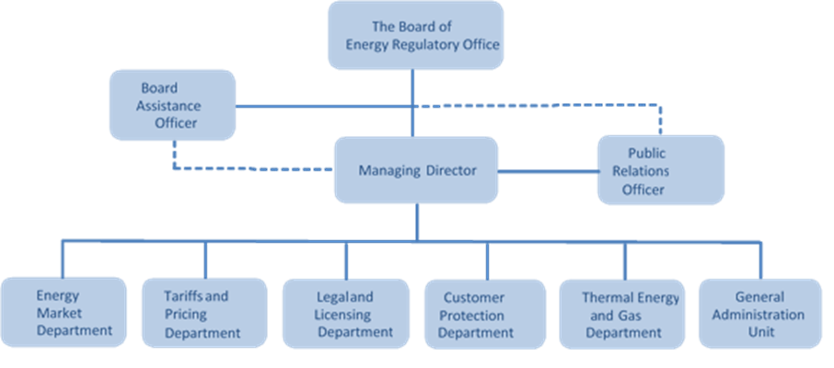
Fig . 2. 1 Organizational chart of the Regulator
The total number of employees, as of 31 December 2024, was 22 employees. This number includes the 5 Board members and 16 staff members employed within the professional departments and the administration unit.
A brief description of the organizational structure with jobs in 2024 is provided in the table below.
Tab . 2. 1 Organizational structure
The Regulator 's staff is a team of experts with proven performance in the areas of responsibility they cover.

Funding of the Regulator
The Energy Regulatory Office (ERO) enjoys the status of an "independent agency". The Constitution of the Republic of Kosovo provides that independent agencies are institutions established by the Assembly based on the relevant laws regulating their establishment, functioning and competences. Independent agencies exercise their functions independently of any other body or authority in the Republic of Kosovo. This means that ERO must have full independence in planning and spending the budget, namely its dedicated revenues, guaranteed by the Constitution and the legislation in force.
The issue of financial independence is mainly regulated by EU Directives, which stipulate that member states must ensure that regulatory authorities or independent agencies must be able to take autonomous decisions independently of any political body, including the ways in which they exercise their mandates, the employees they must recruit, etc. This means that the Energy Regulatory Office must enjoy financial independence, which is enabled through the collection of its own revenues and the implementation of applicable legislation.
The current legislation clearly provides that ERO's revenues are "dedicated revenues", and, in this regard, ERO has the right to collect "dedicated revenues" from certain sources, which in the case of ERO include licensing taxes. This is also provided for in the Law on Public Financial Management and Accountability, which stipulates that "dedicated revenues" are those revenues derived from a certain source of revenue, and these agencies, only in cases where these revenues are insufficient, may request supplementary budgetary allocations from the budget of the Republic of Kosovo, in accordance with the provisions of the Law on Public Financial Management and Accountability.
Based on Article 24 of the Law on the Energy Regulator, ERO collects revenues from:
- Initial and annual licensing taxes;
- Taxes from applications for the issuance and modification of licenses;
- Taxes for issuing Certificates of Origin;
- Taxes for the examination/review of applications for authorization for the construction of new capacities.

ACTIVITIES OF THE ENERGY REGULATORY OFFICE

Licensing of energy activities
Participants in the energy market in Kosovo for energy production, distribution, supply, trading, transmission, etc., can operate only after being licensed by the Energy Regulatory Office for the respective activity. As for how many MW or kW a license is required, this issue is described in more details in the legislation in force, more specifically in Article 28, paragraph 2 of the Law on the Energy Regulator and also in Article 3, paragraph 1 of the Rule on Licensing of Energy Activities in Kosovo (Regulation ERO/No.07/2017, dated ON 31.03.2017).
Based on the legal provisions of the legislation in force, so far the Regulator has issued licenses for the following activities: electricity production; thermal energy production; co-generation of electricity and thermal energy; electricity transmission including operation of the transmission system; electricity distribution including operation of the distribution system; thermal energy distribution; electricity and thermal energy supply, including transit, import or export of electricity; wholesale supply (trading) of electricity; as well as operation of the electricity market.
As mentioned in the above paragraph, there are cases in which a license is not required to be issued by the Energy Regulatory Office, for some activities that do not have a very large impact on the Kosovo electricity system. Therefore, the activities that do not require a license are:
- generation of electricity at the power plant with a total capacity not exceeding five (5) MW;
- production of thermal energy produced by heating plants for own consumption or with a capacity not exceeding 1 MW;
- generation of electricity for own consumption, where the production facility or electricity customers are not connected to the transmission or distribution system.
Despite the fact that the Regulator does not issue Licenses for activities in the above-mentioned points, no legal or natural person may build such capacities, regardless of capacity, without obtaining an Authorization for Construction of Generating Capacity, which is issued by the Regulator in accordance with the legislation in force.
Since its establishment, the Regulator has licensed about one hundred (100) companies for various energy activities and with different license durations, depending on the lifespan of the assets, where about sixty-five (65) had active licenses during 2024 with which they had the right to operate in the energy market in Kosovo, and which are under the monitoring of the Regulator for their activity.
During 2024, as in previous years, ERO has handled a considerable number of applications from interested parties for licensing of energy activities. Compared to 2023, the number of applications handled by the Regulator has been similar for all activities, with the exception of the electricity trading activity, where in 2024 we had only two (2) applicants, whereas for this activity in 2023 we had eight (8) applicants, including the mutual recognition of licenses with Albania and North Macedonia.
The number of licenses processed, in process or issued during 2024 was thirteen (13). It is worth noting that even during this year there was no lack of applications for mutual recognition of licenses, where out of the thirteen licenses in process, issued etc., two (2) of them have been recognized according to the principle of reciprocity (one for trading and the other for electricity supply).
The focus of the licenses handled by the Regulator during this year has been on the supply of electricity in Kosovo and the generation of electricity and thermal energy in Kosovo, followed by the activity of wholesale supply (trading) of electricity, license extensions, etc. As can be seen from the tables below, some licenses are still in process, as a result of the applicants not meeting the licensing conditions.
Following are presented in detail the licenses issued by the Regulator, those in process, etc., for the activities of electricity and thermal energy production, electricity supply and wholesale supply (trade) of electricity for the year 2024.

Licensing of electricity generation activity
Based on Article 29 of the Law on the Energy Regulator, the activity of electricity production cannot be carried out without a license issued by the Regulator for generators with a capacity greater than 5 MW, while under this capacity the Regulator only issues authorization for capacity construction.
This year, the licensing of electricity generation activities, especially from hydropower plants, has remained challenging, with some of the licenses of some companies undergoing legal proceedings for various reasons. As a result, during this year, the Regulator has received one application for generation of electricity from the hydro power plants and one application for the extension of a license for lignite (coal) power generation. We have also had meetings with various parties interested in building generating capacities for wind, water, solar, biomass, etc.
The Regulator, in addition to licensing generators that were built before the establishment of the Regulator, has also licensed other new generators that were built through the Authorization Procedure for Construction of New Capacities, led by the Regulator.
The table below presents data on electricity production companies that have begun applying for licensing their activities during 2024, as well as those that are still in the licensing process because they have not yet met the licensing requirements, according to the legislation in force.
Tab. 3. 1 Enterprises that have been licensed, have had their licenses extended and are in the process of licensing the electricity production activity
Kelkos Energy LLC (HPP Lumbardhi – former co-owner) – was licensed as “TRIANGLE GENERAL CONTRACTORS-INC” Branch Kosovo (HPP Lumbardhi), with an installed capacity of 8.3MW, with license number ERO_Li_09/06, valid from 04 October 2006 to 29 April 2024 (for a period of 20 years as long as the Lease Agreement and the Power Purchase Agreement signed with KEK on 29 April 2004). The same was transferred to “Kelkos Energy” LLC HPP Lumbardhi (former co-owner) with license number ERO/Tr_01/Li_09/06, with the same term until 29.04.2024. This license was modified in 2012 with license number ERO/Tr_01/Li_09/12. The license could be extended, after fulfilling the licensing conditions and in case it would apply six (6) months before the expiration of the license term according to the Rule on Licensing of Energy Activities in Kosovo. The enterprise has not managed to apply within this deadline, therefore the same has been instructed to apply for licensing (as a new application, not a license extension). The company applied on 27.03.2024 for a license for the activity of generating energy from water and has not yet managed to submit the documents requested by ERO, therefore, the application remains in the process of being reviewed by ERO.
Matkos Group LLC (HPP Sharri) – has applied to the Regulator for a license to produce electricity (from water) from the Sharri Hydropower Plant on 23 February 2021, for an installed capacity of 6,453MW. This hydropower plant is still in the licensing process, as this enterprise has not yet fulfilled the environmental criteria required by the legislation in force, despite the fact that the hydropower plant was built according to the authorization procedure led by the Regulator. The case is part of the legal proceedings, therefore in the process of reviewing the application by ERO.
Kelkos Energy LLC (HPP Deçani, HPP Belaje and HPP Lumbardhi II) – this enterprise, which had applied to the Regulator for three (3) generating units, had fulfilled all the licensing requirements according to the Regulator's instructions for two (2) generating units from: the hydropower plant "Deçani" with a capacity of 8.06 MW and the hydropower plant " Belaje" with a capacity of 9.8 MW, for which it was licensed by the Regulator's Board for these two (2) units. Regarding the hydropower plant unit "Lumbardhi II" with a capacity of 6.2 MW, in the absence of meeting the criteria required by the legislation in force, this unit has not been equipped with an electricity production license, therefore remaining in the licensing process since 21 December 2018.

Licensing of electricity supply activity
The interest of the parties to be licensed for electricity supply activities in Kosovo this year has been similar to the previous year. Thus, after applying and fulfilling the licensing criteria, the Regulator’s Board has licensed four (4) energy enterprises, two (2) of them recognized according to the principle of reciprocity with the Republic of Albania. Recognition according to the principle of reciprocity with the Republic of Albania came as a result of the “Memorandum of Understanding on Mutual Recognition of Licenses for the Activity of Trading and Supply of Electricity Between the National Regulatory Authorities of the Republic of Kosovo and the Republic of Albania”, dated on 17.12.2021.
The following table presents all suppliers that have had the right to supply electricity to customers during 2024. For the supply of electricity, the supplier and the customer initially enter into an agreement/contract for supply, in accordance with the license and other applicable legislation in Kosovo. In addition to supplying electricity to customers in Kosovo, licensees for the supply of electricity may also carry out the activity of trading electricity, in accordance with the licenses issued by ERO and other applicable legislation.

Tab. 3. 2 Enterprises that have the right to supply electricity to customers in Kosovo, for which they have a license issued by the Energy Regulatory Office
Unlike previous years, this year the number of licensees that have joined the electricity market has increased. So, in addition to KESCO, during 2024, the companies Future Energy Trading and Exchange Dynamics LLC, GSA Energji LLC, EDS International LLC, and the Kosovo Energy Corporation JSC have also supplied electricity to their customers in accordance with the legislation in force.
Regarding electricity supply, it should be noted that according to the decision V_1925_2024 of 2 April 2024 , issued by the ERO Board, KESCO has been ordered to fulfill the Public Service Obligation for the year 2024 until March 2026, for all customers who enjoy the right to supply within the framework of Universal Service, which are: all household customers, and all non-household customers who have an annual turnover of no more than ten million euros (€10,000,000.00), or no more than fifty (50) employees. Despite this, all end customers have the right to be supplied with electricity in the competitive market, according to the legislation in force in Kosovo.
Tab. 3. 3 Enterprises that have been licensed, have had their licenses extended and are in the process of licensing for electricity supply activities during 2024
TRENDINT GROUP LLC – has applied to the Regulator for licensing of the electricity supply activity, thus completing all the documents required by the licensing application. After this process, the same has been licensed by the Regulator’s Board for a period of five (5) years.
Enerco LLC – has also applied to the Regulator for a license for the electricity supply activity, thus completing all the documents required according to the licensing application. After completing the necessary documents, the same has been licensed by the Regulator’s Board for a period of five (5) years.
Protergia Energy Albania Branch in Kosovo – licensed in Albania for electricity supply, has been registered in Kosovo as a “ branch in Kosovo ” and applied to the Regulator for mutual recognition of the license. The same has been requested to submit the documentation according to the Licensing Rule and the Memorandum of Understanding concluded between the Kosovo Regulator and the Albanian Regulator. After fulfilling the conditions, ERO on 31.07.2024 has recognized the license according to the principle of reciprocity and the same can supply customers with electricity in Kosovo for a period of five ( 5) years, counting from 12 April 2024, as it is licensed by the Albanian Regulatory Authority .
EZ5 ENERGY LLC - Branch in Kosovo - licensed in Albania for the supply of electricity, was registered in Kosovo as EZ5 KOSOVO LLC. Following the instructions from ERO, the same was registered in Kosovo as EZ5 ENERGY LLC - Branch in Kosovo, and applied to the Regulator for mutual recognition of the license. The same was requested to submit the documentation according to the Licensing Rule and the Memorandum of Understanding concluded between the Regulator of Kosovo and the Regulator of Albania. After fulfilling the conditions, the Regulator on 08.03.2024 recognized the license according to the principle of reciprocity and the same can supply customers with electricity in Kosovo for a period of five (5) years, counting from 08.03.2024, as it is licensed by the Regulatory Entity of Albania.
The duration of the supply license according to the legislation in force in Kosovo is determined depending on the financial situation of the applicant with a maximum duration of twenty-five (25) years.
According to decision V_1544_2022, the Kosovo Energy Corporation (KEK) exercises the responsibilities of the Supplier of Last Resort – SoLR (Guaranteed Supplier) from 2022 until July 2025. SoLR is obliged to supply customers who are left without a supplier in cases where: a) the supplier has gone bankrupt or is in liquidation; b) the license of the previous supplier has been temporarily or permanently revoked, or has expired; c) the customer has failed to choose a new supplier after the termination of the contract with the previous supplier. This guaranteed supply cannot last more than sixty (60) days.

Licensing of wholesale electricity supply (trading) activity
Unlike other years, this year the number of applications for licensing the activity of wholesale supply (trading) of electricity in Kosovo has decreased significantly, considering that in 2023 the Regulator had reviewed eight (8) applications for this activity (including extensions and mutual recognitions), this year the Regulator has only received two (2) applications, one of which is a mutual recognition of the license and the other is in the process of evaluation for licensing the activity of wholesale supply (trading) of electricity.
The Law on Electricity provides that licenses issued for the trading of electricity in other Contracting Parties of the Energy Community shall be recognized in Kosovo. Such licensed suppliers shall have the right to trade electricity without the need for an additional license. Traders and suppliers registered in another Party of the Energy Community shall have the right to participate in the electricity market, according to the principle of reciprocity and in accordance with the applicable market rules, balancing rules and fiscal rules. The application process according to the principle of Reciprocity is also presented in detail in the amended Rule by ERO on Licensing of Energy Activities in Kosovo, Rule ERO/No.02/2022 .
According to this rule, ERO may recognize a license, in case a legal entity has a license issued by a Regulatory Authority of another Contracting Party of the Energy Community/a Member State of the European Union, or another country, provided that ERO has concluded a bilateral agreement with that country (regulatory authority) for the mutual recognition of licenses and of course, after submitting to the Regulator the evidence provided for under the legislation in force.
Tab. 3. 4 Enterprises that have been licensed, have had their licenses extended or are in the process of licensing for wholesale electricity supply (trade) activities during 2023
Statkraft Markets GmbH Branch in Kosovo – has applied to the Regulator for a license for the wholesale supply (trade) of electricity at the end of 2024. Accordingly, after submitting the necessary evidence, the process of evaluating the application for licensing has begun.
Protergia Energy Albania Branch in Kosovo – licensed in Albania as Protergia Energy Albania for the electricity activity trading, is registered in Kosovo as “ Protergia Energy Albania Branch in Kosovo ” and has applied to the Regulator for mutual recognition of the license. The same has been requested to submit the documentation according to the Licensing Rule and the Memorandum of Understanding concluded between the Kosovo Regulator and the Albania Regulator. After fulfilling the conditions, ERO on 31.07.2024 has recognized the license according to the principle of reciprocity, starting from 12 April 2024, as it is licensed by the Regulatory Entity of Albania, for a period of five (5) years.
The low number of applications during this year is related to the high number of licenses granted by the Regulator over the years as well as the number of mutual recognitions of licenses with the Republic of Albania and North Macedonia, which licenses also cover the year 2024. Therefore, during 2024, the total number of licenses that had the right to carry out the activity of wholesale supply (trade) of electricity was forty-two (42).
Tab. 3. 5 Enterprises that have the right to trade electricity, according to licenses issued by ERO

Licensing of thermal energy production activity
The Regulator is also competent for licensing the thermal energy activities. Considering that the licensing of energy enterprises for various electrical and thermal energy activities has started in Kosovo since 2006, the term of many licenses has also expired. The applicable legislation allows for the extension of the license term, if the enterprise applies six (6) months before the expiration of the license term and meets the conditions for license extension.
Therefore, two (2) thermal energy enterprises licensed in 2006 as in the table below, whose operating period has expired, have applied for license renewal within the deadline set by the legislation in force.
Tab. 3. 6 Enterprises that have been licensed, have had their licenses extended or are in the process of licensing for thermal energy production activities
District Heating JSC (based in Gjakova) – had applied for licensing of the activity of co-generation of electricity and thermal energy (from biomass), during 2021. The same, in the absence of an environmental permit and other necessary conditions, including that for gas emission measurements, had not managed to be licensed for all the units for which it had applied. Therefore, District Heating was licensed by ERO only for the generation of thermal energy (from biomass) with number ERO/Li_75_21. During 2024, the same also applies for licensing of co-generation of electricity and thermal energy (from biomass). After completing the necessary documents, the District Heating Company will be licensed for this activity for the period from 30.09.2024 to 18.11.2051 (a period that is related to the term of the licenses of thermal energy-only production units, issued by the Regulator’s Board on 19.11.2021, for a period of 30 years).
The construction of this generator was monitored and built through an authorization procedure led by the Regulator, similar to the construction of other generators for the production of energy from renewable energy sources (wind, water, etc.) in Kosovo.
The District Heating “Termokos” JSC – is the only enterprise in the capital city that supplies customers with thermal energy, according to the Thermal Energy Supply Agreement from TPP Kosova B, which transports thermal energy through the thermal energy transport network (in accordance with the License for Cogeneration of Electricity and Thermal Energy, which the Regulator’s Board issued to KEK, TPPP Kosova B during 2017 with a validity period until 2026).
The District Heating Company "Termokos" JSC, despite having applied within the legal deadline for the extension of the license for the production of thermal energy (from fuel oil), has not managed to fulfill the criteria for the extension of the license for this activity and as a result has not been licensed by the Regulator’s Board, therefore it remains in the licensing process until all legal requirements are fulfilled, according to the legislation in force.
Considering that the licensing of energy enterprises for various electrical and thermal energy activities has started in Kosovo since 2006 and the term of many licenses has expired, ERO allows the extension of the term of licenses, if the enterprise applies six (6) months before the expiration of the license term and fulfills the conditions for license extension.

Monitoring of energy companies
Monitoring/supervision of energy enterprises is one of the main competencies of the Energy Regulator, a responsibility which is foreseen by Chapter XII of the Law on the Energy Regulator, the Law on Electricity and secondary legislation.
Therefore, the Regulator, as in previous years, has continued this year with the monitoring of licensed enterprises for energy activities, ensuring whether the enterprises are acting in compliance with the terms of the license, the implementation of rules, individual acts and other decisions issued by the Regulator or other legislation in force. Monitoring is carried out by requesting reports and data from licensees, holding meetings, as well as visiting (monitoring) licensees, with or without notice.
During 2024, the Regulator has monitored licensed energy enterprises, especially those above 5 MW, but has also monitored enterprises that are in the process of construction through the authorization procedure for the construction of new capacities .
Monitoring according to the Energy Sector Reporting Manual – according to this manual, licensed energy enterprises have submitted immediate, quarterly, or annual reports to the Regulator, depending on the requirements described in this manual or other requirements of the Regulator.
For certain license articles of particular importance, i.e. violations of license conditions that may have a serious impact on government policies, customers or the cost for compensation, the licensee must immediately notify the Regulator. In the event that such notice is not submitted in a timely manner, the Regulator has the right to impose administrative measures or fines in accordance with the Rule on Administrative Measures and Fines.
Monitoring of the Compliance Program of the Distribution System Operator (KEDS JSC) – this program has been in force since 2015 (V_750_2015), which is approved by the Regulator’s Board. Following the request of the Regulator, the same was modified and approved by the Regulator’s Board during 2020 (V_1223_2020), according to which the Compliance Officer of KEDS (approved by Decision V_1256_2020) has reported to the Regulator regarding the fulfillment of the obligations set out in this program.

Monitoring of thermal energy enterprises
Given that monitoring is among the regular activities continuously undertaken by ERO, in 2024 the achievements and performance of the DH Termokos and DH Gjakova enterprises were monitored; the monitoring of achievements included:
- Energy balance: thermal energy production and supply as well as network losses;
- Realization of revenues (invoicing and collection) and operating costs;
- Realization of capital costs – specifically allowed new investments;
- New connections and customer supply contracts;
- Unauthorized use and disconnections; and
- Customer complaints and requests and their addressing by the respective enterprises.

Administrative judicial disputes
During 2024, several ERO decisions were challenged in the Commercial Court, Department for Administrative Matters, through lawsuits from interested parties as well as requests for postponement of the execution of decisions until the lawsuit is reviewed on the merits.
The ERO's decision, V_1739_2023 dated 05.05.2023 , regarding the imposition of an administrative fine by ERO, in the amount of €439,405.00 (four hundred and thirty-nine thousand and four hundred and five Euros) has been disputed by the Transmission System Operator (KOSTT JSC) in the Commercial Court, with the request for postponement of the execution of the decision, until the final decision by the court.
The Commercial Court of Kosovo, First Instance Chambers, Department for Administrative Matters, in the merits of the case, deciding on the lawsuit and claim of KOSTT JSC, on 20.02.2024, issued Judgment KA. No. 265/23, by which, under point I. of the enacting clause, it rejected in its entirety as ungrounded the claim of the plaintiff, the Electricity System, Transmission and Market Operator KOSTT JSC, leaving in force the ERO Decision as fair and legal.
Likewise, the Commercial Court of Kosovo, Second Instance Chambers, Department for Administrative Matters, after receiving the appeal of KOSTT JSC, with Judgment K.Dh.Shk.II.no.913/2024 dated on 08.11.2024, rejected the plaintiff's appeal as ungrounded, while upholding the Judgment of the Commercial Court of Kosovo - First Instance Chamber - Department for Administrative Matters KA no. 265/23 dated 20.02.2024.
ERO's decision, V_1929_2024 dated 05.04.2024, regarding the obligation of Electricity Distribution Services (KESD) to implement the judgment of the Basic Court, confirmed by the Court of Appeal of Kosovo, the Supreme Court of Kosovo and the Constitutional Court of the Republic of Kosovo, has been contested by KEDS in the Commercial Court, with the request for postponement of the execution of the decision, until the final decision by the court.
The Commercial Court of Kosovo, First Instance Chambers, Department for Administrative Matters, out of session, deciding on the request for postponement of the execution of the decision, on 17.05.2024, issued the Decision KA. No. 217/2024, by which it rejected the request of the plaintiff Distribution System Operator (KEDS) JSC as ungrounded.
Following the appeal of KEDS JSC, the Commercial Court of Kosovo, Chambers of First Instance, Department for Administrative Matters, in the panel session with the Decision Kom.Dh.Shk.II.no. 1135/2024, dated on 18.06.2024, the appeal of the plaintiff-proposer “KEDS” JSC was rejected, while the Decision of the Commercial Court Chambers of First Instance KA 217/2024 dated on 17.05.2024 was confirmed.
ERO Decision, V_1486_2022 dated 07.02.2022 , regarding the approval of the Maximum Allowed Revenues for the Universal Service Supplier, which has been disputed by KESCO JSC in the Commercial Court.
The Commercial Court of Kosovo, First Instance Chambers, Department for Administrative Matters, after the preliminary review of the lawsuit, on 31.10.2024, issued Decision KA. No. 1123/2022, requesting ERO to submit a response to the lawsuit and to submit all documents to this court.
ERO, within the legal deadline, has submitted the response to the lawsuit with the relevant documents, proposing to reject the lawsuit and the claim of the plaintiff, the Kosovo Electricity Supply Company – KESCO JSC, with address: Boulevard “Bill Clinton” No. 5, Prishtina 10000, Republic of Kosovo, filed against the Energy Regulatory Office, for the partial annulment of the decision, as ungrounded, while Decision V_1486_2022 dated 07 February 2022 on the approval of the Maximum Allowed Revenues for KESCO issued by the ERO Board, to remain in force as grounded and fair. ERO is awaiting the judicial review.
ERO's Decision, V_1240_2020 dated 06.04.2020 , regarding the approval of the Maximum Allowed Revenues for the Universal Service Supplier, which has been disputed by KESCO JSC in the Commercial Court.
The Commercial Court of Kosovo, First Instance Chambers, Department for Administrative Matters, after the preliminary review of the lawsuit, on 29.10.2024, issued Decision KA. No. 929/2022, requesting ERO to submit a response to the lawsuit and to submit all documents to this court.
ERO, within the legal deadline, has submitted the response to the lawsuit with the relevant documents, proposing to reject the lawsuit and the claim of the plaintiff, the Kosovo Electricity Supply Company – KESCO JSC, with address: “Bill Clinton” Boulevard, No. 5, Prishtina 10000, Republic of Kosovo, filed against the Energy Regulatory Office, for the annulment of the decision, as ungrounded, while the decision V_1240_2020 dated on 06 April 2020 on the approval of the Maximum Allowed Revenues for KESCO issued by the ERO Board remains in force as grounded and fair. ERO is awaiting the judicial review.
ERO has also handled other requests, where it has filed procedural objections to lawsuits and claims of legal and natural plaintiffs, complaints and responses to lawsuits and complaints, and has also filed requests for extraordinary review of court decisions in other cases, for which it is awaiting decisions and judgments on the merits from regular courts.

Renewable Energy Sources (RES)
The Law on Energy No. 05/L-081 in force defines the policy for the development of RES , which aims to promote the economic and sustainable use of local RES potential, in order to fulfill energy demand, increase security of supply and protect the environment, which is an integral part of the Energy Strategy of the Republic of Kosovo.
The Law on the Energy Regulator No. 05/L-084 stipulates that the construction of new generation capacities (RES), new systems for the transmission and distribution of natural gas, including interconnectors, as well as direct power lines and direct gas pipelines for the transmission of natural gas shall be carried out in accordance with the Authorization procedures under this Law, which shall be undertaken by the Energy Regulatory Office, in accordance with objective, transparent and non-discriminatory criteria.
The Law on the Promotion of the Use of Renewable Energy Sources No. 08/L-258, which entered into force on 17 May 2024 after its publication in the Official Gazette of the Republic of Kosovo, determines the establishment of a general framework for the promotion of the use of energy from renewable sources in the Republic of Kosovo, with the aim of increasing the use of energy from renewable sources and cogeneration in the electricity sector, in the heating and cooling sector and the transport sector, with the aim of meeting energy needs, increasing security of supply, improving and protecting the environment, as well as providing social and health benefits and promoting equal employment opportunities in the energy sector. This law partially transposes Directive (EU) 2018/2001 on the promotion of the use of energy from renewable sources, adopted by Decision (2021/14/MC-EnC) of the Ministerial Council of the Energy Community.
The Republic of Kosovo is a signatory to the Treaty Establishing the Energy Community, which was signed on 25 October 2005, ratified and entered into force on 1 July 2006 and began to be implemented on 1 July 2007. Based on this, Kosovo has undertaken legal obligations to fulfill all obligations related to the energy sector, which also foresees a mandatory obligation to achieve RES targets by 2020, including the construction of new generation capacities from clean sources.
The Assembly of the Republic of Kosovo has approved the Energy Strategy for the period 2022-2031, where the priority is determined to ensure reliable supply of affordable, clean energy, which is essential for the economic development of Kosovo and the social well-being of citizens, where obligations are also presented for ERO, for the implementation of policies and the drafting of the legal framework for achieving energy objectives.
The Energy Strategy foresees that the most important instruments to diversify the generation mix will be investments in renewable energy sources and the reduction of lignite-based production. New RES capacities, with existing and innovative technologies, will gradually replace the use of coal, achieving coal phase-out by 2050 at the latest.
Through Administrative Instruction No. 01/2023 issued by the Ministry of Economy for the promotion of the use of energy from renewable sources, the type of renewable energy sources used for the generation of electricity and thermal energy, the power plants supported for the use of renewable sources for energy production, the conditions of use and technical standards, the promotion of the support scheme and cooperation measures such as: statistical transfer, joint support schemes, and joint projects for meeting the targets of renewable sources have been determined.
Also, through Administrative Instruction No. 02/2023 issued by the Ministry of Economy on the Target of Electricity from Renewable Energy Sources, the long-term and annual target for the participation of energy from renewable sources in the gross final consumption of electricity by 2030 has been set at 32%.
ERO has drafted Rule No. 03/2022 on the Authorization Procedure for construction of new generation capacities, new gas Transmission and distribution systems, including interconnectors, direct thermal energy pipelines and direct electricity lines and direct natural gas transmission pipelines.
This Rule sets out the criteria and procedure for issuing the authorization for the construction of energy projects , including prosumers with renewable sources in the Republic of Kosovo. The authorization for the construction of energy projects is obtained in accordance with the conditions set out in this Rule, while the review of applications is based on criteria that support the development of a competitive energy market and that promote investments to ensure the security and stability of the energy sector in the Republic of Kosovo.
During 2023, ERO drafted Rule No. 02/2023 for prosumers with Renewable Sources, which sets out the principles and mechanisms regulated for supporting electricity customers who wish to generate electricity in their premises based on renewable technology for their own use .
Through this Rule, opportunities have been created for the end customer operating within his own premises located within narrow boundaries to produce Renewable electricity for his own consumption, as well as who can store or sell Renewable electricity produced by him, provided that, for a non-household prosumer of renewable sources, these activities do not constitute his main commercial or professional activity.
ERO has drafted and finalized the Technical Criteria for the Connection of Prosumers with Renewable Sources to the Distribution Network, which it has approved through Decision V_1777_2023 dated on 31 October 2023.
ERO also, during 2023, for the implementation of the Rule for RES prosumers, has drafted and approved draft/agreements for the sale and purchase of energy from the universal service supplier under the net billing scheme and agreements for the sale and purchase of energy for supply outside the scheme.
During 2024, ERO has handled projects that were in the process of being finalized according to authorization in accordance with the Rule on the Authorization Procedure for the Construction of New Generation Capacities based on RES, including generation capacities for prosumers of renewable sources and the Rule on the Support Scheme from Renewable Energy Sources.

Authorization for the construction of new capacities
ERO, during this year, has continued with the implementation of the authorization procedure, reviewing applications for issuing authorizations for the construction of new generation capacities from Renewable Energy Sources (RES), for companies that have applied for authorization.
ERO, in the framework of fulfilling certain obligations under the legislation in force, has issued authorizations for the construction of generation capacities, where each applicant for obtaining the authorization has been subjected to an analysis of the regularity and correct completion of legal, administrative, technical, financial and environmental documentation, as well as obtaining the relevant permits, issued by relevant institutions in accordance with the activity that the subjects have requested for obtaining the authorization for the construction of new generation capacities based on RES.
During 2024, ERO received 3 applications from various legal entities for authorization to build new RES generation capacities with a total capacity of 11.5 MW. 671 requests for authorization for generators for self-consumption with a total capacity of 13,560 kW were received and reviewed.

Applications that are in the process of being reviewed by the Regulator
ERO, during this year, has reviewed applications for obtaining authorization for the construction of new generation capacities, which are in the phase of completing the applications. The projects are in different stages of completing the permits that are required to be completed according to the legal framework of the institutions of the Republic of Kosovo. The following is a list of projects, which are in the review process.
Tab. 3. 7 Companies that are in the process of being reviewed for the decision on authorization
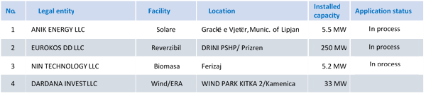

Projects in the construction process according to the final authorization
There are ten (10) projects that are being built according to the Dynamic Implementation Plan and according to the deadlines set by Rule no. 02/2022 on the Authorization Procedure, with a total installed capacity of 244 MW. Where two (2) projects with a capacity of 70 MW are being implemented according to the regulated framework, while the other projects with a capacity of 174 MW are being implemented through the market.
Tab. 3. 8 Projects that are in the construction process with final authorization
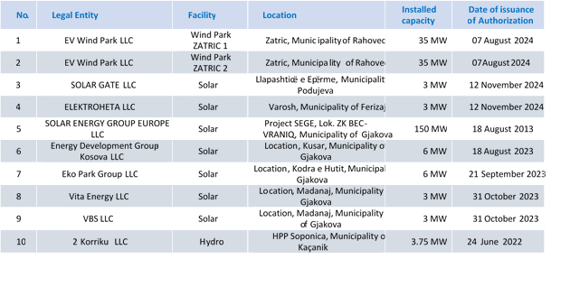

Entry into operation of RES generators
During this year, after the finalization of the projects according to the authorization by the ERO Board, and after technical admission, one ( 1) solar/photovoltaic panel project, the Eling Group LLC project with a total installed capacity of 1 MW, which was subject to the regulated framework, entered into operation .
Fig . 3. 1 View from the realization of a Solar generator – Eling Group SH.PK Capacity 1000 kW, Peja
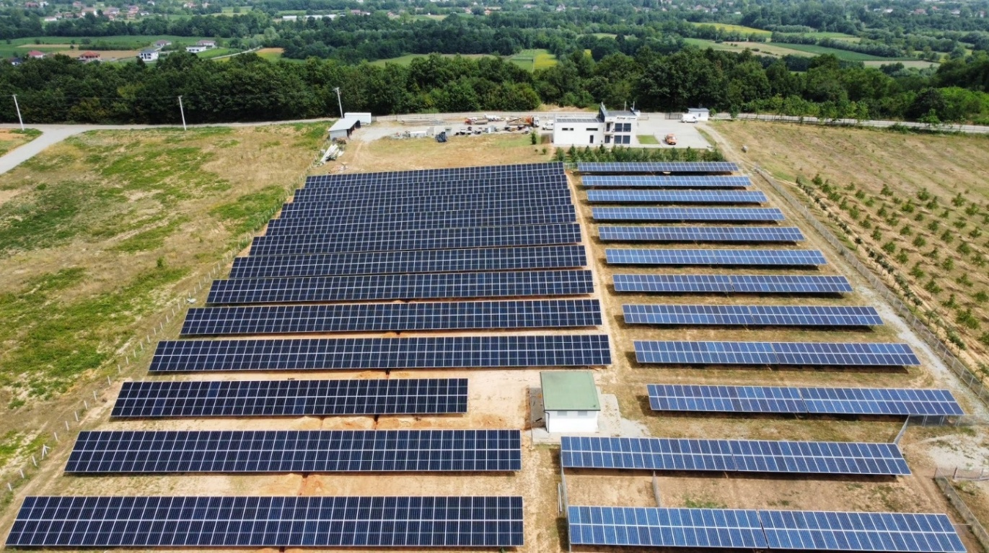

Self - consumption generator​​​
During this year, ERO has also handled requests/applications for generators to obtain the status of prosumer for self-consumption, which, after meeting the legal requirements in accordance with the Rule on Authorization and the Support Scheme, have been allowed to continue with the construction of generation capacities for self-consumption.
The number of decisions issued by the ERO Board, and the total installed capacity of self - consumption generators during 2024 .
Tab. 3. 9 Authorizations for self-consumption

According to the Rule on RES Prosumers, it is determined that every electricity customer, connected to the distribution or transmission network, has the right to become a prosumer. Electricity customers have the right to install in their premises a generating facility that produces renewable electricity for their own consumption and they can choose to maintain the status of prosumers, through a Support Scheme for self-consumption. Provided that all the criteria of the Rule are met, and if the total installed capacity of the self-generating facility is up to and equal to the threshold, the electricity customer has the right to be admitted to the Net Billing Support Scheme. A prosumer within the Net Billing Support Scheme, has the right to sign the supply contract for prosumers within the Net Billing Support Scheme with its supplier. The supplier is obliged to offer this contract to the prosumer.
According to the Rule on RES prosumers, the prosumers outside the Support Scheme are also treated, where they can sell electricity to suppliers on the basis of a mutual contract. To obtain the status of the prosumer outside the Support Scheme, the customer, after receiving the authorization for construction, must send to ERO the contract signed with the supplier, including, among other things, the management of surpluses, without disclosing confidential information.
Prosumers must adequately compensate for the cost of the impact on the energy system and the grid, where the prosumer tariff is paid by all prosumers, regardless of whether they are part of the Support Scheme or not, in order to adequately reduce their negative impact on the costs of the energy system and the grid.
Network operators are obliged to take appropriate steps to develop the network infrastructure to allow for the secure operation of the network in terms of receiving energy from prosumers. The prosumer is obliged to generate electricity that fulfills the quality requirements for electricity set out in the relevant network codes for the Kosovo power system, and according to the technical criteria approved by ERO. The Distribution System Operator must submit to ERO data on electricity generated and consumed by the prosumers.
The above-mentioned projects are expected to be implemented within the period determined according to the Dynamic Project Implementation Plan in accordance with the technical criteria for connection.
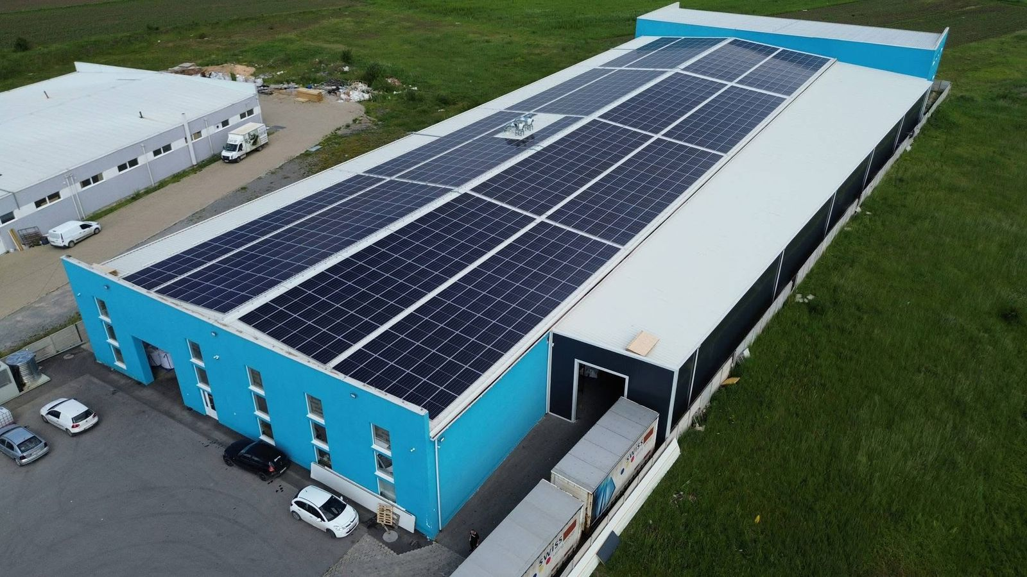
Fig . 3. 2 View from the realization of a generator for self-consumption, legal entity 100 kW
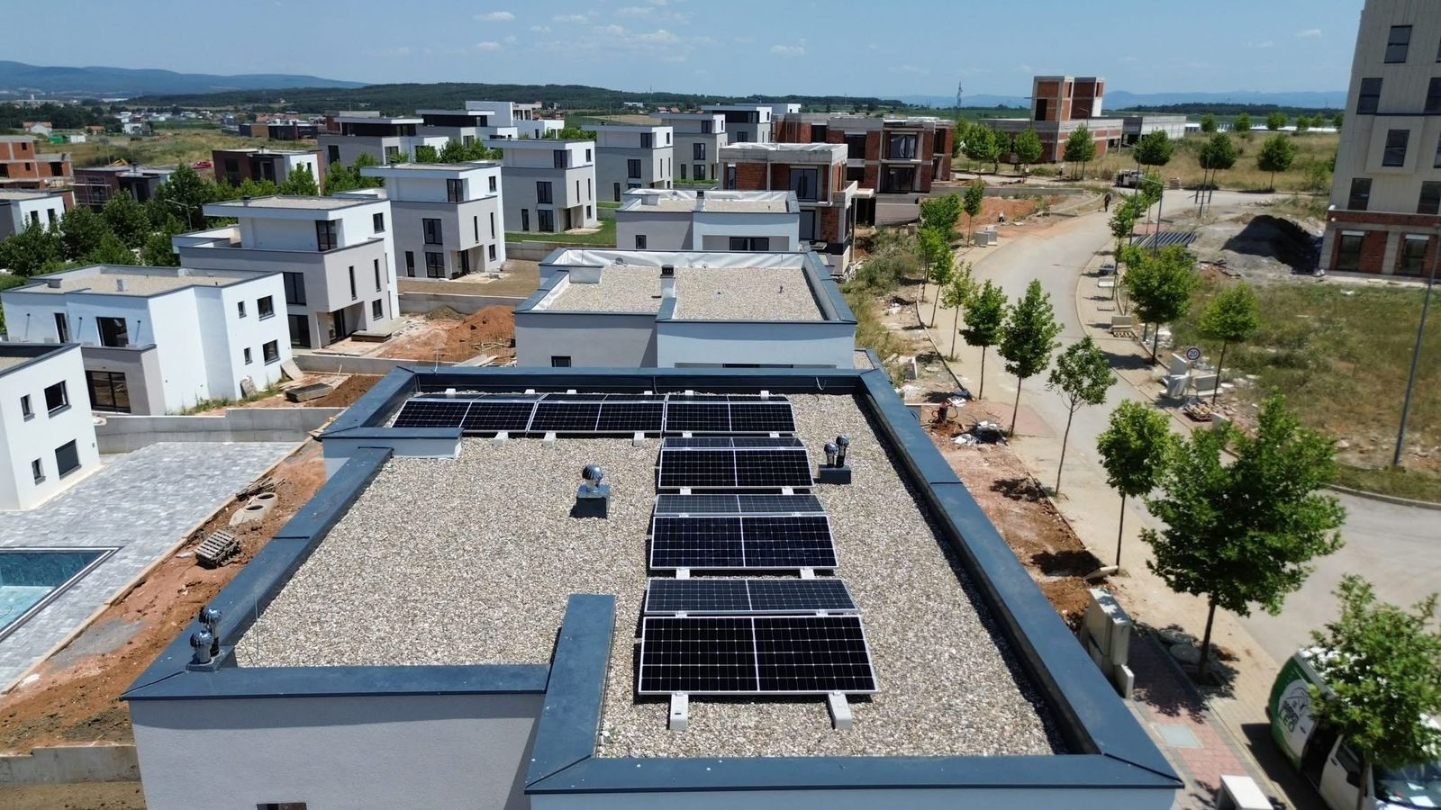

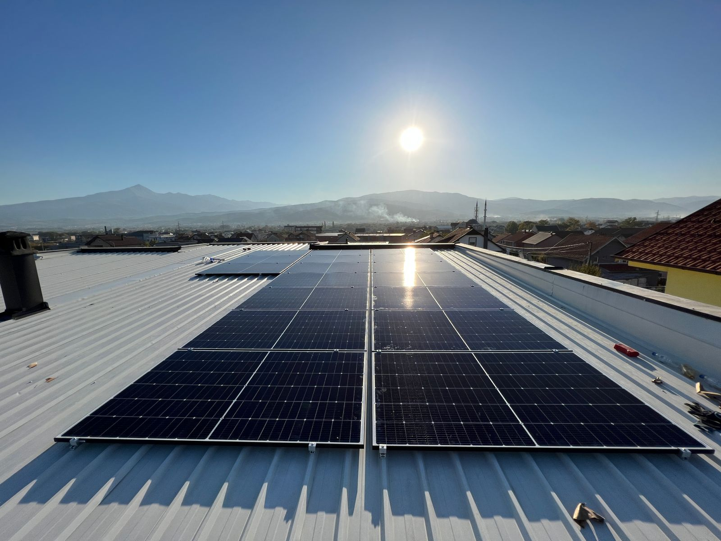
Fig . 3. 3 View from the realization of a generator for self-consumption of a 7 Kw, individual.
ERO has also received other requests from natural and legal persons, which are in the review phase and according to the procedures in force, after completion will be allowed to build new generation capacities from generators for self-consumption.

Monitoring the construction of new generation capacities
ERO, also during this year, has monitored legal entities that are equipped with an authorization for the construction of generation capacities which are in different stages of construction according to the legal deadlines given in the relevant decisions. Their monitoring has been conducted continuously depending on the requests that have arisen during their implementation.
During this year, ERO has monitored the projects of companies that have submitted a request for an extension of the authorization deadline, for the possibility of finalizing the projects.
The company "Energy Development Group -Kosova" LLC, by Decision of ERO no. V_1751_2023 dated on 18 August 2023, was issued the authorization to construct a generator from solar/photovoltaic panels with an installed capacity of 6 MW, in Madanaj, CA Kodra e Hutit, MA Gjakova.
The company "Eko Park Group" LLC, by Decision of ERO no. V_1765_2023, dated on 21 September 2023, was issued the authorization to construct a generator from solar/photovoltaic panels with an installed capacity of 6 MW, in Kodra e Hutit Zone, Gjakova Municipality.
The requests for extension are based on Rule no. 03/2022 on the Authorization Procedure for the Construction of Energy Projects, respectively Article 19.1, which provides that the authorization issued by ERO is valid for a period of 24 months, and according to Article 19, par. 2, the applicant may request to extend the deadline set by par. 1, for another 12 months, on the grounds that such an extension was beyond the applicant's control.
After evaluating the situation on site, it was confirmed that the applicant was carrying out the works according to the presented Dynamic Plan, but in order to finalize the project, the validity period must be extended according to the new Dynamic Plan, and the extended financial guarantee must be provided in accordance with Article 18 of the Rule on Authorization.
By decisions V_2559_2024 and V_2603_2024, requests for extension of the validity period of the decisions on authorizations for the continuation of the construction of generating capacities from solar panels according to the dynamic plans proposed by the applicants were approved.
ERO will continue to monitor the construction of new generation capacities from Renewable Energy Sources, respecting all legal procedures and criteria set out in the legislation in force.

Market integration

Albanian Power Exchange Alpex and the Kosovo-Albania Market Coupling
On 27 April 2016, in order to fulfill the objectives of the third EU electricity package for the establishment of the European internal electricity market and based on the decisions reached at the Western Balkans summit, held in Vienna on 27 August 2015, Kosovo and Albania committed to establishing operators (exchanges) for the operation and consequently the coupling of the day-ahead (DAM) and intraday (IDM) markets into a regional market.
In June 2018, the transmission system operators TSO, KOSTT, the Regulators of Kosovo and Albania signed a Memorandum of Understanding on the coupling of the day-ahead electricity market. In December 2020, the Kosovo Energy Regulatory Office approved KOSTT's request to delegate to ALPEX the authority to organize the day-ahead and intraday markets for the Kosovo market. Meanwhile, ALPEX opened its branch in Prishtina on 6 May 2021, which focuses on the management of market participants for Kosovo, regulatory issues, etc. In line with the WB6 Memorandum of Understanding, on 21 October 2021, another Framework Agreement was signed between TSO, KOSTT, ERE and ERO for the coupling of the day-ahead and intraday electricity markets. Albania and Kosovo signed the Framework Agreement as well as other successful agreements necessary for the operation of the day-ahead and intraday market integration.
On 27 December 2022, the Energy Regulatory Office of Kosovo (ERO) and the Energy Regulatory Entity (ERE) of Albania approved the rules and procedures for ALPEX at a joint meeting in Pristina.
In December 2024, both regulators made amendments to these rules in separate meetings. ERO approved the changes on 6 December 2024, improving trading procedures for ALPEX.
The approval of the amendments to these rules is the final step in the regulatory framework needed to enable intraday trading between the two countries.
The ALPEX Rules consist of these main parts set out as follows in this report:
ALPEX Rules - General Conditions: These rules outline the specific details according to which ALPEX, as the Market Operator, must perform its duties and the conditions under which Exchange Members must trade on the Albanian Power Exchange. Among other things, these rules include: the establishment of organizational units and internal structures within ALPEX concerning market monitoring, supervision, and reporting; the duties and powers of these units; the relevant procedures for their functioning; the determination of the rights and obligations of both ALPEX and Exchange Members; the requirements and conditions for admission as a member of the exchange; the organizational and infrastructural requirements for Exchange Members; the procedures for handling actions by ALPEX in cases of non-fulfillment of obligations by Exchange Members; the clear determination of procedures for the suspension, resignation, and termination of membership; the manner of notifications and communications between the parties; the details of measures ALPEX takes in cases of incompatibility or force majeure events; and the provisions for resolving disputes between ALPEX and Exchange Members.
Trading Procedure: This section of the rules, among other things, defines the treatment of ALPEX market segments, specifically the introduction of the Intraday Auctions market segment. It outlines the determination of auction types and the method for providing results for the relevant auctions. It also covers the addition of products and their specifications for different market segments, clearly defining orders, including their types, content, submission, evaluation, validation, acceptance, and cancellation. The rules specify the bidding model for Exchange Members based on the price-quantity pair and provide clear definitions for the concepts of Transactions and Contracts. Additionally, it introduces the Trading Limit and its effects, and allows for an increase in the number of portfolios, determining their types according to members' requests. Detailed forecasting for products and the operation of the intraday continuous trading segment is included, along with provisions for alternative procedures for the day-ahead market and/or the intraday auction market in the event of circumstances that prevent the operation of the Market Coupling. Lastly, the section includes the concept for the development of a second auction for forecast cases and specifies the communication process between the TSO and ALPEX for the exchange of necessary data, along with the relevant deadlines.
Clearing and Settlement Procedure: defines the conditions for the Clearing and Settlement activities related to transactions for the purchase and sale of wholesale electricity on the ALPEX markets, including the involvement of the banking system in this process. The Clearing and Settlement activities are conducted through an electronic platform, with Clearing being carried out by ALPEX in cooperation with the participants in the exchange.
ALPEX definitions: defines the terminology to be used by the ALPEX Energy Exchange, and ALPEX announces that it has brought innovations in terms of enriching the terminology according to the definitions of the European market guidelines documents. Emphasis is placed on clearly reflecting the terminology used during the drafting of these rules.
The Albanian Power Exchange is forecast to operate the day-ahead and intraday markets with two control zones Albania and Kosovo, implementing future projects for merging with other potential markets. In this process, ALPEX JSC has continued to offer membership for participants in the bidding zone of Kosovo. The General Clearing Member in Kosovo is ProCredit Bank Kosovo.
ALPEX, as the structure responsible for the management and operation of the organized wholesale electricity market for the bidding zones of Albania and Kosovo, has been appointed by ERE and ERO as the Nominated Electricity Market Operator (NEMO).
- On 31 January 2024, the first auction for the delivery date of 1 February 2024 was held in the Day-Ahead Market for the Kosovo bidding zone, marking the coupling of the Albania-Kosovo Day-Ahead market.
- On 11 December 2024, the first auction for the delivery day of 12 December 2024 was held in the Intra-Day Auction Market for the bidding zone of Albania and Kosovo, marking the coupling of this market between the two countries.
ALPEX Trading Indicators during 2024 for the day-ahead market are as follows:
- Total volume traded on the Day-Ahead Market of 1,172,580.58 MWh with an average clearing price of €112.01/MWh.
- Energy flow:
  - From Albania to Kosovo: 27,816.94 MWh
  - From Kosovo to Albania: 241,097.29 MWh.
- Purchase offer: 1,534,425.97 MWh.
- Offer for sale: 1,868,626.34 MWh.
- The trading record for a Market Time Unit (MTU) was 497.87 MWh on 19 May 2024.
- The daily trading record was 7,816.05 MWh on 23 May 2024.
- The monthly trading record was 133,906.13 MWh in May.
- The record for energy flow was recorded in June with 41,859.80 MWh from Kosovo to Albania.
- Total invoicing (purchase/sale) reached 301 million euros.
The figure below presents traded volumes and average clearing prices on a monthly basis for the Day-Ahead Market for 2024.
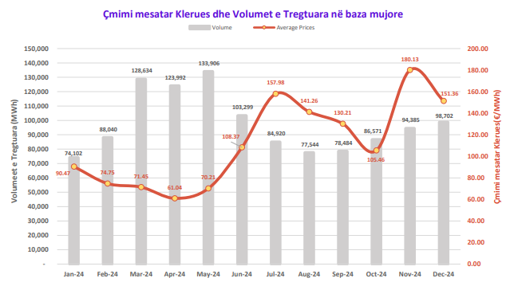

Fig . 3. 4 Traded volumes and average clearing price for the day-ahead market
Intraday Auction Market (IDM) Performance
- Total volume traded in the Intraday Market of 365.53 MWh with an average clearing price of €200.80/MWh
- Energy flow:
  - From Albania to Kosovo: 167.30 MWh.
  - From Kosovo to Albania: 91.15 MWh

Implementation of the Rule on Wholesale Energy Market Integrity and Transparency (REMIT)
Until 2024, ERO has continued to monitor the implementation of the of the Rule on Wholesale Energy Market Integrity and Transparency (REMIT), periodically monitoring the main operators in the energy market. This monitoring has noted the increase in information published in the framework of transparency, mainly by KOSTT, on its website and through the ENTSO-E transparency platform, this is due to the fact that KOSTT is part of ENTSO-E and has the obligation to publish information on the ENTSO-E transparency platform as well.
The REMIT Regulation, which is a transposition of Regulation no. 1227/2011 of the European Parliament and of the Council, was approved by ERO in June 2020. According to the obligations arising from the REMIT Regulation, market participants must register in the national registry established by ERO.
ERO has transposed the format of the questionnaires for collecting data from licensees from the ECRB format, which has been sent to market participants. Based on the data sent by market participants, ERO has created the national register of market participants, according to the legal requirements arising from the REMIT rules. The rules, forms and the national register are published on the ERO website.

Activities of the Regulator in the field of price regulation

Tariff review
The Energy Regulatory Office (ERO), based on the powers granted by primary and secondary energy sector legislation, is the sole authority responsible for setting tariffs for regulated activities within the energy sector. ERO sets revenues and tariffs through an open and transparent process. This regulatory responsibility is not only established by domestic legislation but is also defined by Directive 2009/72/EC on common rules for the internal market in electricity.
ERO has completed the regular annual adjustments process for 2024 in accordance with the respective rules on revenues in the electricity sector. ERO, in accordance with domestic legislation and European Union directives, is the sole authority responsible for setting tariffs for regulated activities in the energy sector in Kosovo.
Tariff review is a complex and transparent process, where ERO takes into account various factors that affect energy prices, such as increased energy demand and the energy prices in international markets that have a direct impact on the costs of purchasing electricity for Kosovar customers.
The review of applications for regulated revenues and tariffs in the electricity sector has included, among others: wholesale energy purchase activities from domestic generators, electricity import, system operator, transmission and market operator activities, electricity distribution activities and universal service supplier (USS) activities.
This entire review process has gone through public consultation, including meetings and communications with stakeholders. ERO, when determining revenues and tariffs for regulated operators, has taken into account the documents that have been published on the official website of ERO, as follows:
- ERO on 22 January 2024 has received applications from the Universal Service Supplier KESCO JSC, the Distribution System Operator – KEDS JSC (DSO) and the Transmission System and Market Operator for review of Maximum Allowed Revenues;
- The Separate Consultations Reports on Maximum Allowed Revenues (MAR) for the Universal Service Supplier KESCO JSC, Distribution System Operator – KEDS JSC (DSO) and Transmission System and Market Operator, were published on 6 February 2024;
- Final separate reports on the Maximum Allowed Revenues for the USS- Responses to Comments: for the Universal Service Supplier, Distribution System Operator and Transmission System and Market Operator, were published on 22 March 2024; .
This revenue and tariff approval process is very important to ensure that the energy sector functions in a fair and sustainable manner, protecting the interests of customers, securing necessary investments, and promoting a sustainable supply of electricity for all.
In 2024, the European energy market faced major challenges, including rising prices and supply uncertainty. This situation also directly affected the Western Balkan countries, including Kosovo. The energy crisis has highlighted the need for investments in renewables and energy efficiency to ensure a stable supply.

Energy purchases in the wholesale market
Electricity prices have remained high in 2024, although prices in international markets were gradually falling during 2023. Expectations were that there would be a decrease in wholesale prices in 2024, but on the contrary, an increase in energy prices has occurred.
Our country is generally a net importer of energy, and is affected by the increase in electricity prices in European markets. The largest imports are usually made during the winter, a period when prices are higher due to higher demand. The majority of the energy for the universal service is covered by domestic generation, which offers relatively low prices, while imports are required mainly during peak hours. During the summer months, energy imports have also been high, when KEK's aging units are usually needed for capital investments and maintenance, to ensure that there are fewer interruptions to the electricity supply during the winter season.
The network operators (KOSTT and KEDS) are also affected by the fact that they procure electricity to cover network losses, and this is done at market prices. In addition to the factors mentioned above, another impact on prices is the trading of generated energy on the ALPEX exchange, where purchase prices are higher than those of current electricity purchase and sale contracts.
The realized prices of the wholesale power purchase by the Universal Service Supplier (USS) for 2024 have been difficult to estimate due to price fluctuations in international markets. During 2024, the average realized prices have been higher than those allowed by ERO, and the amount of energy purchases has been significantly higher than the amount allowed by ERO. The cost allowed by ERO for imports included in the USS tariffs has been 21.1 million euros, while the realized cost has reached 68.96 million euros .
During 2024, prices on European power exchanges have increased, although there were forecasts for their stabilization. Moreover, given that most countries in the region are net importers, cross-border networks have often been overloaded, which has led to an increase in prices for the use of cross-border lines for imports. This has occurred as a result of increased consumption and lower production from renewable energy sources (RES), which has resulted in the substitution of energy with electricity imports at high prices.
Electricity prices on the HUPX energy market for 2024 have been high, with the highest average price recorded on this exchange reaching 163.72 Euro/MWh during November 2024. Also, on 18 July 2024, the highest price recorded at 9:00 PM reached 999 Euro/MWh.
Electricity production must be balanced with real-time energy demand to enable the secure operation of the power system. Kosovo’s power system is designed so that power production depends mainly on thermal power plants, but the energy produced by domestic generation is not enough to cover peak demand. There are also surpluses during peak demand. Therefore, to manage the power system efficiently, it is necessary to import during peak demand and export during low demand, using the wholesale market.
The sources of electricity in the wholesale market from which the country's energy demand is covered are: energy production by KEK, hydro power plants, solar power plants, wind turbines and energy purchases from imports. The energy and financial data of the wholesale market allowed for 2024 are summarized in the following table:
Tab. 3. 10 Allowed costs for energy purchases
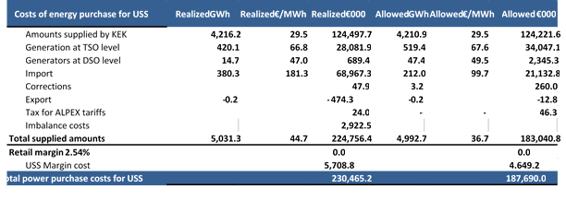

From the data presented in the table above, it is noticed that the planned cost for purchasing wholesale energy is €187.69 million, while the value of purchasing wholesale energy reported by the USS for 2024 is €230.47 million.

Maximum Allowed Revenues for tariff regulated customers
The reasonable costs used to determine the Maximum Allowed Revenues for customers regulated by the universal service obligation include: the supplier's retail costs, the costs of the transmission and distribution network, the costs of energy purchases, working capital, bad debt, adjustments to realized costs, etc. The revenues of the Universal Service Supplier enable it to cover the costs of each activity of the supply chain starting from the generation and mining activity, transmission, distribution to the supplier. Therefore, the supplier collects from the final customers the total costs of electricity supply through the invoices paid by the customers with which it then pays each party depending on the costs of the service.
An important element of the adjustment process is that uncontrollable costs and pass-through costs will be updated regularly based on current information from network operators. This information is essential for setting new tariffs and to reflect any potential changes in costs resulting from developments in international energy markets or in the costs of supplying and operating transmission and distribution systems.
In the following table we have a comparison of the revenues requested by the USS in the amount of 407.75 million euros, allowed by ERO in the amount of 399.62 million euros, while the costs incurred as reported are in the amount of 446.17 million euros for the relevant tariff year 2024.
In 2024, we have a situation where realized costs are higher than allowed revenues, causing a need for tariff adjustments. The largest differences are in the costs of purchasing wholesale energy, where there has been a significant increase compared to ERO's forecasts.
The main allowed costs are the pass-through costs for transmission and distribution network services where the allowed value for 2024 was 153.4 million euros while the data reported as realized is in the amount of 155.77 million euros, whereas the allowed energy purchase costs were 187.69 million euros and the realized value is 230.47 million euros. These differences in costs are part of the revenue and tariff adjustment process for 2024.
Details of these costs for 2024 are presented in the following table:
Tab. 3. 11 Maximum allowed revenues of the Universal Service Supplier
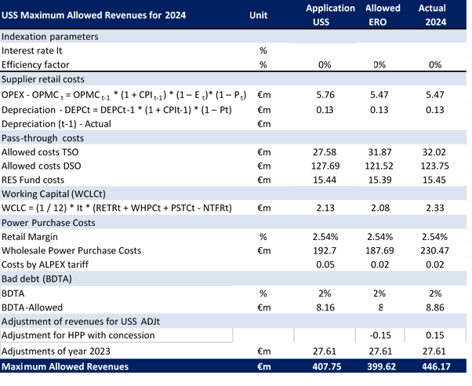

Regulated tariffs for universal service customers
Tariff setting is an important and delicate issue in the electricity sector, as they must balance several important factors. The main purpose of tariffs is to enable optimal use of electricity, ensure affordability for customers, cover operators’ reasonable costs and guide the efficient coverage of energy demand. The regulated tariffs set by ERO for the relevant tariff year 2024 are expected to cover the costs of electricity service for all customers regulated by the Universal Service Supplier. Customers billed at regulated tariffs are customers connected to the 35kV, 10kV and 0.4kV voltage levels, while customers connected to the 220kV voltage level and those at 110kV are supplied at unregulated prices (market prices).
ERO, based on legislation, must determine the regulated tariffs for customers who enjoy the right to supply under universal service criteria. The criteria for which customers enjoy this right are set out in the Law on Electricity, according to which: “The right to supply with universal service is entitled to all household and non-household customers who have an annual turnover of no more than ten (10) million euros, or no more than fifty (50) employees”. However, due to the lack of competition in the electricity market, high prices in the markets, many planned business customers were unable to switch to the deregulated market.
The retail electricity tariff structure for universal service customers (regulated tariffs) was designed to cover the revenues set at 399.62 million euros.
Tariff design aims to achieve two objectives: cost reflection constitutes the first objective because it is a prerequisite for the provision of services and activities of actors in the electricity sector. While the second objective is to send the right economic signals to customers. Since the physical characteristics of electricity are not those of an ordinary commodity, customers must receive the necessary economic signals that would motivate a more efficient behavior towards their energy consumption. In the absence of these signals, the customer would not have any incentive to save energy at certain times or to consume energy at a reasonable level.
Implementing tariff structures with blocks for different categories of customers is a common international practice. Tariff blocks allow suppliers to send economic signals related to electricity demand. This helps motivate customers to take steps to increase energy efficiency, using more energy during periods of low demand and less during periods of high demand, when prices are higher.
The tariff structure is divided into different categories of customers, according to the level of electricity service, and includes fixed customer tariffs, tariffs for active and reactive energy, demand and committed power, as well as the handling of real-time usage and tariff blocks.
ERO has completed the process of regular annual adjustments for the year in accordance with the respective rules on revenues in the electricity sector. After a technical and economic evaluation of the revenues for the USS, the ERO Board decided that the household customers, those who consume over 800 kWh have benefited from a tariff reduction of 8%, the business customers have benefited from a tariff reduction of 3%, while the tariff has remained the same for household customers with consumption up to 800 kWh
The tariff structure for regulated customers is presented in the table below:
Tab. 3. 12 Structure of regulated tariffs for final customers for 2024
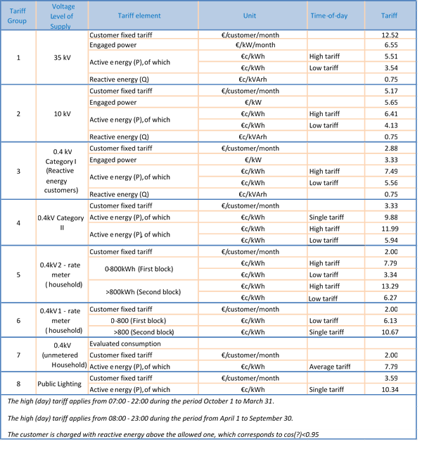
Before designing tariffs, the pass-through costs of the USS, such as the costs of using the transmission and distribution network, must also be determined.

Revenues and tariffs for the use of the transmission system, system and market operation
During 2024, ERO has carried out the process of regular annual adjustments for TSO/MOs taking into account various factors that affect electricity service costs and tariffs: the efficiency factor, the indexation of costs to the inflation rate applied to operating expenses, repairs & maintenance. Adjustments have also been applied to the costs of purchasing losses, the costs of return and depreciation resulting from planned investments according to the development plan and other reasonable costs for operating the transmission system.
The regulatory period is important for tariff setting, as it provides predictability and stability of key regulatory parameters. Setting performance objectives for TSOs/MOs requires sufficient time to meet these objectives. These long-term measures and actions by operators require investment planning and network improvements (e.g. reliability, reduction of network losses, quality of services, etc.).
It is worth noting that the costs of purchasing energy to cover the losses allowed for the TSO/MO were 9.20 million euros, while the realized costs for 2024 are 13.49 million euros calculated according to the principles of the respective rules on revenues, which are higher due to the increase in prices in the electricity markets that are part of the cost adjustments for the relevant tariff year 2025.
The average price of energy (from KEK and ALPEX) has increased from €66.25/MWh as forecast by ERO to €103.79/MWh, or about 56.6% which will adjust to 2025 costs.
The table below presents the Maximum Allowed Revenues approved by the ERO Board for the relevant tariff year 2024 for the TSO/MO.
Tab. 3. 13 Maximum Allowed Revenues for TSO/MO
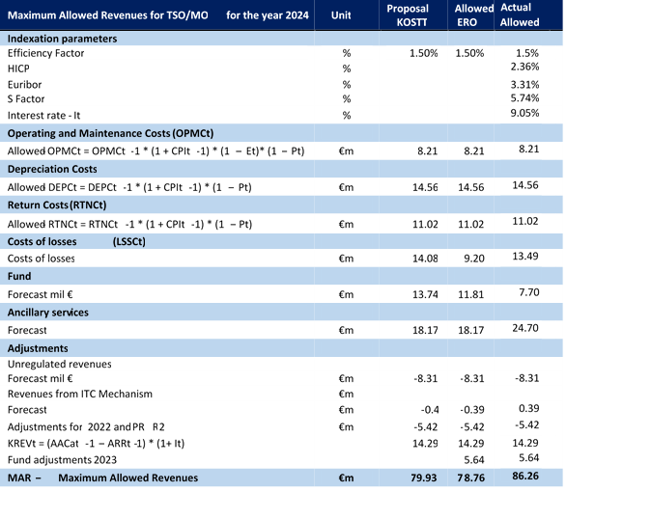
The Maximum Allowed Revenues for KOSTT will be collected through tariffs approved by ERO based on the Methodology on Determination of Transmission System Tariffs, System Operation, and Market Operation.
The following table presents the tariff structure for the transmission use of system, system operation and market operation for the relevant tariff year 2024 .

Tab. 3. 14 TSO /MO tariff structure for 2024 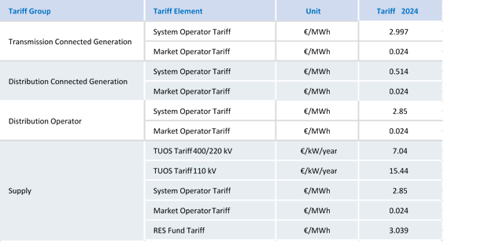

Revenues and tariffs for the distribution use of system
After reviewing the application of the company DSO JSC, ERO has reviewed and assessed the forecast costs compared to the realized ones, as well as the technical, economic and financial indicators of the Distribution System Operator based on the Rule on DSO Revenues. This process has included a public consultation with stakeholders, after which the Maximum Allowed Revenues for the DSO for 2024 have been determined.
The following table presents data on operating expenses (OPEX), depreciation, return on investments, and energy purchase expenses for losses, pass-through costs, unregulated revenues for allowed revenue adjustments for 2024, and the revenue correction factor (KREV).
The values of the realized costs for 2024 are higher than those allowed in some categories, especially for the purchase of energy for losses, where the actual costs are about 32.17 million euros higher than the allowed costs. KEK has not supplied the forecast amount of electricity due to the technical conditions of the power plant units and their lifespan, therefore the replacement of this energy with imports has caused higher costs and significantly higher prices. Therefore, the costs of purchasing energy to cover the losses allowed in the DSO have been 65.37 million euros, while the losses realized in 2024 are worth 97.54 million euros, which have increased due to the higher realized price increase in relation to the ERO allowances.
The average price of energy (from KEK and Import) has increased from €63.03/MWh as forecast by ERO to €98.80/MWh, or about 56.7% which will be adjusted to the costs of 2025. The price increase is a consequence of various factors such as increased demand for energy, lack of local production, and its replacement with imported energy, and increased prices in international energy markets.
The table below presents the Maximum Allowed Revenues and those realized for the relevant tariff year 2024 for the DSO .
Tab. 3. 15 Maximum Allowed Revenues for DSOs for the relevant tariff year 2024
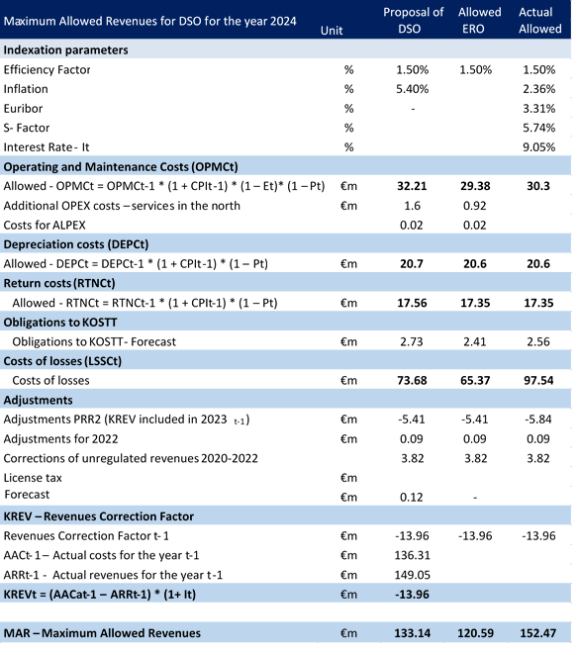
KEDS in their application has requested capital investments for the four northern municipalities of the Republic of Kosovo. ERO has allowed these capital costs in the amount of 2.75 million euros related to the provision of the envisaged services such as in the network, substations, transformers, measuring equipment and instruments, trucks, cranes, etc.
Following the determination of Maximum Allowed Revenues, tariffs should be determined according to the voltage level so that the approved revenues are collected.
The Maximum Allowed Revenues for the DSO will be collected through tariffs approved by ERO based on the Methodology on Determination of Distribution Use of System Tariffs.
As it can be seen in the table below, the tariffs vary according to the voltage level. The 35 kV voltage level has lower tariffs due to lower distribution costs, lower losses and greater efficiency of the power grid. This is more suitable for industrial customers or large areas requiring power.
The table below presents the tariff structure for the Distribution Use of System for 2024.
Table. 3. 16​ Tariff structure for DSO for 2024
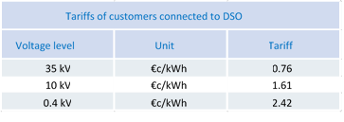

Average electricity prices without taxes
The figure below shows the average prices for household and non-household customers for the period 2013-2024. For the household customers category, the average energy price is 7.39 €cent/kWh, which has increased compared to 2023 when the price was 7.12 €cent/kWh, while for non-household customers the average energy price is 9.30 €cent/kWh, which is slightly lower than the average price in 2023 when it was 9.36 €cent/kWh. This increase among household customers occurred because there was a significant increase in energy consumption, exceeding the threshold of 800 kWh/month, which has influenced the increase in the amount of imports and the increase in the average price.
So, although there has been a tariff reduction for household customers consuming over 800 kWh of 8% since April 2024, the average price has continued to increase. This is because, although some customers may benefit from lower tariffs, there has been a significant increase in energy consumption. When the number of customers who spend more increases, total consumption may also increase, leading to a conclusion that, in general terms, the average tariff increases to cover total costs. For non-household customers, there has been a tariff reduction of 3% and this is also reflected in the average price in 2024.
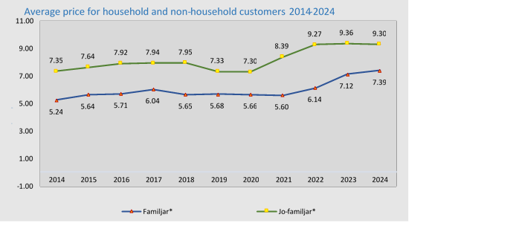
Fig. 3. 5 Average prices for household and non-household customers for the period 2014-2024 (excluding VAT)

The figure below shows electricity prices for household customers for the first 6 months of 2024, for various countries, including Kosovo, as obtained from EUROSTAT.
The price of electricity for household customers in Kosovo for 2024 is 0.0736 €cents per kilowatt-hour, which is one of the lowest prices in Europe and the region. The highest prices for household customers are in Germany (0.395 €cents /kWh), Ireland (0.373 €cents /kWh), and Denmark (0.371 €cents /kWh).
Compared to other countries in the region, Kosovo also has a lower price than all countries in the region such as: Albania (0.111 €cent /kWh), Serbia (0.108 €cent /kWh), Montenegro (0.097 €cent /kWh), etc.

* Data source from EUROSTAT
Fig. 3. 6 Average prices for household customers for 2024 (excluding VAT)
The figure below shows electricity prices for non-household customers (customers with a consumption range of 500MWh – 2000MWh) for the first 6 months of 2024 in various countries, as provided by Eurostat. The price per kilowatt-hour excluding taxes is divided into several European countries and the region, with Kosovo having the lowest value for 2024 compared to other countries.
The price of electricity for non-household customers in Kosovo for 2024 is 0.074 Euros per kilowatt-hour, which is a relatively lower price compared to many European countries, especially those of the European Union and several other countries in the region.
Kosovo has a much lower electricity price than many European countries such as Ireland (0.254 €cent/kWh), Switzerland (0.188 €cent/kWh), and Germany (0.197 €cent/kWh).
In the region, Kosovo has lower electricity price than countries like Serbia (0.135 €cent /kWh), Albania (0.125 €cent/kWh), and North Macedonia (0.101 €cent/kWh), but it is above countries like Moldova (0.099 €cent kWh) and Bosnia and Herzegovina (0.095 €cent/kWh).

* Data source from EUROSTAT
Fig. 3. 7 Average prices for medium and large non-household customers for 2024 (excluding VAT)

Thermal energy tariffs
In accordance with primary legislation – Articles 47 and 48 of the Law on the Energy Regulator, the Energy Regulatory Office (ERO) is responsible for determining the tariff methodology and approving tariffs in the regulated energy sector.
Within its legal powers and obligations, the Energy Regulatory Office has issued the Thermal Energy Pricing Rule. The Rule sets out the procedures for submitting, reviewing tariff applications and approving tariffs, as well as the Methodology for calculating Maximum Allowed Revenues and tariffs.
Schematically, the tariff methodology is shown as follows:
Fig. 3. 8 Scheme for calculating allowed revenues
From the schematic presentation, it is seen that the costs that the enterprise must cover consist of operating costs, depreciation that represents the opportunity for the enterprise to replace its assets, the cost of network losses and the return on the Regulated Asset Base (RAB).
The process of determining tariffs and approving them for the 2024/2025 season was carried out in two steps:
- Determination of Maximum Allowed Revenues, based on: i) the information and data provided in the tariff application; ii) the information presented during the regulatory reporting of realizations in the previous season 2023/2024; and iii) the coordination between actual and forecast realizations, which is based on the difference between planned and actual revenues of the previous heating season.
- Calculation of tariffs based on Maximum Allowed Revenues and tariff structure.
To determine the allowed revenues of thermal energy enterprises (district heating) for the 2024/2025 season, in accordance with the Thermal Energy Pricing Rule, ERO has undertaken the following:
- Estimating and determining allowed operating costs;
- Valuation and determination of depreciation;
- Determining the allowed Return on RAB (return on investments), which includes:
- determining the RAB – assessing and approving the company's assets, verifying and approving planned investments and working capital; and
- calculation of the Allowed Rate of Return (RoR)/WACC;
- Estimating and determining the allowed cost for network losses.
ERO has engaged the available expertise to make a realistic evaluation of the forecast information submitted by the companies. A comprehensive analysis and evaluation of the information submitted has been carried out, which has been followed by a comparison of the respective data from previous seasons, in order to make the most accurate determination (forecast) of the allowed revenues for the 2024/2025 season.
As part of the tariff review for thermal energy enterprises: DH Termokos and DH Gjakova, ERO has drafted regulatory reports for determining the Maximum Allowed Revenues and for determining thermal energy tariffs for the 2024/2025 season.
After reviewing the relevant tariff review documents, at the session of 12 November 2024, ERO Board approved the Maximum Allowed Revenues (MAR) for DH Termokos for the 2024/2025 season, in the amount of €10,760,536. Also, in the same session, the tariffs reflected by the MAR of DH Termokos for the 2024/2025 heating season were approved.
Decisions issued:
- V_2440_2024 - on the approval of the Maximum Allowed Revenues (MAR) for DH Termokos that will be collected from thermal energy (heating) tariffs for final customers for the 2024/2025 season;
- V_2441_2024 - on the approval of thermal energy tariffs for end customers of DH Termokos for the heating season 2024/2025;
While for DH Gjakova, after reviewing the relevant reports and documents, at the session of the ERO Board on 25 November 2024, the Maximum Allowed Revenues (MAR) in the amount of €1,017,167 were approved. Also, the tariffs reflected by the MAR of DH Gjakova for the 2024/2025 heating season were approved at the same session .
Decisions issued:
- V_2574_20 24 - on the approval of the Maximum Allowed Revenues (MAR) for DH Gjakova to be collected from thermal energy (heating) tariffs for final customers for the 2024/2025 season;
- V_2575_2024 - on the approval of thermal energy tariffs for final customers of DH Gjakova for the 2024/2025 heating season.
The structure and levels of thermal energy tariffs for DH Termokos and DH Gjakova are presented as follows.
Tab. 3. 17 Thermal energy tariff structure for the year 2024/2025
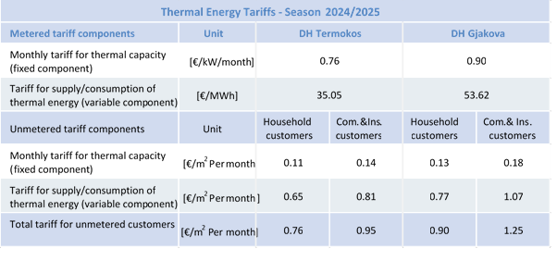

The Regulator's activity in the area of customer protection
In accordance with Article 17 of Law No. 05/L-084 on the Energy Regulator, the Regulator is responsible for resolving complaints and disputes between customers and energy enterprises, system operators and energy enterprises, as well as between two energy enterprises. In addition to other competencies provided for in the Law on the Energy Regulator, ERO is responsible for ensuring the application of customer protection legislation in the energy sector in Kosovo.
According to the provisions of the Rule on the Resolution of Complaints and Disputes in the Energy Sector, all customers have the right to file complaints related to the services provided by the supplier or system operator, and that these complaints must initially be addressed to the supplier or system operator, as a body of first instance, which reviews the complaint and issues a response within the legal deadline. After receiving the response, the customer may address the Regulator for further review of the complaint.
During 2024, the Regulator has registered 176 official complaints from customers and applicants for new connections who have exercised their right to object to the responses issued by the Supplier and Distribution System Operator, has returned 74 complaints to the Supplier and Distribution System Operator for review, and has processed 23 customer complaints regarding the review of metering accuracy to the DSO, which have been reviewed fully. During 2024, in addition to registered and resolved customer complaints, the Regulator has also provided support in providing information, explanations, verbal consultations, e-mail, and by telephone for all energy customers.
The number of complaints received by customer categories is presented in the table below.
Tab. 3. 18 Customer complaints by category, 2024
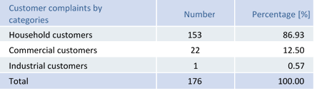
The figure below shows the number of customer complaints submitted to ERO according to their nature.

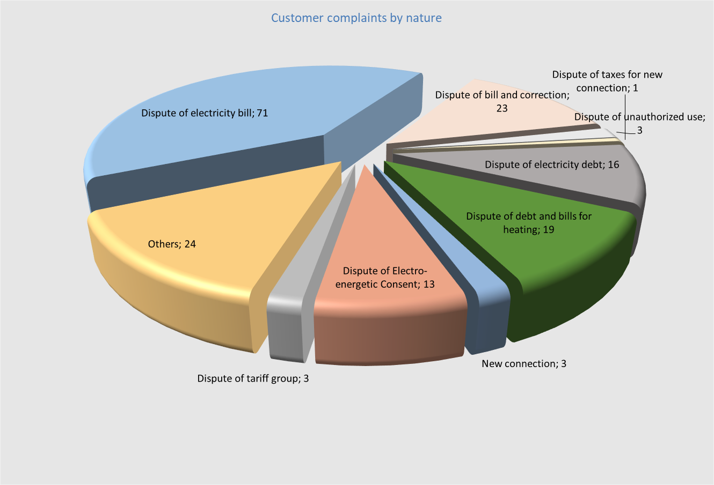
Fig. 3. 8 Number of customer complaints by their nature
Below is a breakdown of the nature of customer complaints registered for 2024:
- Disputing electricity bills concerns customer complaints about cases of reading errors and irregular readings, which in this case are considered to have given an inaccurate reflection of the real situation of electricity consumption.
- Disputing unauthorized use of electricity concerns complaints from customers who have been charged by the energy company for unauthorized use of electricity (loss recovery). ERO, based on the Law on Electricity and the legal provisions of the Rule on the Resolution of Complaints and Disputes in the Energy Sector, is not competent for these cases of complaints, and has instructed customers to address the competent authorities for further action.
- The dispute of new connections concerns complaints from customers who have been denied the right to a new connection by the Distribution System Operator. In these cases of complaints, customers, in order to obtain a new connection, have been forced by the company to first make payments on debts at the old amount that existed previously.
- Disputing additional charges concerns customer complaints regarding additional billings from regular billing. These complaints are the result of incorrect recording of electricity consumption, as a result of a faulty metering system.
- Disputing electricity debt concerns customer complaints related to problems regarding the supplier's failure to accurately define uncollected electricity debt in cases of property sales and for properties that have been occupied.
- Tariff group dispute concerns customer complaints about changing the tariff group, where customers request to change the tariff group for various reasons.
- The dispute of electricity consents concerns complaints from customers or even applicants for new connections that relate to the technical solutions offered by the System Operator.
- Disputing "Termokos" heating bills concerns complaints from customers who have disputed thermal energy bills, heating area, heating quality, previous debts, issues related to the statute of limitations on debts.
During 2024, the Regulator resolved 242 customer complaints, including complaints that were returned for review to the supplier and the Distribution System Operator, which mainly related to new connections, meter inspections, meter replacement, deactivation, account name change, financial corrections, enforcement of court decisions, and customer requests for review of metering accuracy. Of the total number of resolved complaints, 148 of them were decided in favor of customers or expressed in percentage as 61.16%, while 88 customer complaints or 36.36% were rejected as ungrounded and 6 complaints or 2.48% of the resolved complaints were outside the competence of ERO. All complaints reviewed by the operators, which have been processed by the Regulator, have been reviewed once again by the Regulator in order to verify the full resolution of the complaints according to the customers' requests, and the customers have been notified. In all reviewed cases, the customers have agreed with the offered solutions.
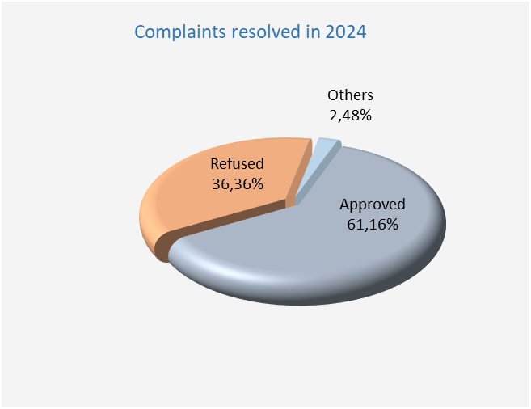
Fig. 3. 10 Complaints resolved, 2024
The figure below shows the number of customer complaints registered and resolved by the Regulator by year.
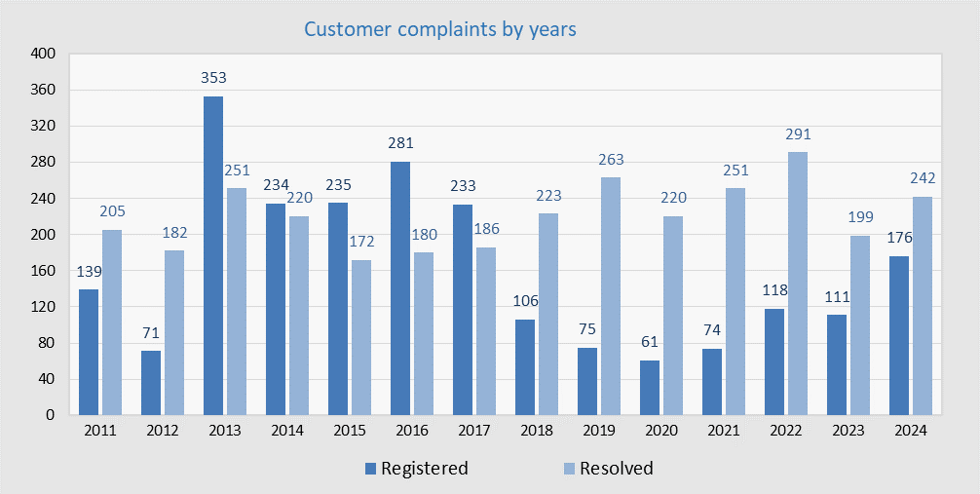
Fig. 3. 11 Customer complaints registered and resolved 2011- 2024

Decisions of the Regulator’s Board in the area of customer protection
Based on the Rule on the Resolution of Complaints and Disputes in the Energy Sector, customers and licensees have the right to file a complaint against the decision of the Department for Customer Protection (DCP) as a first instance decision to the Regulator's Board as a second instance of review and decision-making.
During 2024, the Regulator’s Board issued forty-seven decisions related to customer complaints and licensees' objections, filed against CPD decisions, as well as several other cases related to the implementation of court decisions on customer complaints.
Customers have filed 19 complaints with the Regulator’s Board against the decisions of the CPD. Of the 19 complaints filed, the Regulator’s Board has reviewed all of these complaints and rejected them as ungrounded.
Furthermore, 13 objections (complaints) of the supplier KESCO, filed against the decisions of the CPD, were also reviewed. The Board has carefully reviewed and analyzed these objections and other relevant documentation and has rejected them as ungrounded and the decisions of the CPD have remained in force.
Based on the Rule on the Resolution of Complaints and Disputes in the Energy Sector, for the categories of customers of Tariff Group 1, 2 and 3, the CPD has issued eleven (11) recommendations to the ERO Board, regarding complaints submitted by non-household (commercial) and industrial customers, so that, after reviewing and analyzing the recommendations and other relevant documentation, the ERO Board has approved 10 of the recommendations issued by the CPD and 1 was partially approved.

Other activities in the area of customer protection
During this reporting year, in addition to registered complaints, the Regulator's staff has also held 723 meetings and telephone conversations with the parties, including electronic communication, who have addressed the office on various contractual issues between customers and licensees. During communication with customers, the Regulator's staff has clarified the issues raised by the customer, and has instructed the parties on the rules, procedures, as well as their rights and obligations regarding energy supply.
During 2024, the Regulator has also received 39 complaints from customers via mail, which despite the fact that they should have addressed the licensees or the courts, they insisted on addressing the Regulator for the resolution of their complaints. It is worth noting that the nature of these complaints was mainly for unauthorized use of electricity, compensation for damage or even requests that are not within the scope of the Regulator's review. In all these cases, the Regulator has responded to customers in writing, instructing them on further procedures regarding their complaints.
As in previous years, during 2024 the Regulator has had close cooperation with the Department of Customer Protection within the Ministry of Trade and Industry, where during this reporting year it has also received several customer complaints from this institution. These complaints have been received and reviewed by the Regulator in accordance with legal provisions.

CPD activities related to disputed decisions before the competent courts
Referring to Article 25 – Board Sessions, Chapter VI – Administrative Procedures, of Law No. 05/L-084 on the Energy Regulator, as follows: “The Board's decisions shall be immediately applicable and shall not be subject to any review, except judicial review”, customers and licensees, exercising their legal right to appeal these decisions, have initiated administrative dispute procedures and other judicial procedures against the final decisions of ERO in administrative proceedings.
Therefore, during 2024, a certain number of decisions of the ERO Board were disputed at the Basic Court of Pristina - Department for Administrative Matters, as well as at the Commercial Court - First Instance Chambers, and at other basic courts at the national level, with requests to assess the legality of these decisions, as well as other specific requests related to certain cases. Thus, during this year, ERO has received 41 decisions from the competent courts and within the legal deadlines, ERO has submitted forty-one (41) Responses to the Claim, so that, subsequently, it continued with holding the main hearings and reviews regarding these cases and a total of twelve (12) court hearings were held during this year. Furthermore, ERO has prepared three (3) appeals against first instance court decisions, two (2) responses to appeals and has filed one (1) request for extraordinary review of the court decision, at the Supreme Court of Kosovo.
It is worth noting that the majority of ERO's final decisions during 2024 have been confirmed as legal and fair decisions by the competent courts, in administrative conflicts initiated by lawsuits of plaintiffs, such as customers or licensees. Meanwhile, for the remaining part of the decisions that have been returned for review, ERO will continue to use all legal means, appealing the same, so as to confirm their legality.
In conclusion, even for this reporting year, the initiation of administrative conflicts by authorized parties has required great commitment and dedication. However, ERO will continue to make maximum efforts to ensure that final decisions in administrative procedures ensure the protection of customer rights, and licensees as well, by reviewing all complaints of customers and licensees fairly and accurately.

COOPERATION WITH OTHER PARTIES AND TRANSPARENCY
ERO has demonstrated full transparency in the exercise of its functions by holding Board sessions open to the public and publishing all decisions. Through press releases, notices, and other publications on the official website and the profile of ERO on Facebook, the general public has been informed in a timely manner about all ERO activities and events.
All interested parties can access the published data directly through the ERO website at the link: http://www.ero-ks.org/zrre/sq/te-dhena .
Also, in order to provide the best possible information, ERO has continuously informed customers and the general public about all the activities it has conducted. With this aim, during 2024, over seventy-two notices and press releases were issued which were sent to the media and published on the ERO's website and on the official profile of ERO on Facebook in order to inform parties and customers about the various regulatory processes and in certain cases to clarify various misinformation that has circulated regarding energy supply prices.

Public involvement in regulatory processes through public consultations
For the review of various regulatory documents and with the aim of the proper functioning of the energy sector, ERO during 2024 has conducted public consultations and published the following documents:
- On 6 February 2024, ERO published the draft consultation reports related to the annual adjustments of the Maximum Allowed Revenues for the Transmission System and Market Operator, the Distribution System Operator and the Universal Service Supplier.
- On 22 March 2024, the Board of the Energy Regulatory Office (ERO) approved the Maximum Allowed Revenues for the regulated operators (Transmission System and Market Operator /KOSTT; Distribution System Operator/KEDS and Universal Service Supplier USS/KESCO). The Maximum Allowed Revenues for the Universal Service Supplier USS/KESCO were approved in the amount of €399,617,290 million, for the Transmission System and Market Operator/KOSTT were approved in the amount of €78,764,846 84mil, whereas for the Distribution System Operator/KEDS were approved in the amount of €120,591,798mil.
- On 2 April 2024, the Board of the Energy Regulatory Office (ERO) approved the retail tariffs for final customers supplied under universal service criteria. The decline in prices in the European electricity markets has affected the wholesale costs of electricity in Kosovo. As a result of these changes, the costs of supplying imported electricity to final customers for 2024 are expected to be lower compared to previous years. These changes have resulted in a reduction in electricity tariffs for final customers, namely an 8% tariff reduction for household customers for the block with consumption over 800kWh and a 3% tariff reduction for commercial and industrial customers. The ERO Board also approved the tariffs for the relevant tariff year 2024 for the Transmission System and Market Operator (KOSTT) and the Distribution System Operator (KEDS).
- On 05 April 2024, the Board of the Energy Regulatory Office (ERO) has taken legal action to implement the Judgment of the Constitutional Court regarding the compensation of damage to customers who have been billed for electricity costs in the four northern municipalities of the Republic of Kosovo for the period from 06.02.2012 to 20.10.2017. The ERO Board, according to the Court's Judgment, has decided to oblige the Electricity Distribution Services to compensate only customers who are proven to have been active and have fulfilled their payment obligations for the period from 06.02.2012 to 20.10.2017. These customers will be compensated by deducting the relevant compensation amount from their regular monthly bills. According to the decision of the ERO Board, customer compensation will be made starting from 1 June 2024 until 28 February 2030.
- On 3 May 2024, the ERO Board approved the Long-term Thermal Energy Balance for the period 2024-2033 of DH Termokos and DH Gjakova as well as the Five-Year Development Plan and the One-Year Investment Plan of the Distribution System Operator (KEDS).
- On 13 May 2024, the Board of the Energy Regulatory Office held an extraordinary session to review the request of the Distribution System Operator (KEDS) to postpone the execution of Decision V_1929_2024, dated on 05.04.2024, until the final court decision. In this extraordinary session, the Board rejected the request of the Distribution System Operator (KEDS) to postpone the execution of this decision.
- On 04 June 2024, ERO published for public consultation the Tariff Determination Methodology for the Nominated Electricity Market Operator, a document which establishes the basis and process for determining the level of Allowed Revenues for the Nominated Electricity Market Operator (NEMO), which it may recover in any relevant year in order to allow it to cover the reasonable costs of operating and maintaining the electricity market in accordance with the Law on Electricity, as well as the principles and processes by which NEMO tariffs will be approved, reviewed and adjusted. After considering the comments, this methodology was approved by the ERO Board on 24 December 2024.
- In August 2024, ERO published for public consultation the Rule on the Principles for Determining Tariffs for Use and Connection Fees in the Distribution System, while in November 2024 the Final Report with amendments to this rule in response to comments was published. On 12 November 2024, the final version with the approved amendments was published.
- On 13 September 2024, ERO published for public consultation the Consultation Report - Evaluation of the Maximum Fixed Price for the 75 MW Wind Auction, while on 12 November the Final Report with Responses to Comments was published. The ERO Board, on 12 November 2024, approved the Maximum Fixed Price for the 75 MW wind auction in the amount of €80.2/MWh.
- On 12 November 2024, the Board of the Energy Regulatory Office approved the Maximum Allowed Revenues and tariffs for DH Termokos JSC for the 2024/2025 heating season.
- On 12 November 2024, the ERO Board approved the report 'Evaluation of Competition in the Electricity Sector in Kosovo 2022 - 2023' with the aim of analyzing the opportunities and challenges for improving competition and the functioning of the electricity market in Kosovo.
- On 25 November 2024, the Board of the Energy Regulatory Office approved the Maximum Allowed Revenues and tariffs for the Gjakova District Heating Company for the 2024/2025 heating season.
- On 5 December 2024, ERO published for public consultation the Consultation Report - Evaluation of the Maximum Fixed Price for the 100 MW Wind Auction .
- On 6 December 2024, the Board of the Energy Regulatory Office (ERO) approved various amendments to the trading rules and procedures for ALPEX, namely the proposal for the approval of the Maximum Clearing Price of the Intraday Market Auction, the Minimum Clearing Price of the Intraday Market Auction, the Maximum Price of the Intraday Market Auction Orders and the Minimum Price of the Intraday Market Auction Orders as well as the approval of the Maximum Clearing Price of the Day-Ahead Market Auction, the Minimum Clearing Price of the Day-Ahead Market Auction, the Maximum Price of the Day-Ahead Market Orders and the Minimum Price of the Day-Ahead Market Orders.
- On 13 December 2024, ERO published for public consultation the Consultation Report - Evaluation of the Maximum Feed-in Tariff and the Maximum Fixed Price for the 100 MW Solar Auction.
- On 16 December, ERO published for public consultation the Consultation Report - Input Values and Operating Costs of the Universal Service Supplier - Review of Input Values (2025-2027) . This review is based on the legal mandate and obligations arising from the Rule on Determination of Revenues for the Universal Service Supplier (USS) which sets out the methodology for establishing and updating the Maximum Allowed Revenues of the Universal Service Supplier, which cover the costs of providing regulated services to universal supply customers (household customers and customers entitled to universal service).
- On 24 December 2024, the Board of the Energy Regulatory Office approved the following documents: Methodology on Determination of Tariffs for the Designated Electricity Market Operator, Methodology on Distributing Congestion Revenues between Albania and Kosovo, Reserve procedures for the day-ahead electricity market coupling and the intraday electricity market coupling Albania – Kosovo.

Reporting and cooperation with the Assembly of Kosovo
As every year, during 2023, the Regulator continued with regular reports to the Assembly of the Republic of Kosovo, and according to the requests it received from parliamentary committees, there were also other reports regarding various regulatory issues in the energy sector.
- On 2 July 2024, the Chairman of the ERO Board, Mr. Ymer Fejzullahu, presented before the Parliamentary Committee on Economy, Industry, Entrepreneurship and Trade of the Assembly of the Republic of Kosovo, the Annual Report on the activities of the Energy Regulatory Office (ERO) and the energy sector that took place during 2023.
- On 10 July 2024, the ERO Board presented the ERO Financial Report for 2023 to the Committee on Budget, Labour and Transfers of the Assembly of the Republic of Kosovo.

Meetings with other stakeholders
- On 04 March 2024, the ERO Board participated in the ceremony of the operationalization of the organized day-ahead electricity market for the Kosovo area and the coupling of the Kosovo-Albania market. This market coupling is the first within the contracting parties of the Energy Community, marking an important step towards increasing security of supply and unifying prices between the two countries.
- On 17 May 2024, the ERO Board held a meeting with the Ambassador of Austria, Mr. Georg Schnetzer, at the ERO offices, where they discussed recent developments in the energy sector, with a particular focus on Renewable Energy Sources and recent legislative changes.
- On 4 June 2024, the Chairman of the ERO Board, Mr. Ymer Fejzullahu, hosted a meeting with the Director of the Energy Community Secretariat, Mr. Artur Lorkowski, where they discussed the general situation in the energy sector as well as ERO's commitments in the function of the joint market between Kosovo and Albania and the next project of market coupling between Kosovo, Albania, North Macedonia and Greece. The ERO Board held another meeting with Mr. Lorkowski, respectively on 09.10.2024, where the Methodology for the Calculation of Regional Capacities (CCR) and other legislative changes, the Albanian Power Exchange (ALPEX), investments in renewable energy sources and other issues related to the functioning of the sector in general were discussed.
- On 27-28 June 2024, the Chairman of the Board of ERO, Mr. Ymer Fejzullahu, participated in the Second International Conference on Renewable Energy and Smart Technologies (REST 24), which was held at the University of Prishtina “Hasan Prishtina”, Faculty of Electrical and Computer Engineering. Chairman Fejzullahu contributed to the panel by highlighting the important role that ERO has in the energy transition towards renewable sources by making the necessary preparations for the relevant legal framework to support the generation of electricity from these sources.
- On 26 July 2024, representatives from the Energy Regulatory Office organized a one-day meeting with representatives of the Energy Regulatory Entity of Albania, in Tirana. The aim of the meeting was to exchange experiences regarding the AIB membership process, together with representatives from the Luxembourg Development Agency project. On 12 August, the Energy Regulatory Office (ERO) held a meeting with representatives of solar photovoltaic (PV) system installers, where current challenges were discussed and proposed solutions were reviewed to improve processes related to the generation of energy from renewable sources.
- On 23 October 2024, a meeting was held at the Energy Regulatory Office ( ERO) with the World Bank energy team. During the meeting, a number of key issues in the Kosovo energy sector were discussed. Among the main topics was the review of the network codes by KOSTT and their submission to ERO, the process of their review and the relevant legal deadlines. The support provided by the World Bank for renewable energy projects, with a special focus on those developed through auctions, was also highlighted.
- On 29 October 2024, the Board of the Energy Regulatory Office (ERO) held a meeting with the International Monetary Fund mission. During the meeting, new projects for the generation of electricity from renewable energy sources and recent legislative changes regarding the transposition of the IV Energy Package as well as the development of wind farms and the role of ERO in further advancing these processes were discussed.
- On 5 December 2024, the Board of the Energy Regulatory Office held a meeting with Mr. Mathias Conrad, Deputy Head of Mission and Head of the Economic Section at the German Embassy in Kosovo. The discussion focused on recent developments in the energy sector, regarding the progress of the market integration process and the generation of electricity from renewable energy sources.

Implementation Group meetings within the SEE - MC market integration initiative
Within the framework of the project for the coupling of the markets between Kosovo , Albania , North Macedonia and Greece ( SEE - MC ), on 07 March 2024, under the leadership of the Chairman of the Board of ERO Mr. Fejzullahu, the first meeting of the Project Implementation Group was held. At this meeting, the Joint Steering Committee Group of the South East European Electricity Market Union prepared and presented the gap analysis of ALPEX JSC, MEMO, KOSTT, TSO, and MEPSO.
The second meeting of the group, held on 07.06.2024, in Athens, Greece, discussed the current status and progress of the project, the proposal of the Greek Regulator for the inclusion of bidding zone borders in the EU South Eastern Europe Capacity Calculation Region (EU SEE CCR). During the meeting, the members of the Market Coupling Implementation Group agreed to support the Transmission System Operators in their efforts to extend the implementation of SEE CCR methodologies to all bidding zone borders of the respective countries.
This group held its next meetings on 04.10.2024, virtually, and on 11.12.2024, in Athens, Greece, where various issues were discussed such as the transposition of all elements of the Electricity Integration Package, coordination with regional stakeholders, challenges in harmonizing and applying relevant methodologies, drafting plans for the transposition of CACM guidelines, and other issues related to the functionalization of market integration between the signatory parties.

Cooperation with international organizations
Cooperation with NARUC/TETRATECH/USAID
- In cooperation with the National Association of Regulatory Utility Commissioners (NARUC), with the support of the United States Agency for International Development (USAID), as part of the AWLE – Advancing Women Leaders in Energy program, representatives from the Energy Regulatory Office participated in the AWLE DEIA Toolkit Training, held on 11-13 June 2024 in Podgorica, Montenegro, as well as in the AWLE Mid-Career Phase II Leadership Training, held on 24-26 June 2024 in North Macedonia.
- The NARUC Advancing Women Leaders in Energy (AWLE) internship program, supported by USAID, as part of its ongoing support to ERO, has also enabled the engagement of two female students who had completed/would soon complete their undergraduate or graduate studies, by offering them internships at ERO to learn more about the energy regulation sector. The interns completed their internships at ERO for a period of nine (9) months and were paid by NARUC.
- Within the framework of the cooperation agreement with Tetra Tech, through the Energy Sustainability activity, during 2024, three (3) interns from the “New Energy” program have completed internships at ERO for a period of six (6) months. ERO has provided the interns with the necessary working space and tools. ERO has also adapted the work tasks that match the interns’ field of study and previous experience, making efforts to maximize their experiential learning. The interns have been monitored/supervised by experienced employees, who have guided them during their engagement at ERO.
Memorandum of Understanding on the coupling of European markets
In accordance with the Memorandum of Understanding, regarding the Market Coupling project, signed between the Board of ERO and the Boards of Regulators of Albania, Greece, North Macedonia, the Executive Directors of the Transmission System Operators (TSOs), and the Power Exchanges (PXs) of the respective countries, the Implementation Group for the Coupling of Electricity Markets has been established.
The Implementation Group for the coupling of electricity markets, led by the Chairman of the Board of the Energy Regulatory Office, Mr. Ymer Fejzullahu, has continued regular meetings within the framework of the work plan.
Furthermore, by majority vote, the mandate of the Chairman of the Board of the Energy Regulatory Office was extended for another year to lead this Implementation Group.

Participation of the Regulator in international activities
Participation in international activities is considered by ERO as one of the main elements that serves institutional strengthening, increasing the knowledge and experience of its staff. The following are presented as main activities and active participation in international organizations, international conferences, working tables or multilateral and bilateral meetings.

ERO has received Observer status from the AIB Board
On 18 October 2024, the Board of the AIB (Association of Issuing Bodies) approved the granting of Observer Status to the Energy Regulatory Office (ERO) of the Republic of Kosovo. AIB is a non-profit organization with 35 members from 27 European countries, which was established to develop and promote a standardized system of certificates (guarantees) of origin.
This step marks an important achievement for ERO, the regulatory authority for the electricity, gas and renewable energy markets, which also serves as the entity issuing certificates of origin and operates the Grexel registry. The next step for ERO includes fulfilling the relevant criteria for full membership in the AIB.

Participation in the Energy Community Regulatory Board (ECRB)
The Energy Community (EC) is an international organization established through an international Treaty (the so-called Energy Community Treaty) in October 2005 in Athens, where the countries of the European Union and the South-Eastern Europe and Black Sea region participate. The EC's activities during 2024 are focused on achieving common goals: the implementation of the " acquis communautaire ", the development of a harmonized regulatory framework at regional level, and the liberalization and integration of the electricity and natural gas sector markets.
The Contracting Parties of the EC are: Albania, Bosnia and Herzegovina, Kosovo, North Macedonia, Montenegro, Serbia, Moldova, Ukraine and Georgia. The participants are the Member States of the European Union, while Norway, Turkey, Armenia and have Observer status.
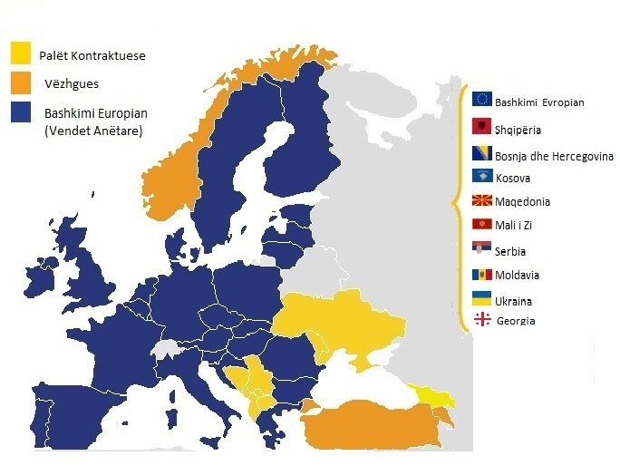
Fig. 4. 1 Member States of the Energy Community of South-East Europe
The Energy Community Treaty (ECT) is a key strategic component of the European Union (EU) for South-Eastern Europe and an effective pre-accession tool, aiming to expand the benefits of the regional Energy Market, before the countries of the region become EU members.
The main institutions of the EC are: the Council of Ministers (CM), the Permanent High Level Group (PHLG), the Energy Community Regulatory Board (ECRB), the EC Secretariat located in Vienna, and the four consultative forums: for electricity, natural gas, social affairs and oil.
The Energy Community Regulatory Board (ECRB) is an institution established under Article 58 of the ECT, consisting of Regulatory Authorities of the Contracting Parties, Participants and Observers. The ECRB has the role of a coordinating body of regulatory authorities for the harmonisation of the regulatory framework, the exchange of knowledge, and the development of practices for the implementation of the Treaty.
Based on the provisions of the EC Treaty, the ECRB has the following responsibilities:
- Advises the Ministerial Council and the PHLG on statutory, technical and regulatory matters;
- issues recommendations to the parties, in accordance with the provisions of the Treaty, on cross-border disputes, etc.;
- takes measures against the parties, if authorized by the CM;
- facilitates cooperation and coordination between regulatory authorities;
- makes recommendations and prepares reports regarding the functioning of energy markets; and
- requires the fulfillment of obligations by the parties under the ECT.
To fulfill its responsibilities, the ECRB is organized into working groups that develop activities in relevant areas. The ECRB is led by a chair elected annually by representatives of national regulators, and a vice-chair who is delegated by the European Commission.
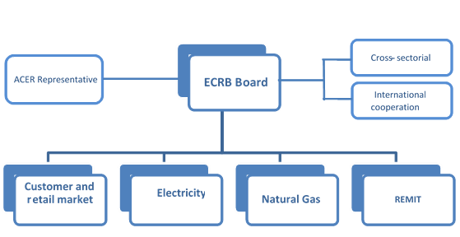
Fig. 4. 2 Structure of the Energy Community Regulatory Board

Activities of the Regulator within the ECRB
According to its obligations to the EC, ERO has appointed its members to the ECRB and to each working group, and actively participates in the work of the Board and the relevant working groups.

Kosovo has taken over the Presidency of the ECRB for the first time
Kosovo for the first time after the signing of the Athens Treaty in 2005 has taken over the presidency of the ECRB. The Energy Community Regulatory Board (ECRB) in its extraordinary meeting held on 05.06.2024 in Athens, elected the Chairman of the Energy Regulatory Office, Mr. Ymer Fejzullahu, as the new President of the ECRB. On 01 October 2024, the 58th regular meeting of the Energy Community Regulatory Board (ECRB) was held, chaired by the Chairman of the Board of the Energy Regulatory Office (ERO), Mr. Ymer Fejzullahu. This was the first meeting of the ECRB under the leadership of Mr. Fejzullahu.
On 10 October 2024, the CEER-ECRB-MEDREG trilateral workshop was held in Lisbon, Portugal, attended by the Chairman of the ERO Board and the current President of ECRB, Mr. Ymer Fejzullahu, other representatives from ERO and senior representatives from CEER and MEDREG .

Electricity Working Group
This working group, during 2024, has developed regular activities and meetings within its scope of activity; for more efficient work, this group has undertaken activities through subgroups ('Task Force'-TF) as follows:
- TF1 – Wholesale electricity market opening and integration - in order to support the effective opening of the regional electricity market in the Energy Community, this subgroup is focused on activities for regulatory support, integration of 'day-ahead' and 'intraday' markets in South-Eastern Europe;
- T F2 – Investment-friendly regulatory environment – the activities of this sub-group are focused on creating a stable, sustainable and harmonized regulatory framework at the regional level, as a fundamental prerequisite for attracting investments in energy infrastructure.
- TF3 – Monitoring the wholesale electricity market- market monitoring, as a key component of regulatory responsibilities, includes full reporting on market performance and development prospects, enabling the promotion of competition, customer protection, energy efficiency, investments and security of supply.
- TF4 – Renewable Energy Integration and Balancing – within the framework of this task force, the regulatory challenges of integrating renewable energy into energy systems and the responsibility of energy producers from renewable sources for balancing the system were evaluated.
- TF5 – Opinions on Electricity Network Codes and Regulatory Guidelines – the main task of this subgroup has been the coordinated review and provision of opinions on electricity network codes and relevant regulatory guidelines.
- T F6 – Implementation of network codes and regulatory guidelines – under this task, the EWG will review the monitoring process of ACER and ENTSO-E and report on the monitoring activity, and mainly focuses on monitoring the implementation of the Network Codes - Connection Code.

Gas Working Group (GPG)
This working group focuses its activities on issues of regulation of the natural gas sector, harmonization of the regulatory framework at regional level and other issues related to the development of natural gas infrastructure in the SEE region. In order to be efficient and address specific issues, activities have been undertaken through the following separate subgroups (“Task Force” – TF):
- TF1 – Monitoring the wholesale natural gas market - market monitoring as a key component of regulatory responsibilities includes full reporting on market performance and development prospects, enabling the promotion of competition, customer protection, energy efficiency, investments and security of natural gas supply.
- TF2 – Implementation of the Network Code for Congestion Management - activities within this task force are focused on monitoring congestion at interconnection points considering capacity trading in secondary markets and the use of 'interruptible' capacity, as well as the analysis of existing long-term contracts.
- TF3 – Implementation of the Network Code for Capacity Allocation Mechanism – activities are focused on the involvement of National Regulatory Authorities and Gas Transmission System Operators in the selection of the joint capacity reservation platform, with the aim of implementing Article 37 of the Network Code for Capacity Allocation.
- TF4 – Investment-friendly regulatory environment – the activities of this subgroup are focused on creating a stable, sustainable and harmonized regulatory framework at the regional level, as a fundamental prerequisite for attracting investments in natural gas infrastructure.
- TF5 – Opinions on Natural Gas Network Codes and Regulatory Guidelines – the main task of this subgroup has been the coordinated review and provision of opinion on electricity network codes and relevant regulatory guidelines.

Working Group on Customers and Retail Markets
Within the ECRB, there is a customer working group with its own subgroups, which deals with activities related to customer protection, retail tariffs and prices, contractual relations between suppliers and customers, as well as the quality of energy supply and voltage quality regulation.
- TF1 – Retail Market Monitoring - Market monitoring as a fundamental component of regulatory responsibilities includes full reporting on market performance and development prospects to enable the creation of an effective framework that balances the needs of market participants and promotes competition, customer protection, energy efficiency, investment and security of supply.
- TF2 – Customer Protection – since customer protection is considered one of the main tasks of regulatory authorities, this responsibility is consequently also conveyed to regional/international organizations such as ECRB, CEER and MEDREG. The activities are focused on the cooperation of these 3 regional bodies for the exchange of best and most efficient experiences in the field of customer protection.
- TF3 – Customer empowerment and protection - the main task of this sub-working group has been to evaluate the inclusion/transposition of Directive 2019/944 in the primary and secondary legislation of the Member States regarding customer rights as it establishes a solid basis for the active participation of customers in electricity markets by introducing dynamic price contracts, the possibility of pooling with other customers, demand response (through aggregation) and the involvement of citizens as an energy community.
- TF4 – Regulatory framework for active customers - within the framework of the relevant activities, this task force, taking into account that active customers have an important role in the energy transition through their contribution to the generation of electricity from renewable energy, the 2020 report on the Legal and Regulatory Framework for the support and handling of micro-generators, with a particular focus on photovoltaic (PV) systems connected to the distribution grid and taking into account the requirements of the Clean Energy Package, aimed to further analyze the development of the regulatory framework for prosumers, also taking into account the Policy Guidelines from the Energy Community Secretariat on the Integration of prosumers (self-producers) from renewable sources.

Working Group on REMIT and Cybersecurity
Within this group, 4 task forces have operated:
- TF1 – REMIT Guide will assess whether the relevant guidelines developed by ACER can be used in the same way or whether adaptations to the specificities of the Contracting Parties or the "REMIT light" version applicable in the Energy Community are needed. In the latter case, the working group will develop specific ECRB guidelines.
- TF2 – New Central Registry Maintenance: will assess the feasibility of implementing the registration and creation of the central registry, including potential IT requirements for automated collection of registration data.
- TF3 – Platform for inside information: This task force will discuss and assess the need for a centralized platform for the publication of inside information.
- TF4 – REMIT Implementation: The Regulator will report on cases, investigations undertaken etc., in relation to REMIT, including cases discussed and coordinated by the ECRB .

Participation of the Regulator in ERRA activities
Being an associate member of ERRA, ERO has its regular members appointed to the working groups and the Chairmen’s' group, which have held their meetings during this period as well.
The Chairman of the Board of the Energy Regulatory Office (ERO), Mr. Ymer Fejzullahu, participated in the Energy Regulators Regional Association (ERRA) Chairs’ Meeting, held on 28 October 2024, in Tirana. This meeting brought together key regulatory figures and experts from the energy sector to discuss the challenges and urgent developments in energy infrastructure and policies. The meeting addressed critical issues such as the lack of grid connectivity resulting from the increase in renewable energy deployment and the regulatory adjustments needed to manage this transition, and presented several case studies. The session on cybersecurity highlighted vulnerabilities in energy infrastructure, highlighting the need for increased protection against threats and the importance of relevant infrastructure in the development of a functioning energy market.

Procurement activities
The Regulator continues to follow procurement procedures by the Central Procurement Agency (CPA), which sometimes, as a result of the amendment to the law on public procurement, are lengthy and cause difficulties in securing services and supplies that are necessary for the normal functioning of the office.

Financial Reporting to the Regulator
The Energy Regulatory Office is financed from its own revenues, in accordance with the Law on the Energy Regulator, Chapter 4, namely from taxes collected from licensed operators in the energy sector.

The revenues
All collected revenues of the Energy Regulatory Office are deposited in accordance with Article 64 of the Law on Public Financial Management and Accountability, in the official bank account established by the Director General of the Treasury.
In 2024, the Energy Regulatory Office has generated revenues in the amount of €6,055,738.35. Considering that the total amount of the budget spent by ERO in 2023 is €739,156.46. The unspent revenues in the amount of €5,316,581.89, in accordance with Article 23 of the Law on the Energy Regulator, have been transferred to the Budget of the Republic of Kosovo.
Tab . 5. 1 Revenues

The budget
The Assembly of the Republic of Kosovo, with Law No. 08/L-260, Law on Budget Appropriations for the Budget of the Republic of Kosovo for 2024, approved the budget of the Energy Regulatory Office in the amount of €898,761, which was entirely allocated as a government grant, despite the fact that under the Law on the Energy Regulator, ERO is financed from its own revenues and only in cases where these revenues are insufficient, then ERO can use budget allocations in the form of a government grant. According to economic categories, ERO's budget was as follows:
Tab. 5. 2 Budget at the beginning of the year
By Government's Decision No. 03/239, dated 24.12.2024, the budget of the Energy Regulatory Office has been cut by €99,842.85 in the economic category "Salaries and Allowances". These funds are savings in this category of expenses due to unfilled positions.
Expressed as a percentage, the ERO budget has been cut by 11%.

Tab. 5. 3 Final budget

Budgetary expenditures
To finance activities carried out in 2024, ERO has spent €739,156.48.
According to economic classification, ERO's expenses are:
Tab. 5. 4 Expenditures by economic categories
Budget execution in relation to the remaining budget after cuts is 92.52%.
The budget execution rate by economic categories, expressed in percentage, is presented in the table below.
Tab. 5. 5 Budget execution expressed in percentage

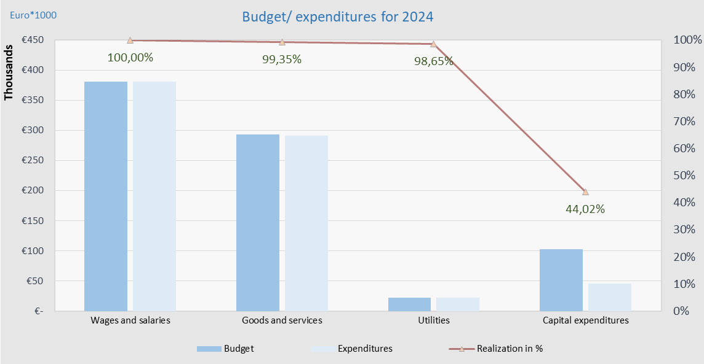
Fig. 5. 1 Budget and expenditures for the year 2024
The following tables reflect expenses according to economic codes.
Tab. 5. 6 Wages and salaries
Tab. 5. 7 Goods and services
As can be seen from table 1.7, the amount of funds spent for this category of expenses is €291,070.38. Budgetary expenditures based on activities are as follows €.
Tab. 5. 8 Municipal expenditures

Tab. 5. 9 Capital expenditures

ELECTRICITY SECTOR

Characteristics of the electricity sector
The energy system in the Republic of Kosovo, consisting of electricity generation, electricity transmission , electricity distribution and suppliers as well as wholesalers, is designed primarily to produce baseload electricity, which is based on lignite as a raw material, but not to cover peak loads and balance the system, which remains a major challenge for all participants in the sector.
Despite investors' interest in investing in new RES capacities, there were no new electricity generation capacities in 2023. The installed generation capacities in Kosovo are 1,572 MW, including RES generation capacities. The operational capacity is considered to be around 1,240 MW, of which lignite - fired thermal power plants (TPPs) account for around 77.44%, while the rest consists of HPP Ujmani, RES in transmission and other RES (hydropower plants, solar panels and wind power plants) with 22.56%.
Most of the consumption is covered by domestic generation, but due to the age of the power plants and their lack of flexibility to adapt to demand in different periods, especially during peak times, the need for imports and sometimes exports to balance the system has arisen.
The figure below presents the production, import, export and demand of electricity over the last ten years.
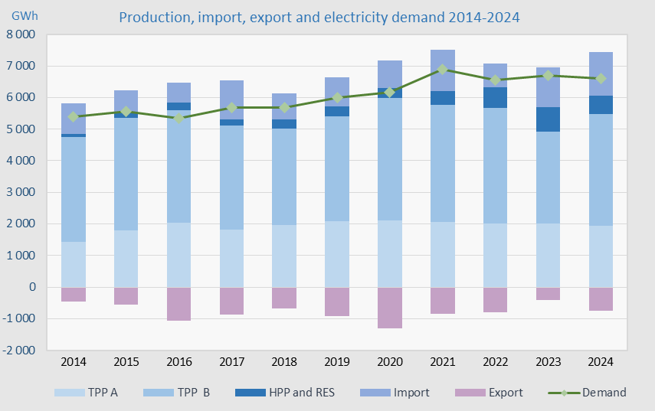
Fig. 6. 1 Energy generation, import and demand 2014 - 2024

Electricity market
The electricity market in Kosovo continues to develop with significant steps, undergoing profound reforms according to legal requirements.
The year 2024 marked great progress in the development of the electricity market in Kosovo. As of 1 February 2024, Kosovo has established the day-ahead market and at the same time, market coupling with Albania has been achieved, marking the first market coupling in the Energy Community. This coupling has enabled a more efficient functioning of the electricity market and has increased liquidity, transparency and competition.
In December 2024, Kosovo and Albania also launched the intraday market, marking a major advance in flexibility and responsiveness to sudden changes in electricity demand and supply.
Despite these advances, wholesale electricity trading continues to be conducted primarily through bilateral contracts between producers and suppliers (traders). However, with the operationalization of the intraday market and the coupling of the Albania-Kosovo markets, more opportunities have been created for market participants, improving liquidity and price stability.
Previous contractual obligations have created limitations on the liquidity of the organized market, since the electricity generated by KEK, under the Bulk Supply Agreement (BSA), is offered to the Supplier that supplies customers entitled to Universal Service and to cover system losses. Only the surpluses from this obligation are traded in the wholesale market according to market principles.
In 2024, HPP Ujmani continued to trade all its energy In the free market, participating in the ALPEX day-ahead auctions.
Also, the energy generated by RES generators with support schemes is traded through ALPEX with Contracts for Difference (CfD).
Despite the progress, Kosovo's power system continues to face challenges due to the aging of its power plants and the lack of regulating generators, limiting its flexibility to cope with high demand during peak times. As a result, the country continues to need imports and occasionally export electricity.
Interconnection capacities have played a key role in the functioning of the energy market. Serbia's unilateral blocking of interconnection lines has created serious constraints in regional markets, with Kosovo being the most impacted. This has caused interconnection capacity prices to increase to an unprecedented level, further hindering access to international energy markets, and consequently increasing import prices.
The overall demand for electricity at the national level has decreased slightly, with the total demand for electricity at the national level being 6,611 GWh (including transmission and distribution losses). The majority of this demand is covered by domestic production, while the rest is covered by electricity imports.
The table below presents the balancing of the system; from which it can be seen that our country continues to be a net importer in 2024.
Tab. 6. 1 Balancing of the electricity system 2024
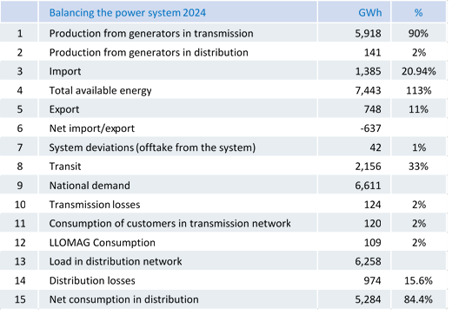
Production from generators that send electricity to transmission increased by 7.3% compared to 2023. Imports under contracts in 2024 increased by approximately 29.1% compared to the previous year, and exports also increased by approximately 86%. National demand in 2024 was 6,611 GWh, while demand in the distribution network was 6,258 GWh.
KOSTT continues to operate as a regulatory area within the Kosovo-Albania Regulatory Block, where system balancing is the full responsibility of KOSTT, which also includes covering all system deviations and responsibility for the secure operation of the interconnection system, as well as cross-border capacity allocation and congestion management, which includes collecting revenues from cross-border trading, in addition to the allocation of cross-border capacity with Serbia .
The figure below shows the flow of electricity from generation, transmission to distribution to customers, as well as the flows of electricity to and from regional networks, including transit.
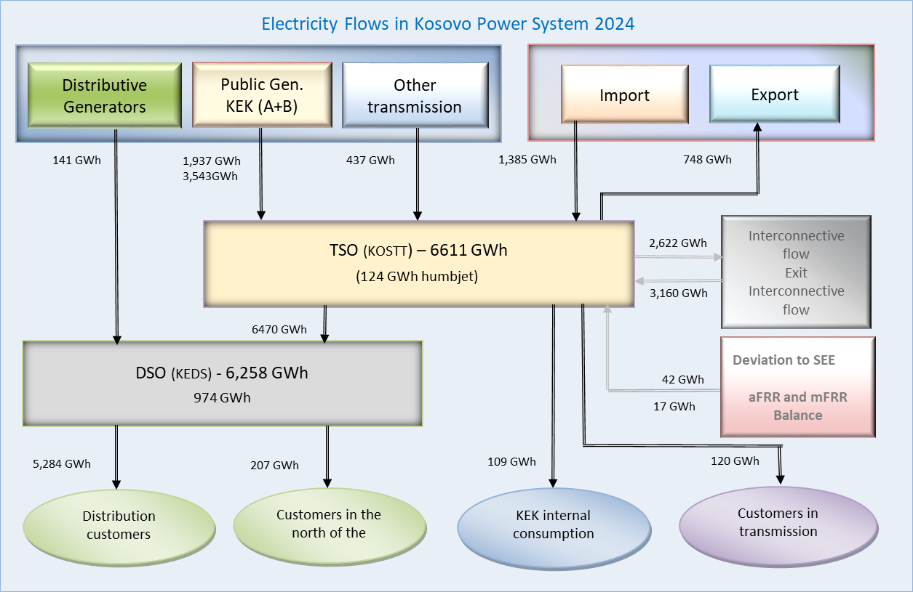
Fig. 6. 2 Electricity flows in the system in 2024

Generation adequacy and security of supply
Domestic generation is not sufficient to cover the maximum load in the Kosovo electricity system. This lack of energy to fulfill national demand is covered by electricity imports.
Total operational capacity of generators in Kosovo​ is 1,240 MW, while the maximum load during this year was 1,472 MW, therefore the generation adequacy ratio to maximum load is 84.23%.
In the table below​​​​ the maximum and minimum loads during 2023 are presented on a monthly basis.
Tab. 6. 2 Maximum and minimum loads in 2024
While the generation system has deficiencies in terms of adequacy, the transmission system contains sufficient reserves to enable electricity flows to fulfill domestic demand, including covering maximum (peak) load, as well as to enable transit through interconnection lines.
The table below shows the maximum and minimum loads (P _{max} and P _{min)} of the Kosovo power system over the years, the time of their occurrence, production, and the corresponding import and export of electricity.
Tab. 6. 3 Maximum and minimum loads of the electric power system
* System deviation towards the interconnecting system
As mentioned earlier, the energy needed to cover losses in the transmission and distribution network is initially provided in a proportional manner from the energy remaining from KEK after the allocation of energy for universal service, while the remaining part of the energy to cover losses is provided by import, in a market.

Primary energy sources​
In the recent years, there has been an increase in generation capacities from RES such as: water power, wind power, solar power, but in Kosovo, energy generated from lignite still continues to dominate as the primary energy source, which on the one hand enables long-term security of electricity generation, but the environmental impact due to the emission of greenhouse gases and other pollutants remains a problem .

Lignite production and consumption
Lignite production in 2024 was 6.924 million tons, whereas consumption was 8.07 million tons, amounts that are higher compared to 2023.
The production and consumption of lignite by months for 2024 is presented in Table 6.4.
Tab. 6. 4 Lignite production and consumption in 2024
The figure below shows the production and consumption of lignite during the years 2014 - 2024.
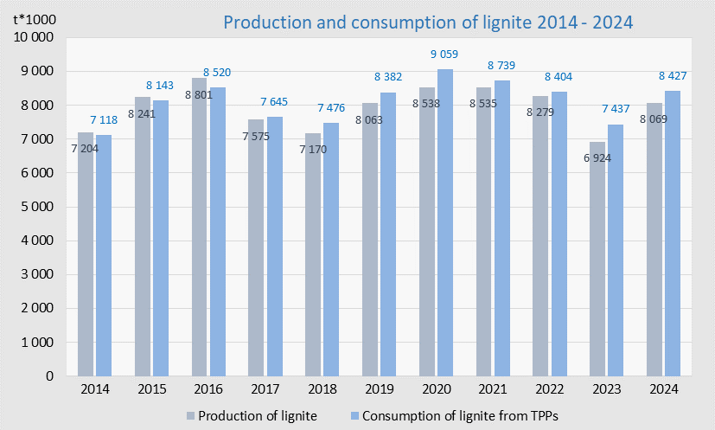
Fig. 6. 3 Lignite production and consumption in 2014 – 2024

Electricity production

Electricity production capacities
The total operating capacity of electricity generation in Kosovo is 1,240 MW, of which 960 MW or 77.44% are from thermal power plants and the rest are hydropower plants and renewable energy sources (hydropower plants, wind power plants and photovoltaic panels).
The capacity of the generating units is presented in the table below according to the type of primary source, installed and operating capacity, minimum and maximum production limits, and the year of entry into operation.
Tab. 6. 5 Generating capacities in the Kosovo electricity system

Electricity production
The total electricity production in 2024 was 6059 GWh, while in 2023 it was 5,698 GWh, which means that there is an increase of 6.3%. Meanwhile, compared to the electricity balance for 2024, the production was realized at around 90.7%.
The table below presents national production and own consumption by units and months during 2023.
Tab. 6. 6 Electricity production in 2024
The gross production of thermal power plants in 2024 was 6,178 MWh, of which 698 MWh or 11.3% was consumed by the thermal power plants themselves as own consumption. A part of this own consumption (for both generators TPP Kosova A and TPP Kosova B) is realized directly by the internal plants, while the rest is fed into the transmission system and then consumed by the thermal power plants.
The figure below shows the participation of generators in total electricity production in 2024.
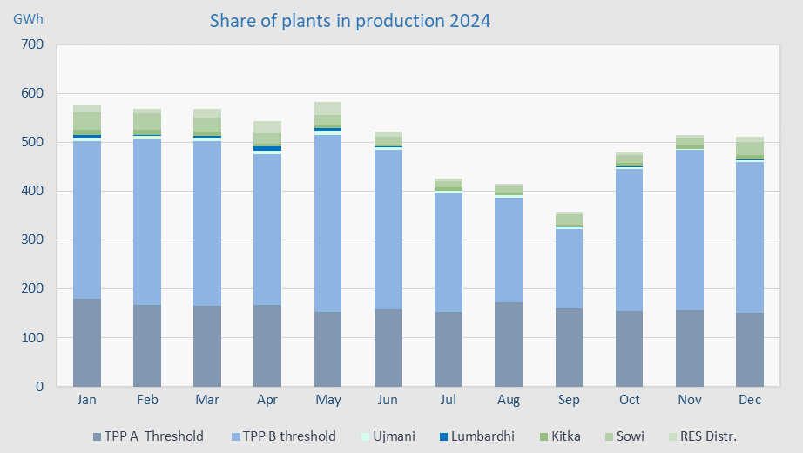
Fig. 6. 4 Production of generating units in 2024
The generation of RES connected to the transmission network in 2024 was 437.5 GWh and is 24.8% lower compared to 2023. Similarly, the generation of RES connected to the distribution network was 141 GWh, and is 24.4% lower compared to 2023.
The following tables present the generation of electricity from RES connected to the transmission network, respectively to the distribution network.
Tab. 6.7 Generation of RES connected to the transmission network in 2024
Tab. 6.8 Generation of RES connected to the distribution network in 2024
Operation of generating units
Compared to last year, the number of outages from the operation of lignite-fired generating units has been slightly higher, which proves that the reliability and sustainability of thermal power plants is decreasing from year to year. The table below presents all types and frequency of outages and the availability in working hours of thermal power plants for 2024, where it is noted that the availability of the generating units of TPP Kosova B2 has been good.
Tab. 6. 9 Outages of generating units 2024
The operating hours of the generating units of TPP Kosova A and TPP Kosovo B are presented in graphic form in the figure below, with variations according to units, where it is noted that units B1 and B2 have operated for over 80% of the hours of the year, 86.6% and 83.4% respectively, while units A3, A4 and A5 have operated for 61.4%, 62.9% and 69.9% respectively per year.
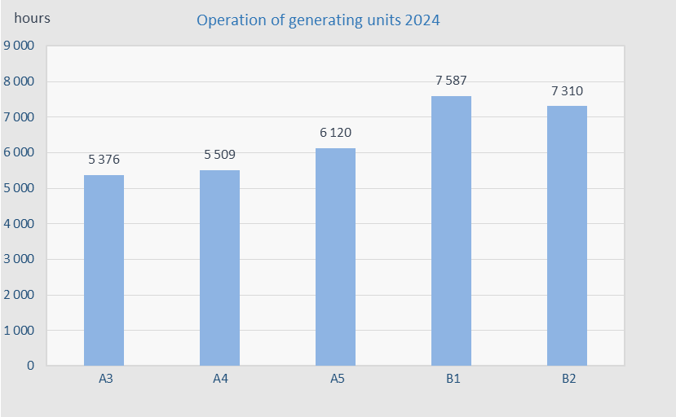
Fig. 6. 5 Operation of generating units in 2024
The figure below shows the production of generating units for the period 2014 – 2024.
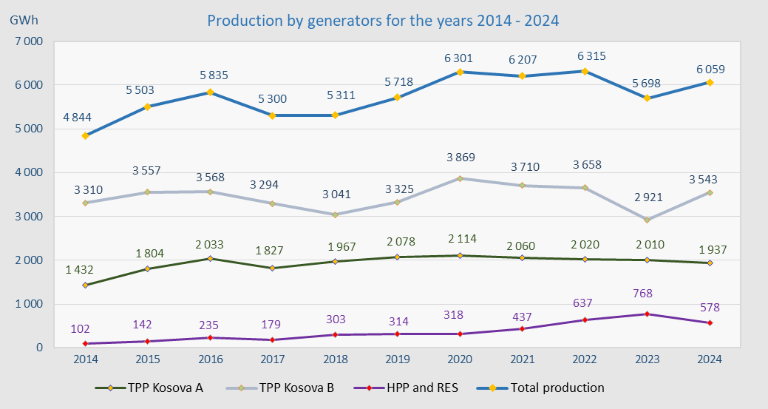
Fig. 6. 6 Electricity production for the years 2014 – 204 3

Transmission system
Transmission as a regulated energy activity is responsible for the operation, management, maintenance, development and construction of the transmission network, transmission lines and system balancing, as well as ensuring the long-term ability of the network to fulfill the demands needed for the transmission of electricity.
The transmission network of the Kosovo electricity system is well developed and provides sufficient system security and is well connected to the regional and European system through interconnection lines with:
- Albania, North Macedonia, Montenegro and Serbia – with 400 kV lines;
- Albania and Serbia – with 220 kV lines; and
- Serbia - with two 110 kV lines.
The transmission network of the Kosovo electricity system fulfills domestic transmission needs as well as the N-1 criterion for the entire high voltage level.
The following tables present the transformation capacities and transmission network lines, according to voltage level:
Tab. 6. 10 Substations in the transmission network
Tab. 6. 11 Lines in the transmission network
The diagram below presents basic information on the number of substations (SS), transformers (TR) and installed transformer power, the length of lines, as well as the power plants connected at the respective voltage level.

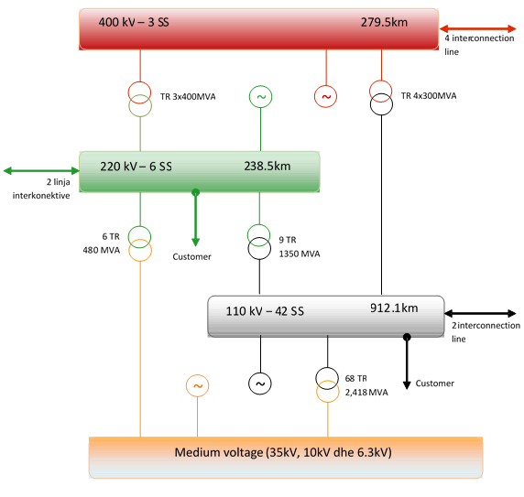
Fig. 6. 7 Basic data of the transmission network

Electricity flows in the transmission network
The transmission system in Kosovo is well connected to the regional and European system through interconnection lines with neighboring countries and has sufficient capacity to cope with energy flows in the system, to cover customer demand from local production and imports, but also for eventual exports of surplus electricity, as well as for energy that passes in transit from other countries.
It should be emphasized that the transit of electricity loads the network by increasing losses, network depreciation, and the need for maintenance of the transmission network, for which the operator is compensated through the ITC Mechanism. The transit of electricity through the Kosovo network in 2024 was 1,970 GWh or about 29.7% compared to demand or 21 % to the total entry into the transmission network.
The figure below shows the energy flows through all interconnecting lines in both directions (input, output).
Fig. 6. 8 Power flows through interconnecting lines

Investments in the transmission system
During 2024, investments were made in the transmission network, where investment projects are presented in the following categories:
Projects that have been completed in 2023 and are under a one-year guarantee period
During 2023, the project was technically and financially completed and in 2024 the one-year warranty period ended and the assets were transferred to the Transmission System:
The project in Kastriot includes:
- The construction of SS. 110/35/10(20) kV Ferizaj 3 (Kastrioti) with a 40MVA transformer, even during 2024, has remained with the same status, and
- Construction of the 110kV line/cable for connection of the new 110/35/10(20) kV Kastrioti substation, the line construction process has been delayed, due to the suspension by MESPI
Projects financed by KOSTT, where the contract was signed during 2021/2022 and are in the implementation phase
- Construction of the 110kV line/cable for connection of the new 110/35/10(20) kV Kastrioti substation, the line construction process has been delayed, due to the suspension by MESPI
- Construction of SS. 110/35/10(20) kV Fushë Kosova, the project was implemented according to the contract on time and within budget. Based on the protocol of the works performed by the end of 2024, approximately 98% of the works have been completed in total. After commissioning on 19.12.2024, the substation was energized.
Projects financed by KOSTT and tendered during 2024
- Supply and installation of 40MVA power transformer for SS Fushë Kosova
- Preparation of construction design documentation for SS 220/35/10(20) kV Malisheva
Phase VI and VII projects – Financing from the German Development Bank KfW for the implementation of the projects
According to the Investment Plan, this group of projects is planned to be co-financed by KFW/KOSTT. Borrowing between the Government of the Republic of Kosovo, KfW (Kreditanstalt für Wiederaufbau) and KOSTT within the framework of interstate cooperation between the Republic of Kosovo and the Federal Republic of Germany. The planned projects are as follows:
  - Consulting services for the preparation of tender dossiers and supervision of project implementation;
    - LOT 1 - NS 110/10(20) kV Dragash with 1x40MVA transformers and transmission lines;
    - Shunt reactor 100 MVAr at SS Ferizaj 2
  - LOT 2 - SCADA and Telecom;
    - Supply and installation of equipment for SCADA adaptation (RTU & SCS);
    - Replacement of the existing SCADA/EMS system for the National Dispatch Center and the Emergency Dispatch Center;
    - Telecom system migration and advancement
  - LOT 3: Supply and installation of 40 MVA power transformers in SS:
    - Supply with 110/10(20) kV power transformer at SS Fushë Kosova;
    - Supply with power transformer at SS 110/10(20) kV at SS Ferizaj 3- Kastrioti;
    - Replacement of the power transformer at SS Gjakova 1, 110/10(20)/35 kV;
    - Replacement of the power transformer at SS Prishtina 5, 110/10(20) kV;
    - Replacement of the power transformer at SS Prizren 1, 110/10(20)/35 kV;
    - Replacement of the power transformer at SS Peja 1, 110/10(20)/35 kV;
    - Replacement of the power transformer at SS Ferizaj, 110/10(20)/35 kV;
    - Replacement of the power transformer at SS Deçan, 110/10(20) kV;

  - LOT 4: Transmission Lines Loan/Grant (WBIF):
    - New double overhead/cable line and dismantling of the existing line between SS Prizreni 1 and SS Prizreni 2;
    - Re-vitalization of the 110kV line SS Prizren 1 - Prizren 3;
    - New 110kV line field at SS Prizreni 1;
    - Double overhead line 110kV SS. Dragash - Zhur (end of the double line), with only one conductor;
    - New single overhead line SS Zhur – NS Prizren 2;
    - New 110kV overhead line SS Dragash – SS Kukës (border with Albania);
    - New single cable 110 kV line SS Prishtina 4 - SS Prishtina 2.
The year 2024 is also characterized by the continuation of the work of the government working group in the process of developing the program of the financing agreement from the United States of America through the MCC foundation, for the battery installation project. For KOSTT, an investment will be made to secure and store energy in a capacity of 45 MW, which will be used for secondary regulation.

Maximum loads and energy demand in the power system
To analyze the functioning of the electric power system, among other things, the value of the maximum (peak) loads is also important, and for this purpose, five (5) maximum loads realized at different hours and days of the year are usually taken. The following table presents the values of the maximum (peak) loads for the year 2024.
Tab. 6. 12 Maximum (peak) load values in 2024
The maximum load on the Kosovo power system was recorded on 26 December 2024 at 23:00 at a value of 1,472 MW, which is higher than the maximum load in 2023, which was 1,413 MW. The minimum load was recorded on 26 May 2024 at 06:00 at a value of 317 MW.
As mentioned above, due to the inflexibility of the energy system, and especially the inflexibility of existing power plants, it happens that on the same day, and even at the same hour, we have imports and exports of electricity. Therefore, generally within the same day, during the daytime hours (high tariff) production does not cover demand and electricity needs to be imported, while at night (low tariff) there is a surplus of electricity that needs to be exported.
The difference between the monthly average of daily maximums and minimums of consumption during the months of 2024 is shown in the diagram below.
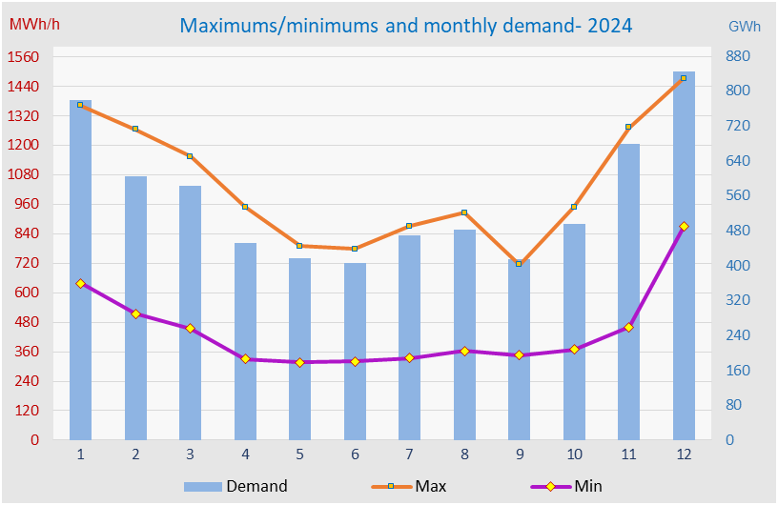

Fig. 6. 9 Monthly average demand and daily maximum/minimum loads 2024

Reductions due to electricity shortages
Based on operator reports, during 2023, electricity reductions due to power shortages were small and totaled 76 MWh.
It should be emphasized that the ERO Board at the end of 2018 issued a decision to prohibit reductions due to energy shortages, except in cases where facilities are at risk.
As can be seen from the diagram below, despite all efforts to eliminate supply reductions due to electricity shortages, there have been reductions over the years. However, in recent years, reductions have been significantly reduced and in some years have been completely eliminated.
The figure below shows the reductions due to electricity shortages over the years.
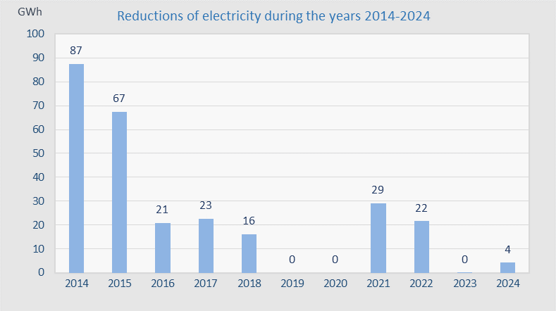
Fig. 6. 10 Consumption reductions during 2014 - 2024

Electricity demand and losses in the transmission network
The total national electricity demand in 2024 was 6,610 GWh and represents a decrease of 1.26% compared to 2023, when it was 6,695 GWh, while compared to the forecast in the 2024 electricity balance, the demand is 8.56% lower.
Table 6.13 presents the total demand and transmission losses realized in 2024 and compared to the 2024 electricity balance.
Tab. 6. 13 Total demand and losses in the transmission network in 2024
Since 2011, there has been a stabilization of the electricity demand, with small fluctuations from year to year, and in the last year a small decrease has been observed, which can be seen in the figure below.
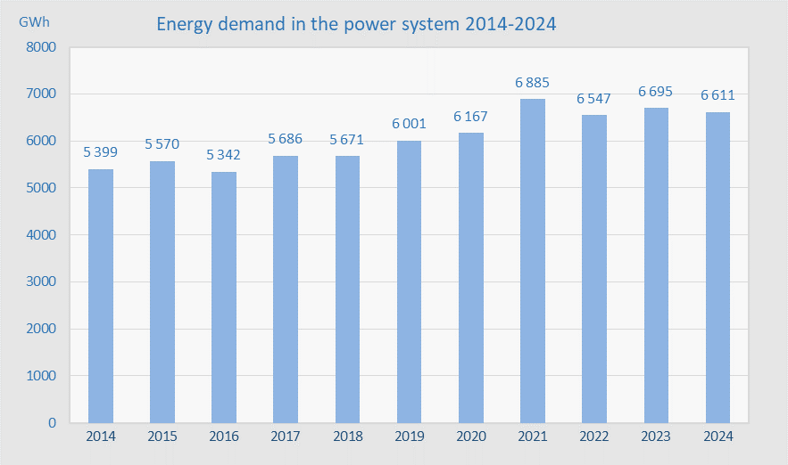
Fig. 6. 11 Total demand in the power system 2014-2024
The total electricity demand is divided into the consumption of customers connected to the transmission network, consumption in the distribution system (including losses), own consumption for the needs of production facilities, as well as transmission losses, and this is presented in the table below divided by category for the year 2024.
Tab. 6. 14 Demand by category and energy losses
(*) Electricity received in distribution from transmission + production in distribution
The electricity taken from the transmission network for own consumption for the needs of production facilities in 2024 was 149 GWh.
The demand for electricity varies according to the consumption period but also according to customer categories, and this is presented in the following table, which also includes losses in the transmission and distribution network (technical and commercial losses).
Tab. 6. 15 Participation of different categories in the total demand 2024
The demand for electricity, presented in Table 6.15, varies by month, and in some categories this variation is quite pronounced, such as household consumption and commercial losses which are higher in the winter season, which is mainly due to the use of electricity for heating.
Losses in the transmission system are at an acceptable level thanks to investments made by KOSTT and are approximately at the same level as losses in transmission networks in the region and Europe.
The figure below shows the percentage losses in the transmission network compared to the total demand of the Kosovo electricity system.
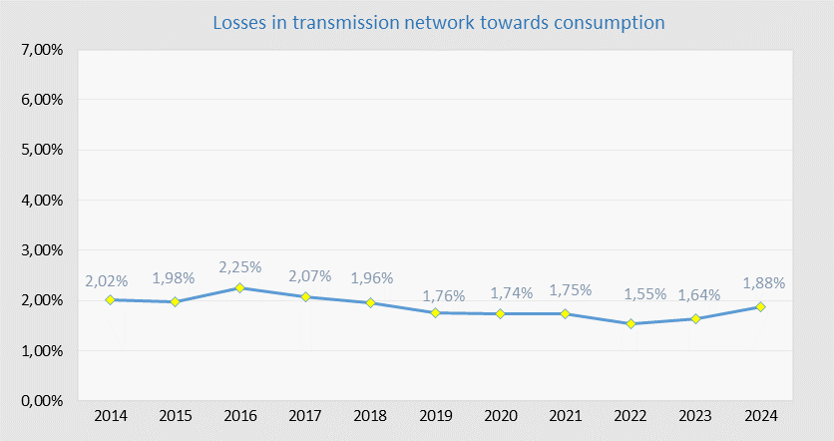
Fig. 6. 12 Percentage losses in the transmission network 2014-2024
The losses shown in the figure above are expressed as a percentage of local demand and amount to 1.87%. However, the level of transmission losses is influenced by all the energy entering the transmission system. Therefore, to calculate the percentage of losses relative to the total load on the transmission network, additional flows, such as transit, energy for generators' own consumption, and others must also be included. When calculated this way, the percentage of transmission losses is 1.25%.

Electricity distribution system
The distribution network, as a regulated energy activity, is responsible for the operation and maintenance of the distribution system and the management of generators connected to the distribution system.
The distribution network consists of 35 kV, 10(20) kV, 6 kV and 0.4 kV voltage lines, as well as the corresponding 35/x kV, 10(20)/0.4 kV and 6/0.4 kV level substations.
Basic data of substations and lines including capacity, transformation and length of distribution system lines are presented in the following tables.
Tab. 6. 16 Substations and transformers by voltage level in the DSO
Tab. 6. 17 Lines in the DSO
The diagram below presents basic information on the number of substations (SS), transformers (TR) and transformation power ( MVA), the length of the lines, as well as the power plants connected at the respective voltage level.
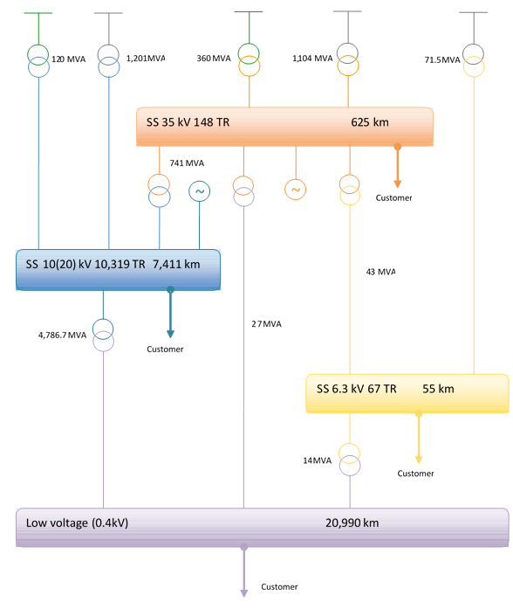
Fig. 6. 13 Basic data of the distribution system

Investments in the distribution system
The Distribution System Operator continuously invests in the distribution network based on the allocated investment budget approved by the Energy Regulatory Office, and in this way enhances the functioning of the distribution system to provide reliable electricity supply, as well as increasing the capacity of the existing network. Investments include projects in the medium and low voltage network as well as projects in the digitalization and modernization of the network such as SCADA, smart meters PLC, etc.
Projects are selected by analyzing the need for investment in the most critical areas, evaluating them through priority criteria to achieve key investment objectives, such as:
- Reducing technical and non-technical losses,
- Reliable and higher quality electricity supply,
- Increasing existing network capacities and modernizing the network.
Investments made during 2024 by the Investment Department
Urgent investment in the 35 [kV] Rahovec-Malisheva line
Project “35 [kV] Line Rahovec-Malisheva”; In order to alleviate the electricity supply situation in Malisheva, until the construction of the new substation by KOSTT, the Energy Regulatory Office (ERO) has approved an emergency investment for the project “35 kV Line Rahovec-Malisheve”. This project is of particular importance, as the existing line did not have sufficient capacity to supply the 35/10 kV Malisheva substation, affecting the quality of distributed energy and causing unplanned outages. With the implementation of this investment, 15,131 customers have benefited, reducing supply problems until the construction of the substation by KOSTT.
Investments at level 35 [kV]
Project "Extinction of SS 35/10 [kV] PR II" - 10[kV] feeders: Hospital, Mechanics, Don Bosko, Police, Lesna, Kosovatrans-Kazerma, Veterniku 2, Ipko, Kosovatex Spinnning Mill and Batllava, which have been supplied by SS 35/10 [kV] Prishtina II, part of them have been transferred to SS 110/35/10(20)[kV] Prishtina 1, while part have been extinguished. The 10kV feeders Mechanics, Police and Kosovatrans have been extinguished. With this investment, the ring connection between the 10[kV] Banesat e Arabve and Kalabria 3 feeders has also been established.
Conversion of outputs to 20 kV voltage level
KEDS has continued with the process of implementing investments in the transition of 10kV feeders to operation at the 20kV voltage level.
Pristina District,
Feeders New feeders 1, 2 and 3 between Prishtina 2 and 3; New feeders 1, 2 and 3 between Prishtina 3 and 5; New feeders 1, 2 and 3 between Prishtina 2 and 5; New feeders 1 (Përparimi), 2 (Qyteza Pejton) and 5 (Faculty of Philosophy) between Prishtina 3 and 6; New outputs 1 & 2 Arbëria from Prishtina 3; New feeders 1, 3, 6 and 7 from Prishtina 7; New feeders 1, 2, 3, 4 and 5 from Prishtina 5 & Prishtina 5 - Butovci Branch. Investment in these feeders has provided quality and reliable supply to customers, and will continue the conversion process to 20 [kV] even after 2024.
Gjakova District,
Feeders supplied by SS Gjakova I 35/10 [kV] and feeders supplied by SS Gjakova 2 110/10(20) [kV]: Cermjani, Dobroshi, Skivjani, Beci and Ponosheci are supplied by SS Gjakova I, while Ura e Terzive and Bistazhini are supplied by SS Gjakova 2 which are among the investment projects due to overload, losses and problems with voltage drops. The feeders Ereniku and Piskota have been added to the list of investments due to the combination of existing feeders into new configurations. These projects will benefit 14,325 customers , the implementation of which will continue after this year .
Feeders supplied by SS Malisheva 35/10 [kV]: Carralluka, Mirusha, Bellanica, Kijeva, Banja, Dragobili and Malisheva are supplied by NS 35/10 kV Malisheva. As is known, the feeders are overloaded and large voltage drops occur starting from the voltage level 35 [kV]. 15,124 customers will benefit from these projects. The Bellanica, Mirusha and Kijeva feeders are almost completed, while the investments in the other feeders have been completed and will be converted to 20 [kV].
Mitrovica District: Qirezi, Likovci, Turiqevci and Llausha are the feeders selected for investment due toissues such as voltage drops, losses and overload. Although the Lausha feeder was not initially included in the Investment Plan, it has been added through ongoing projects. The Qirezi, Likovci, Turiqevci, and Llausha feeders will be reconfigured and combined into new feeders to ensure a more balanced load distribution.
The Qirezi and Turiqevci feeders are almost complete, while Likovci and Llausha have already been finalized. All of these projects are planned for conversion to 20 kV in 2025.
The City and Village Feeder is one of the most problematic in the district, characterized by high load, high technical losses [MWh], voltage drops and a high frequency of outages. A full investment in this feeder is planned, which will benefit 3,129 customers, with implementation continuing beyond this year.
Peja District: Barani Feeder: the Barani feeder is a long 18 km line with scattered branches and narrow segments, which negatively affect voltage levels for end users. This project involves comprehensive investment in the entire feeder and will benefit 2,590 customers. Implementation is ongoing and will continue beyond this year.
Investments at level 10 [kV]
Pristina District:
“Bardh i Madh” Project: this project targets segments of the network that pose safety risks to local residents. It will benefit 1,768 customers and is nearly complete.
"Trasing" Project: comprehensive investment is being made in the entire feeder as part of this project, which will benefit 283 customers. This project is also nearing completion.
“Business Park” Project: as part of this project, the Llapushnik, Komorani, and Zabel i Ulët feeders will be transferred from the Business Park substation to the 220/10 kV Drenas substation. This project is almost completed.
“Shkabaj” Project: this investment aims to strengthen the network and improve reliability. It will benefit 1,093 customers and is nearing completion.
"Vragoli, Miradie e Epërme and Kablloviku" Project: a total of 272 customers will benefit from this project, which is scheduled to continue beyond this year.
Peja District
"Maja e Zezë, Peja Hospital" Project - this project will benefit 533 customers. Implementation is ongoing and will continue after this year.
"Ledinat" Project - this project will benefit 1,012 customers, with implementation continuing beyond this year.
"Rugova" Project - This project involved investment across the entire feeder, benefiting 1,331 customers.
Ferizaj District- these investments have addressed line overload issues and significantly improved the technical performance of the network, including easier fault detection and repair.Project “Bobi” Project - 848 customers benefit from this project, which is nearly completed.
"Gaçka" Project - will benefit 2,547 customers; implementation will continue beyond this year.
“Magure Fshatrat” Project - 2,453 customers have benefited; this project is complete.
“Carraleva, Voskopoja & Glloboqica Villages” Project - This project has been completed.
"Varoshi" Project - will benefit 1,553 customers; implementation will continue after this year.
Mitrovica District:
Maxhunaj Feeder - the investment in this feeder has improved supply security, reliability, and technical quality for 2,785 customers. Implementation will continue after this year.
Prizren District:
“Hasi 2, Krusha Madhe ” Project - 3,737 customers have benefited; project completed.
Project “Studenqani 2” - The network has been relocated alongside the road to ensure permanent access for maintenance and repairs. 999 customers have benefited; project completed.
"Hoqa e Qytetit" Project: Aims to reduce line overload and improve technical conditions. 1,347 customers will benefit; implementation will continue beyond this year.
"Rapça and Zhupa" Project - This project has been completed.
“Arbana and Ortakolli 1” Project - Enabled the use of the ring network with Ortakolli 1 feeder, easing the load on Arbana feeder. 1,448 customers have benefited; project completed.
"Ortakolli 2" Project - the project has been completed, benefiting 2097 customers.
“Bajram Curri, Poslishta” Project - the project has been completed, benefiting 51 customers.
Project "Dogana, Dobrushtë" - Improved supply security and fault isolation; completed; 690 customers have benefited.
"Mamusha Municipality" project - improved voltage levels and other technical parameters; project completed, benefiting 1,793 customers.
Gjilan District:
Begunca Project - this project will benefit 1,021 customers. Implementation will continue beyond this year.
The “Ropotova” project -the investments under this project will benefit 1,852 customers, with implementation continuing after this year.
Gjakova District: Pataqani Feeder: this investment has benefited approximately 1,265 customers. The project has been completed.
Investments in the low voltage network
Across the KEDS network, several areas require urgent investment due to aging and deteriorated infrastructure. To address the most critical needs, an assessment was conducted based on defined priority criteria to guide project selection.
Pristina District - in 2024, projects were implemented in Drenas, Obiliq, Podujevo and Pristina regions within the framework of low voltage projects. Around 2,557 customers benefited from these projects.
Prizren District - in 2024, within the framework of low voltage projects, projects were implemented in Suhareka and Prizren regions, benefiting around 3,318 customers.
Peja District - in 2024, projects were implemented in Deçan and Klina regions within the framework of low voltage projects. Around 3,300 customers benefited.
Gjakova District - in 2024, projects were implemented in Gjakova and Malisheva regions within the framework of low voltage projects. Around 1,979 customers benefited.
Mitrovica District In 2024, within the framework of low voltage projects, projects were implemented in the Vushtrri, Skenderaj and Mitrovica regions, benefiting around 2,793 customers.
Ferizaj District - in 2024, projects were implemented in the regions of Ferizaj, Lipjan, Kaçanik and Shtime within the framework of low voltage projects. Around 3,912 customers benefited from these projects.
Gjilan District - in 2024, within the framework of low voltage projects, projects were implemented in the regions of Gjilan, Viti and Kamenica, where around 912 customers benefited.
New Connections - within the framework of low voltage projects, projects of the new connections type have also been implemented. These projects have been invested in all of Kosovo.
In conclusion, for all investments in 2024 for the MV and LV network, the following materials have been used:
Tab. 6. 18 Quantities of materials used in 2024
Investments made during 2024 by the System Operation Department
Projects and works carried out during 2024 by the System Operation Department
In addition to the implementation of medium voltage projects from previous years, this year's medium voltage projects were directed more towards the most critical areas for investment, such as Ferizaj, Gjakova, Prizren, etc. These projects were implemented to solve the problems of rapid consumption growth, network overload and improvement of other technical parameters, where at the same time these projects were intertwined with the urban plans of the municipalities of the Republic of Kosovo:
During 2024, the Operating System Department, within the implementation of projects, has invested in projects related to the following areas:
- Good maintenance and rehabilitation of the network
Replacement of MV and LV poles; cleaning of the MV and LV network route as a preventive measure in creating conditions for the lines to work without being affected by external factors such as tree branches, etc.; replacement of conductors and their tightening, replacement of insulators, surge arresters, consoles and any other element, which during the preliminary inspection was destined to fail very quickly and become a source of breakdown; Relocation of 10 and 0.4 kV lines in order to maintain and repair breakdowns as easily as possible; reinforcement of transformer pole foundations, metal construction poles; repair of transformer shields, their metal constructions; replacement of damaged and overloaded transformers
- Cleaning of 10, 20 and 35 [kV] distribution lines, a total of 95 feeders with a total length of 159 km were cleaned.
- Replacement of overloaded transformers in total 22 feeders
- Investments in projects 10 [kV] - Rapqa & Zhupa, Economic Zone in Qylagë, LP Bletaria - Pobërgjë - Hulaj segment, LP J11 Gjakova III, LP Music School, LP Industriali, TS Bazeni - St. Hamdi Kurteshi, LP 35 [kV] Mazgit - Koliq, LP Dobroshi in the village of Nivokaz, LP 35 [kV] Rahovec - Malishevë, Branching of LP from TS Tabet - Qershiat, LP Rimanishtë - TS Lahovit 4.
- The reconstruction of the HV and MV network are projects completed during this year, which include investments in new lines, unloading of overloaded 10(20) [kV] feeders, relocation of the network, installation of transformers and implementation of PLC meters.
  - TS Gracka e Vjetër – Kulla, TS Babushi i Muhaxherëve II, TS Sllatinë (at the cemetery), TS Cakajt in Stanofc, TS Prekaz Shabani, TS Bernicë e Ulët 5, TS St. Bujana, TS Shiroka 2, TS Baicë village, TS Jashanicë Bajraktarët (Te Blinda), TS Tupec 4, TS KEDS – Calibration Center, TS Kulla Frashër, TS Kulla (at the Gymnasium), TS 17 Nëntori 2, TS Kovragë – Halitaj, TS Instituti V, TS Ambulanta, TS Primary School, TS Busia.
- Investments in 0.4 [kV] projects - throughout the KEDS network, there are parts of the 0.4 [kV] network that require investments due to their poor condition. In order to invest in the most critical areas, priority criteria for project selection were taken into account. Therefore, investments in low voltage in the 2024 investment plan were directed to regions such as: Klinë, Ferizaj, Gjakova, Mitrovica, Prishtina, Prizren, etc.
  - TS Botusha 1, TS Business Park 2 – Kalabria Neighborhood, TSB No. 4, TS IX – Xhemajl Kada Street, TS Ali Hadri Street, TS Zekollët – Bllacë, TS Petrova III – Qeshmja (Hyrojt), TS Lower Gadime – Jupajt (Blinda), TS Drobesh – Arbeni, TS Lubishtë te Şajja, TS Novoselle, TS Jabllanicë Lapidari, TS Radavc MH, TS at Shaljanët, TS Bellopoja Kadriovi, TS Vërmica I, TS Pirana 1, Relocation of the network to Sheshi – Rahovec, TS Fortesa IV.
- Unloading overloaded TS - During 2024, the Network Maintenance Unit has invested in unloading overloaded TS feeders, for which projects have also been opened.
  - TS Kujdestaria (MBTS), TS Qiragjitë, TS Komogllavë (Kurdovit – Hajdarajt), TS Kulla – Xhiranat, TS Pacaj, TS Mahalla e Shehut 1, TS Zabel, TS Viti – te Pasqyra, TS Mushtisht – Kulla 1, TS Semetisht IV, TS te Baja – Bazeni, TS Llukar school
- Implementation of PLC Projects - The implementation of these projects has significantly reduced technical and non-technical losses where they have been implemented, enabling the creation of conditions for better quality electricity supply and quality voltage to affected customers, where 1,547 customers have been affected by these PLC investments.
- Investments in the metering point - During 2024, the following meters were invested:
  - 1,750 meters with direct measurement with GSM GPRS communication;
  - 13,744 meters with direct measurement with PLC;
  - 1,303 meters with semi-indirect and indirect metering, of which 174 are new meters and 1,129 are replaced meters;
  - 4,681 mechanical meters that have been replaced with digital ones;
  - 27,041 meters dedicated to new connections;
- Replacement of relay protections at substations: the substations in which relays have been replaced include 26 substations, while the total number of relays replaced is 267 pieces.
- Investments in the SCADA system
  - Installation of SCADA system in a total of 91 plants
  - Finalization of the second SCADA system control center
- Replacement and installation of power transformers in substations
  - Replacement of power transformers at 8 [MVA] in SS 35/10(20) [kV] Pirana
  - Replacement of power transformers at 8 [MVA] in SS 110/35/10 [kV] Shtime
  - Replacement of the 4 [MVA] power transformer at the SS 35/10 [kV] Artana
  - Replacement of power transformer 4 [MVA] at SS 35/10 [kV] Dikanca
  - Replacement of the 2.5 [MVA] power transformer at the SS 35/10 [kV] Koliqi
- Maintenance of medium voltage substations - Regarding the maintenance of power transformers, 15 transformers were maintained during 2024.
- Installation of the reactor at SS 35/10 [kV] Dragash: the installation of the 4 [MWAr] reactor in the Kosovo distribution network increases voltage stability by offsetting the demand for reactive power, therefore reducing the risk of voltage fluctuations.
- Revitalization of substations: During 2024, the DSO has changed the premises at these substations:
  - SS 110/10 [kV] Prishtina 6 (24 new bays)
  - SS 10 [kV] Gjakova II (14 new cells)
  - SS 110/35/10 [kV] Prizren 1 (11 new bays)
  - SS 110/10(20) [kV] Prishtina 3 (14 new bays)

Consumption and distribution losses
Energy flows in distribution include consumption, technical and commercial losses, which are calculated by districts and by months of the year.
The DSO is organized in seven districts: Prishtina, Mitrovica, Peja, Gjakova, Prizren, Ferizaj and Gjilan. Based on the reports from the DSO, the highest consumption was realized in the district of Prishtina with 30.4% of the total consumption in distribution, while the lowest consumption was in the district of Gjakova with 8.68% of the total consumption.
The energy flows in distribution by district, including electricity losses, are presented in Table 6.19. The data for the Mitrovica district also include consumption in the northern municipalities, which is calculated in the category of commercial losses.
Tab. 6. 19 Consumption and distribution losses by districts for 2024
The table below presents the demand (load), billed energy, and technical and commercial losses in distribution by month.
Tab. 6. 20 Consumption and distribution losses in 2024
Total losses in the distribution system are measured and represent the difference between the energy entering the distribution system and the energy billed. Since technical and commercial losses cannot be measured separately, the separation of these losses is done by calculating technical losses through relevant software, while commercial losses are further calculated as the difference between total and technical losses.
Technical losses, according to data sent by the DSO, reach 10.83% or 677.6 GWh, where the high level of these losses is influenced by the age of the network, the length of the lines, the quality and type of conductors and transformers, the loading of equipment, as well as their maintenance. While non-technical (commercial) losses were 296 GWh and constitute 9.19% of the total distribution demand.
It should be noted that with the licensing of the supplier Elektrosever, as of 1 January 2024, energy will also be billed in the four northern municipalities of Kosovo , and out of the total demand of 274.5 GWh in these four municipalities, about 207.3 GWh or about 75% of the energy demand has been billed.
Therefore, total non-technical losses to overall distribution demand, including losses in the four northern municipalities of Kosovo, in 2023 were 572.4 GWh, or 9.19% to total distribution demand.
The electricity demand at the Distribution System Operator level in 2024 was realized at 6,258 GWh, while in 2023 it was 6,228 GWh, which represents an increase of approximately 0.5%.
The figure below shows demand data in the distribution system from 2014 to 2024.
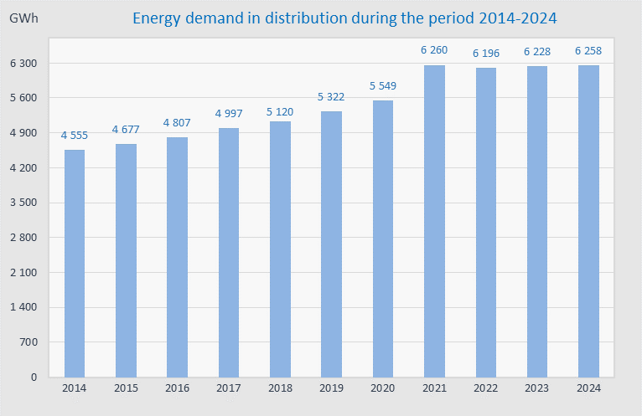
Fig. 6. 14 Electricity demand in the distribution system 2014-2024
Despite the investments made so far in the distribution network, electricity losses still remain high and represent a worrying problem for the electricity sector. The losses also have a negative impact on the supply of customers and the financial sustainability of supply and distribution operators, as well as the entire energy sector.
The cost of electricity losses up to the level set by the Regulator is covered by the customer tariff. The distribution system operator makes continuous efforts to reduce distribution losses, but despite the reduction of losses over the years, the DSO has not managed to meet the targets set by the Regulator, which means that the cost of the exceeded part of these targets is borne by the DSO itself.
Below is a graph with data on technical, commercial and total distribution losses from 2014 to 2024, showing the trend of decreasing loss limits but also fluctuations in the level of technical and commercial losses.
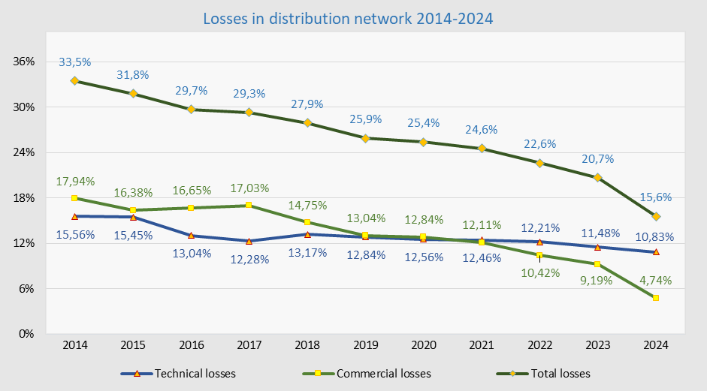
Fig. 6. 15 Technical and commercial losses in distribution for the period 2014-2024
Overall, electricity losses in the DSO, including losses (consumption) in the four northern municipalities of Kosovo, have decreased significantly from 20.67 % in 2023 to 15.6 % of the demand in distribution. This significant decrease is due to the fact that from 1 January 2024, the energy consumed in the four municipalities in the north of the country has started to be billed, and is not considered entirely as a loss, as it was until 2024 .

Electricity supply
The supply of electricity to final customers during 2024 continued to be carried out by KESCO, which is a supplier with a universal service obligation, that supplied customers with regulated prices, while customers with unregulated prices were supplied by KEK Supplier, Future Energy Trading and Exchange Dynamics LLC , KESCO, GSA ENERGJI LLC and EDS International LLC.
The share of household customers in the total billed consumption still remains dominant with around 58.40%, followed by commercial consumption with 24.57%, then industrial consumption with 12.41%, consumption in the four northern municipalities with 3.84% and finally public lighting consumption with 0.82%. Compared to the previous year, gross demand decreased by 0.7%, household consumption increased by 0.85 % , commercial consumption increased by around 7 %, and industrial consumption increased by around 4 %.
The figure below shows the percentage participation of consumption categories compared to total consumption (presented with and without losses).
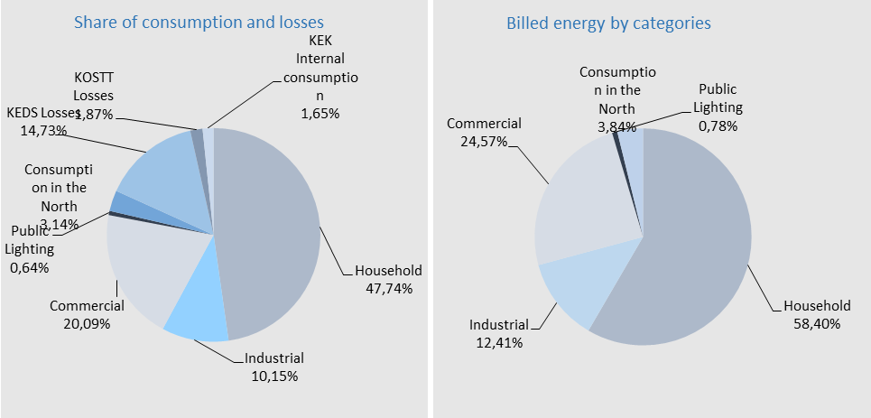
Fig. 6. 16 Share of consumption categories - with and without losses 2024

Billing and collection
The energy billed in the distribution system in 2024 was 5,284 GWh and represents about 84.44 % of the distribution system load, which compared to 2022 when it was 4,940 GWh is higher by 6.95 % .
The table below presents billing, energy collection and gross distribution collection as well as the ratio between billing and energy collection by month for 2024, where it can be seen that in some months this ratio is higher than the value of 100%, which means that in these months the electricity billed for the previous months was collected.
Tab. 6. 21 Billing and collection by months in distribution for 2024
Compared to last year, there is a 2% improvement in electricity collection.
It should be noted that load and realization also include energy flow and billing in the four northern municipalities of Kosovo.
The energy billed in the distribution network, excluding billing in the four northern municipalities, was 5,077.2 GWh or worth €411.9 million (€444.3 million with VAT), while the collection was €418.72 million with VAT, or 94.2%.
The energy billed in the distribution network in the four northern municipalities was 171.5 GWh or worth €12.7 million (€13.7 million with VAT), while the collection was €2.6 million with VAT, or 19%.
The electricity billed and collected (gross) in distribution as well as the ratio between billing and gross collection from 2014 to 2024 is presented in the figure below.
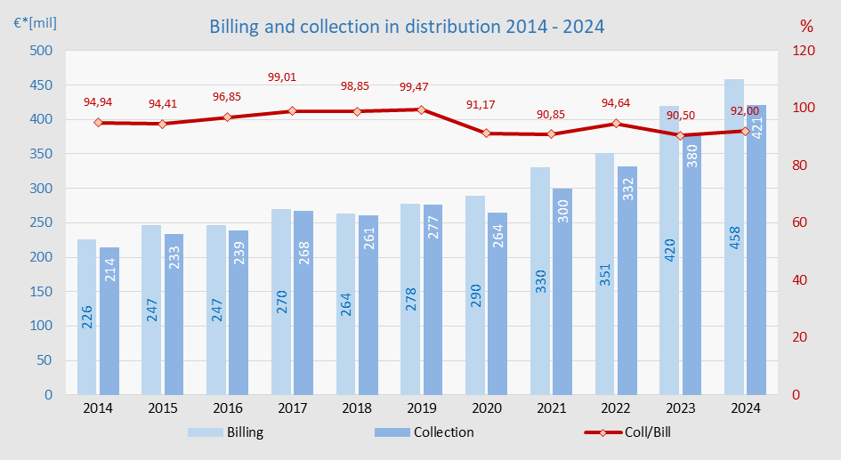
Fig. 6. 17. Billing and collection in distribution during 2014-20 24
The level of collection only for energy in distribution for 2024 was around 92.01%, while when customers connected to the transmission network are also counted, the total collection reaches 91.91% .
Consumption categorized by voltage level and customer groups using electricity for 2024 is given in the figure below.
Tab. 6. 22 Electricity billed by tariff categories 2024
The national energy demand in 2024 was 6,611 GWh, while the electricity billed in the transmission system was 120 GWh or in monetary value 14.54 million € and in the distribution system was 5,284 GWh or in monetary value 458 million €.
The following table presents billing, collection, and the ratio between collection and billing.
Tab. 6. 23 Invoicing and collection in 2024
Average price of electricity
The average selling price of electricity is based on the tariffs for regulated electricity activities and varies depending on the category of customers, the voltage level to which customers are connected and the use of electricity at different tariffs according to the season and time at which the energy is used. This average selling price (excluding VAT) is presented in the figure below. The average selling price also varies by district depending on the concentration of commercial/industrial activities that use electricity at certain periods.
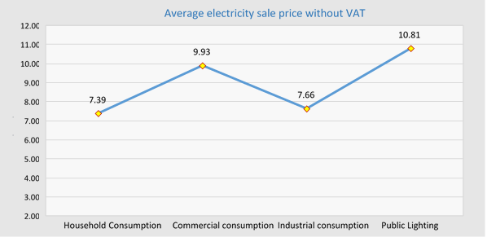
Fig. 6. 18 Average electricity sales price 2024 (excluding VAT)
For the household customer category, the average energy price is 7.39 €cent/kWh. It is 3.7% higher than in 2023 when it was 7.12 € cent/kWh, while for non-household customers the average energy price is 9.30 €cent/kWh which is slightly lower than the average price in 2023 when it was 9.36 €cent/kWh.
The figure below shows the average electricity prices for household and non-household customers for the last ten years, prices which do not include VAT.
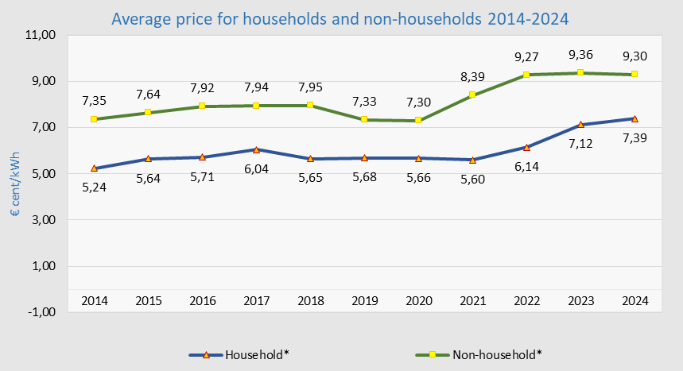
Fig. 6. 19 Average electricity sales price (excluding VAT) over the years
Compared to the countries of the region and based on data released by Eurostat for the first half of 2024, Kosovo has the average price excluding VAT lower than almost all countries for household customers. Eurostat data categorized by household consumption 2500-5000 kWh/year, for the first half of 2024 for some countries, since data for the second half is still missing, are presented in the figure below.

* Data source from EUROSTAT
Fig. 6. 20 Average prices for household customers for the first 6 months of 2024 (excluding VAT)
Also compared to EU and regional countries based on data released by Eurostat for the first half of 2024, Kosovo has the lowest average prices for non-household customers.
Eurostat data categorized by EU countries and countries in the region for the first half of 2024 are presented in the figure below.

Fig. 6. 21 Average prices for non-household customers for the first 6 months of 2024 (excluding VAT)
*The prices presented in the figures above have deducted the subsidy paid by the Government.

Import and export of electricity
In general, the majority of the total demand for electricity in the Kosovo power system is covered by domestic generation dominated by thermal power plants, while the remaining part is provided by imports carried out through cross-border lines.
The share of imports in total energy demand was 20.9%, marking an increase of about 2.3 percentage points compared to the previous year, which was about 18.65%.
Through the interconnection lines from the regional system to the Kosovo electricity system, 3,159.8 GWh have entered, while 2,662.2 GWh have exited, where -537.67 GWh represents the difference between entry and exit, which is divided into net import and deviations to the regional system.
The table below presents the electricity flows in the interconnection lines with neighboring countries.
Tab. 6. 24 Electricity flows in interconnection lines for 2024
The import realized for the year 2024 was 1,384,511 MWh, which filled energy shortages, especially during the peak winter season when demand was unaffordable for domestic production.
This amount includes imported electricity for regulated and unregulated customers, for losses in the transmission network and losses in the distribution network, which is provided through commercial contracts, through ALPEX as well as through the energy-for-energy exchange between KEK and KESH.
The import of electricity for 2024, including the exchange with KESH, was 1,384,511 MWh and is 136,108 MWh higher than in 2023, or 10.9% , which was 1,248,403 MWh. While the import under contracts was 1,373,264 MWh or 309,826 MWh higher than in 2023, when it was 1,063,438 MWh.
The average price of electricity imports under commercial contracts during 2024 was €122.76/MWh, and compared to last year, which was € 129 /MWh, this year the average import price is lower by € 6.24 / MWh.
Data on imports and exports of electricity are presented in the following table.​
Tab. 6. 25 Import and export of electricity for 2024
The data represent energy values recorded at interconnections and netted as sent by KOSTT. There are differences between the data reported by KEK and the data from KOSTT, because the KEK data also includes transit, therefore the data in MWh from KOSTT are taken as relevant.
The average price of electricity exports under commercial contracts during 2024 was €86.48/MWh. In addition to exports under contracts, a certain amount of electricity was also exported as an exchange (energy for energy) between KEK and KESH, the total electricity export for 2024 was 747,858, of which 683,521 MWh was export under contracts.
As can be seen from the data presented above, in 2024 Kosovo was a net importer of electricity, amounting to 636,653 MWh, presented by months in the figure below .
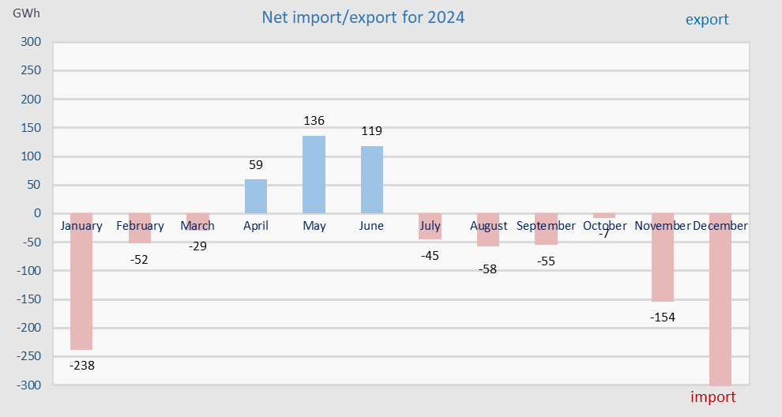
Fig. 6. 22 Import and export of electricity in 2024
Electricity surpluses occur mainly at night (during low tariff times), when surpluses also occur in regional systems, which causes export prices to be significantly lower than import prices.
The price of electricity imports and exports has increased and decreased over the years, and the figure below shows import and export prices from 2014 to 2024.
Fig. 6. 23 Average import and export price over the years
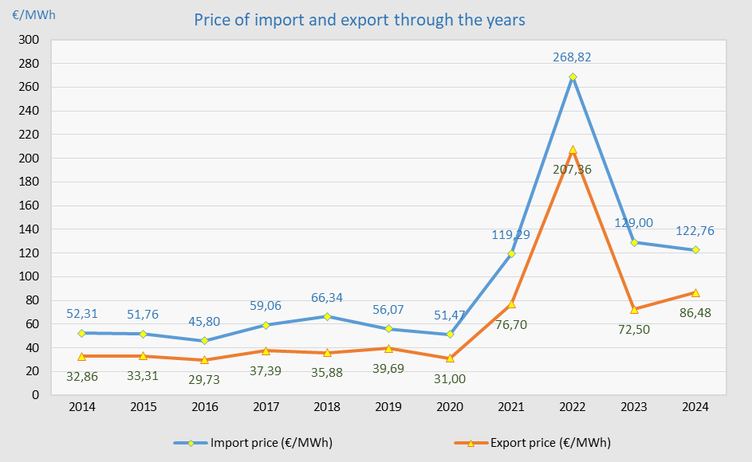

Electricity supply and service quality standards
The standards for the quality of electricity supply and service are regulated in the Rule on Electricity Service Quality Standards, which the ERO Board approved on 05.06.2019. The purpose of this rule is to determine the indicators of the quality of electricity service for customers, regarding the services provided, the uninterrupted supply of electricity and the quality of voltage.
The electricity supply services that are included in the rule are:
- quality of service;
- uninterrupted supply; and
- voltage quality.
The Rule on Electricity Service Quality Standards presents individual and general indicators of electricity service quality, indicators of uninterrupted supply, as well as voltage quality indicators.
It should be noted that the standards for the quality of electricity supply and service are an important element of the regulation of the energy sector. These standards are set so that the quality of electricity supply and service, as well as the quality of voltage to customers, is continuously improved by the energy enterprise.
During this reporting year, the quality standards of electricity supply and service were monitored according to the following areas:
- Continuity of supply;
- Voltage quality; and
- Commercial quality.

Continuity of supply
Continuity of supply is related to the availability of the energy system, namely it represents the number and duration of outages for each customer within a year.
Power outages are recorded by the Transmission System Operator (TSO) and the Distribution System Operator (DSO). Based on the Rule on Electricity Service Quality Standards, power outages are classified as short and long interruption. Any power outage lasting up to 3 minutes is classified as a short interruption, and any outage longer than 3 minutes is classified as a long interruption. It is worth noting that according to the rule in question and international standards, only long interruptions are recorded and reported by the system operators. Long interruptions are classified as planned and unplanned.
Continuity of supply is measured by indices:
- SAIDI - System Average Interruption Duration Index;
- SAIFI - System Average Interruption Frequency Index;
- ENS - Energy Not Supplied; and
- AIT - Average Interruption Time.
During 2024, the continuity of electricity supply was monitored by the Regulator for both system operators: the Transmission System Operator (TSO) and the Distribution System Operator (DSO).

Measurement indices reported by the TSO
According to the Rule on Electricity Service Quality Standards, the general supply indicators that the Transmission System Operator must record and report are:
- Average Interruption Time ( AIT);
- Energy Not Supplied (ENS).
The average interruption time (AIT) in the transmission network represents the cumulative duration of power supply interruptions per customer.
Energy not supplied (ENS) is the energy that would have been supplied by the system if there had been no interruption in the power supply.
The general measurement indices reported by the TSO for electricity supply and service quality standards for 2024 are presented below.
- AIT - for planned outages was 18 minutes or 0.30 hours;
- AIT - for unplanned outages was 54 minutes or 0.90 hours;
- ENS - for planned interruptions in the transmission system was 0.53 GWh; and
- ENS - for unplanned interruptions in the transmission system was 0.94 GWh.
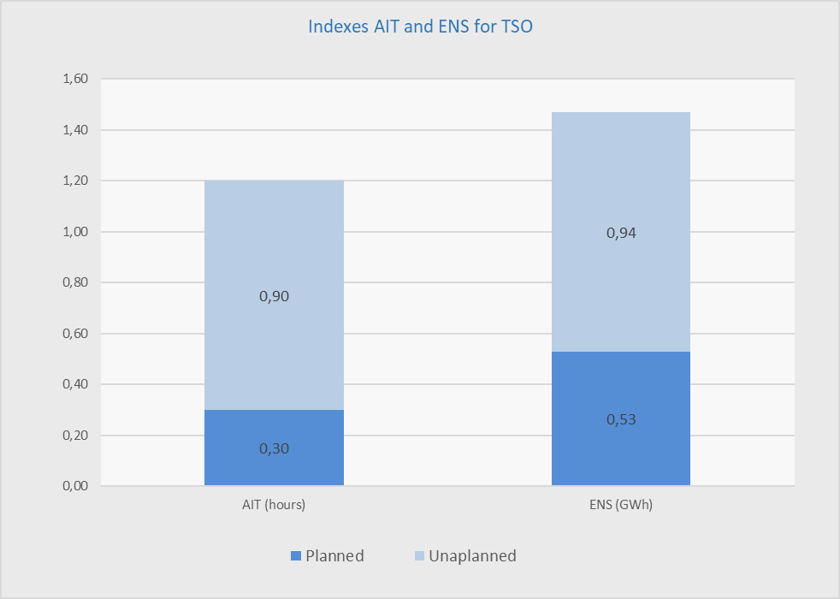
Fig . 6. 24 AIT and ENS measurement indicators for KOSTT for 2024
The figures below show the measurement indices reported by the TSO for the quality standards of electricity supply and service during the years 2021 - 2024 for the AIT index, while for the ENS index they are presented for the period 2015 - 2024 .
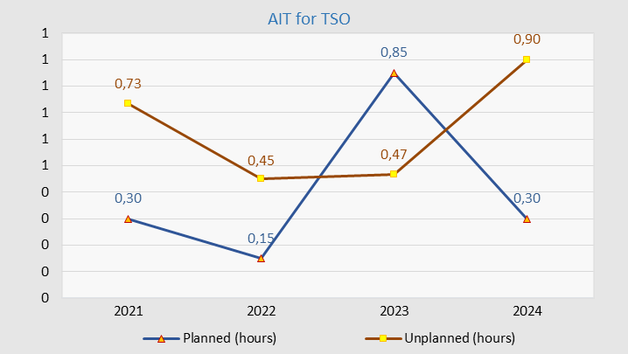
Fig . 6. 25 AIT measurement index for TSO for the period 2021 – 2024
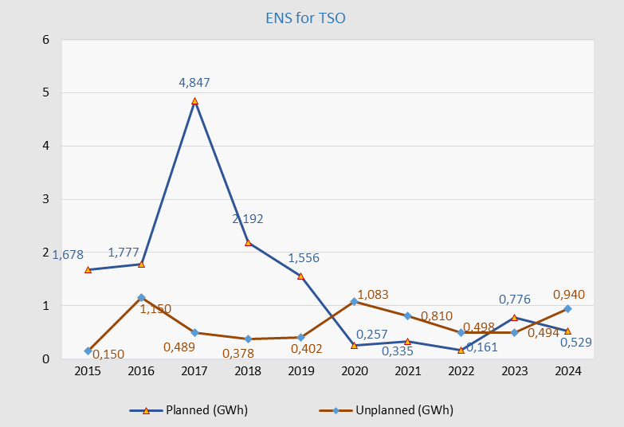
Fig . 6. 26 ENS measurement index for TSO for the period 2015 - 2024
From the above data, it is noticed that the reported AIT and ENS measurement indices in 2024 generally showed no significant change or improvement compared to 2023.
According to the data reported for the AIT measurement index during 2024, it is noticed that in total there is a decrease or improvement in this index of 8.86% compared to 2023, respectively, there is a decrease in planned outages of 64.71% and an increase in unplanned outages of 92.86%.
During 2024, the energy not supplied (ENS) generally has no improvement compared to 2023, and according to the reported data, it is noticed that during 2024, there is a total increase in unsupplied energy of 15.7% compared to 2023, respectively, there is a decrease in planned outages of 31.83%, while there is an increase in unplanned outages of 90.28% .

Measurement indices reported by the OSSH
The measurement indices reported by the DSO on the quality standards of electricity supply and service for 2024 are presented below.
- SAIDI - for planned interruption in the distribution system was 33.01 hours;
- SAIDI - for unplanned interruptions in the distribution system was 39.50 hours;
- SAIFI - for planned interruptions in the distribution system was 7.90;
- SAIFI - for unplanned interruptions in the distribution system was 42.32;
- ENS - for planned interruptions in the distribution system was 21.84 GWh; and
- ENS - for planned interruptions in the distribution system was 32.49 GWh.
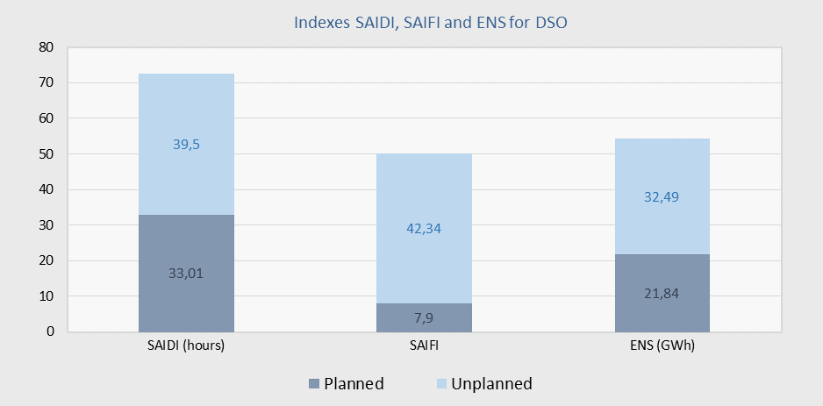
Fig. 6. 27 SAIDI , SAIFI and ENS measurement indices for DSO for the year 2024
The following figures show the measurement indices reported by the DSO for the quality of electricity supply and service standards during the years 2011 - 2024 for the SAIDI and SAIFI indices, while for the ENS index they are presented for the period 2015 - 2024.
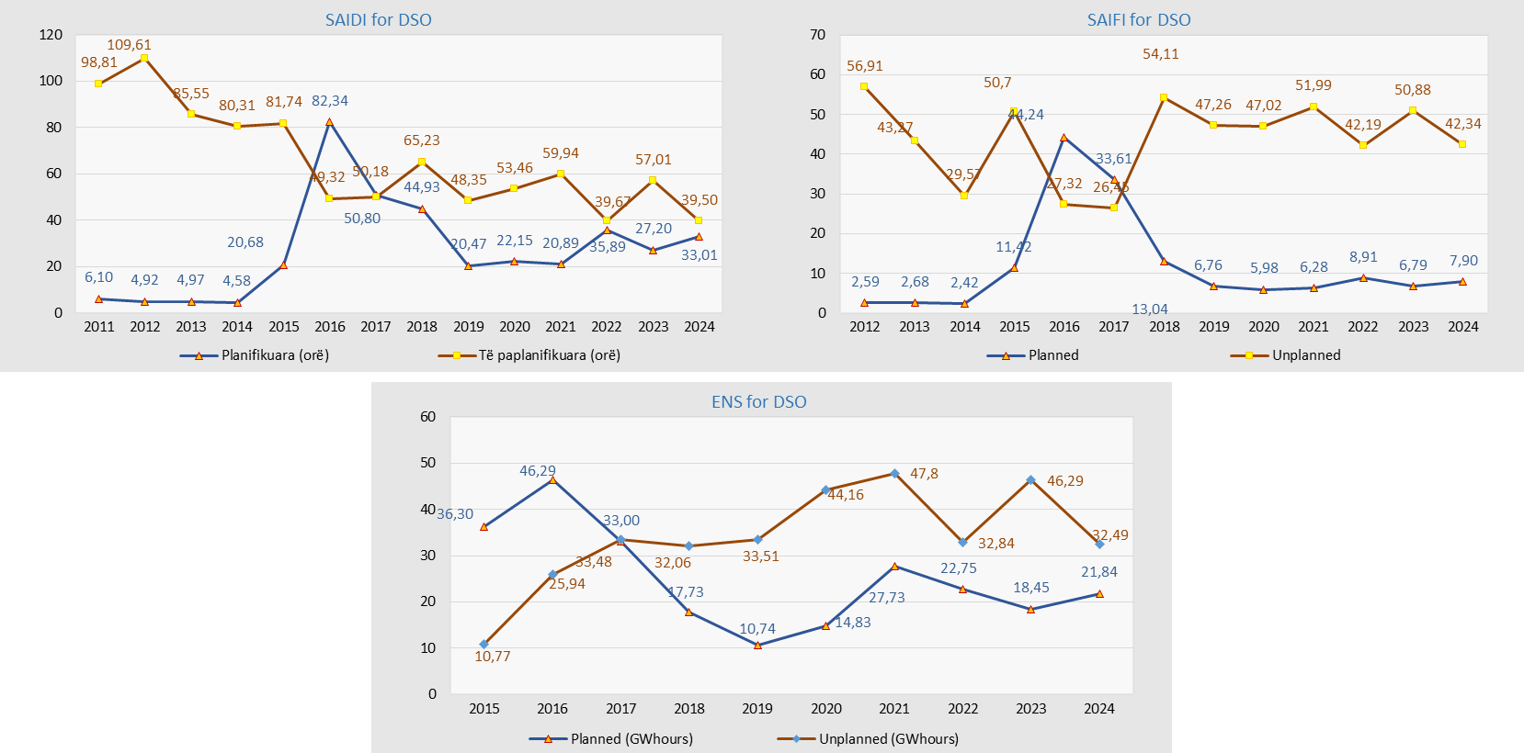

Fig. 6. 28 SAIDI , SAIFI and ENS indicators for DSO for the period 2011-2024 and 2015 - 2024
From the data above, it is noticed that in some of the SAIDI, SAIFI and ENS measurement indices in 2024 there was generally an improvement compared to 2023.
According to the data reported for the SAIDI measurement index during 2024, it is noticed that there has been an improvement in this index compared to 2023, which means that in 2024 there is a total decrease in outages of 13.89% compared to 2023. During more detailed analyses of the SAIDI index, it is noticed that in 2024 there is an increase in planned outages of 21.36% compared to 2023, as well as a decrease in unplanned outages of 30.71% compared to 2023.
From the analysis of the SAIFI index, it is noticed that during 2024 there is an improvement in this index compared to 2023, which means that in 2024 there is a total decrease in outages of 12.88% compared to 2023. It is worth emphasizing that during the more detailed analysis of the SAIFI index, it is noted that in 2024 there is an increase in the frequency of planned outages per customer (SAIFI) of 14.05% compared to 2023, as well as a decrease in the frequency of unplanned outages per customer of 20.17% compared to 2023.
During 2024, the energy not supplied (ENS) generally improved compared to 2023, and according to the data, it is observed that in 2024 there was a decrease of 16.08% compared to 2023. During more detailed analyses of the ENS index, it is observed that in 2024 there was an increase in energy not supplied due to planned outages of 18.37% compared to 2023, as well as a decrease in energy not supplied due to unplanned outages of 29.81%, compared to 2023.

Voltage quality
Voltage quality is related to the technical aspect of the electricity system and is compared to the nominal voltage, which during this period was mainly monitored through the registration of customer complaints regarding voltage quality.
During 2024, the number of complaints submitted by customers to the DSO regarding voltage quality was 398 complaints, of which 171 complaints or 42.96% were resolved, while 227 complaints or 57.04% are in the review process.
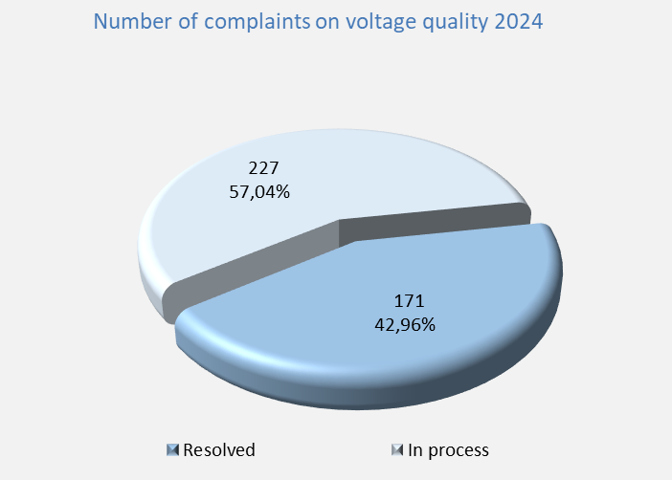
Fig. 6. 29 Customer complaints about voltage quality in 2024
Below is a figure with the status data of resolved customer complaints regarding voltage quality in the DSO for 2024.
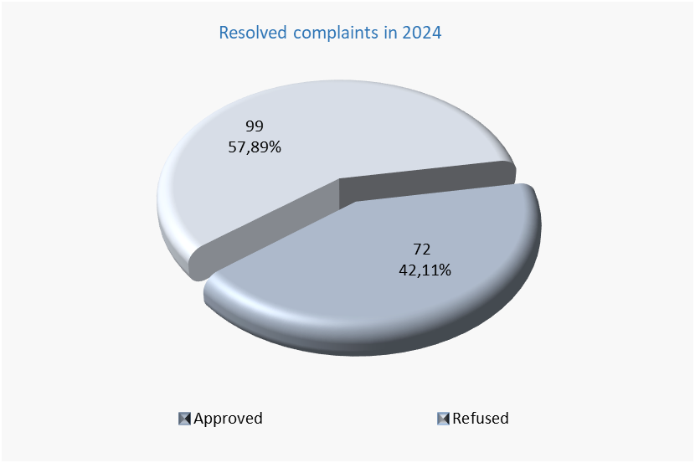
Fig. 6. 30 Status of resolved customer complaints for 2024
From the figure above, it can be observed that out of 171 resolved customer complaints regarding voltage quality, the DSO approved 72 complaints in favor of the customers, representing 42.11%, while it rejected 99 complaints, or 57.89%, as they did not indicate any actual problems.
The figure below shows customer complaints about voltage quality by year, showing that in 2017 there was an increase in customer complaints about voltage quality compared to previous years, while from 2019 it is noticed that there is a decrease in customer complaints about voltage quality, while in 2024 compared to 2023 there is another increase in complaints about voltage quality.
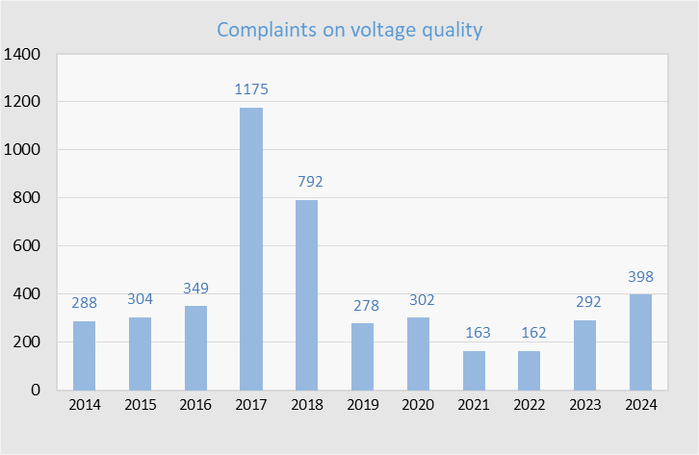
Fig. 6. 31 Complaints about voltage quality by year
Voltage quality standards are defined in the Rule on General Conditions of Energy Supply, the Distribution Code and the Distribution Metering Code.

Commercial quality
Commercial quality determines the efficiency and accuracy of resolving customer complaints and requests. Commercial quality regulation takes into account the mutual relationship between customers and suppliers.
For the purpose of analyzing commercial quality, the data received from the licensee is presented in two categories that directly affect customer issues. These categories are:
- New connections
- Energy consents; and
- Customer complaints.

New connections
Commercial quality standards, among other things, also include new connections, which evidence how quickly the energy company takes measures to implement new connections.
During 2024, a total of 30,616 regular requests for new connections were registered for tariff groups 4, 5, 6, 7 and 8, while 25,645 or 83.76% of requests for new connections were approved, including requests carried over from the previous year, while the remaining part is in the process of registration. It should be noted that requests for new connections carried over from the previous year were 5,563.
From KESCO's data, it can be seen that of the total number of requests for new connections, the most requests were from household customers (tariff groups 5 and 6) 27,028 or 88.28%, followed by requests for new connections in the commercial tariff group 0.4 kV Category II - tariff group 4 which were 3,383 or 11.05%, while there were 205 or 0.67% requests for tariff group 8 - public lighting.
Of the total number of registrations of applicants as customers in the "CCP" billing program, household customers are 23,267 or 86.48%, followed by tariff group 4 (0.4 kV Category II - commercial) with 3,399 registrations or 12.63%, as well as tariff group 8 (public lighting) with 237 registrations or 0.88% .
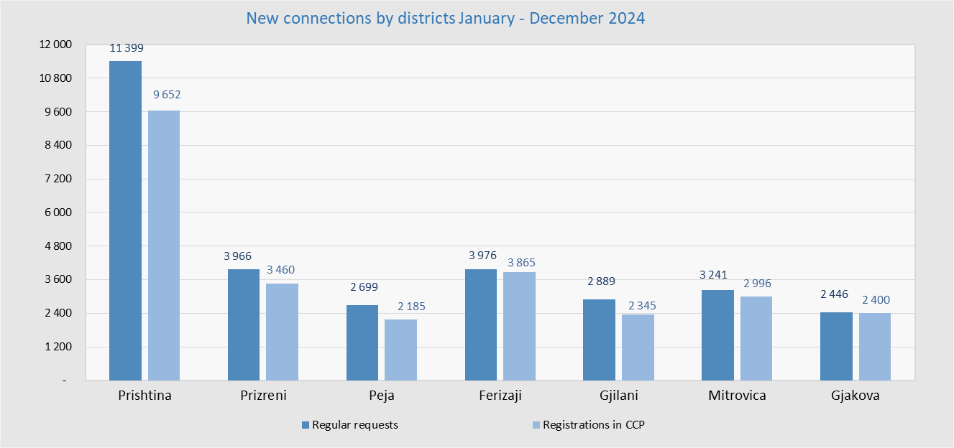
Fig. 6. 32 New connections by district for the year 2024
From the diagram above, it can be seen that for the year 2024, out of the total number of requests for new connections, the most requests were in the Prishtina district, respectively 11,399 or 37.23%, followed by the Ferizaj district with 3,976 or 12.99%, while the lowest number of requests for new connections were registered in the Gjakova district with 2,446 or 7.99%. It should also be noted that in terms of registrations of requests in the billing program, out of the total number, the most registrations were in the Prishtina district, respectively 9,652 or 35.88%, followed by Ferizaj district with 3,865 or 14.37%, while the least registrations were recorded in Gjilan district with 2,185 or 8.12%.
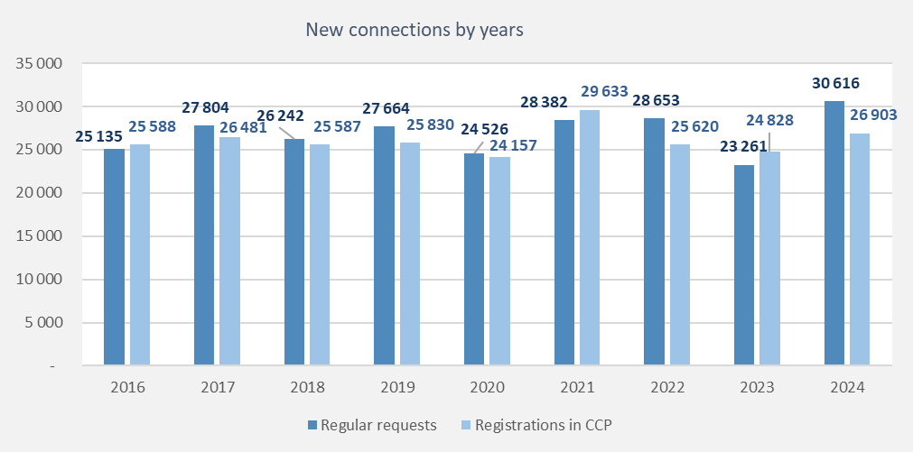
Fig. 6. 33 New connections by year
From the diagram above, it can be seen that during 2024 there were 31.62% more requests for new connections than in 2023, and 8.36% more customer registrations than in 2023.

Electro-energetic Consents
From the data presented, it can be seen that during 2024, 2,819 requests for Electro-energetic Consents were submitted to KEDS, while 49 consents were carried over from 2023.
Tab. 6. 26 Electro-energetic Consents for the year 2024
From the table above, it can be seen that of the total number of requests for Electro-energetic Consents for 2024, the highest number of requests was registered in the Pristina district, respectively 735 or expressed as a percentage 26.07%, followed by Ferizaj district with 586 or 20.79%, while the lowest number of requests was in the Mitrovica district, with 230 or 8.16%.
Tab. 6. 27 Electo-energetic Consents by District for the Year 20 24
From the table above, it can be seen that out of 2,819 requests from applicants for Electro-energetic Consent for 2024 and 49 carried over from 2023, 2,108 requests were reviewed and Electro-energetic Consent was issued, 522 requests were reviewed and the parties were provided with information regarding their request for Electro-energetic Consent, 125 requests were reviewed and the parties were given a response, while according to KEDS data, 81 other requests were also reviewed, but according to the Electro-energetic Consents Department within KEDS, it was determined that these requests should not be issued the Electro-energetic Consent, but that these requests have been delegated to other departments and the remaining 32 requests are in the process of review and the same will be reviewed during 2025.
Below is a diagram of requests for Electro-energetic Consents for the period 2014 - 2024, and from the diagram it is clearly seen that for each year there has been an increase in requests for Electro-energetic Consents from applicants for connection, but in 2024 compared to 2023 we have an increase of 559 applications or expressed as a percentage of 24.73% .
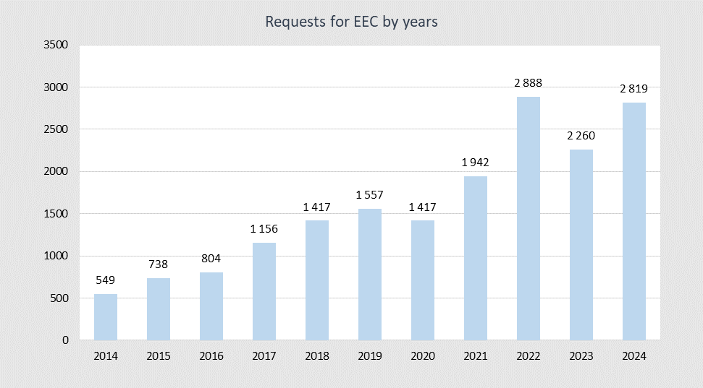
Fig. 6. 34 Requests for Electro-energetic Consents for the period 2014 – 2024

Customer complaints to the supplier - KESCO
According to KESCO's reported data during 2024, the total number of customer complaints registered in the KESCO's Customer Department was 11,596, while 4,886 complaints were carried over from the previous year, while 11,007 were resolved/completed.
Below is a chart of registered and resolved customer complaints for 2024 by district.
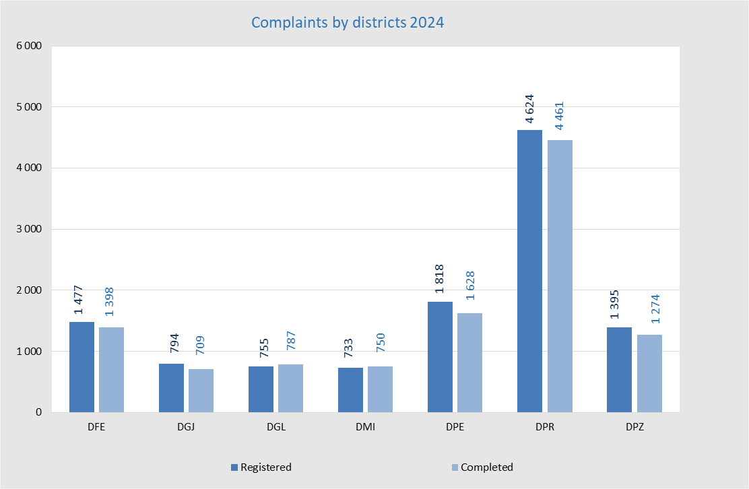
Fig. 6. 35 Complaints and the number of customers by districts, 2024
From the figure above, it can be seen that the highest percentage of customer complaints registered with KESCO during 2024 is in Prishtina district, respectively 39.88%, followed by Peja district with 15.68%, while the lowest percentage is in Mitrovica district with 6.32%. It should be noted that the highest number of complaints in Prishtina district is mainly because this district also has the largest number of customers in Kosovo. Also from the figure above it can be seen that the highest percentage of customer complaints resolved by the Customer Department in KESCO compared to the total number of complaints resolved at the national level is in Prishtina district, respectively 40.53%, followed by Peja district with 14.79%, while the lowest is in Gjakova district with 6.44%.
Below is a report of customer complaints submitted at KESCO with the number of active customers and billing for this period by months.
Tab. 6. 28 Report of complaints and number of customers by month for the year 20 24
From the table above, it is noted that the number of complaints registered during 2024 is 11,596, which compared to the total number of active customers represents 1.59% of the total number of customers who have submitted complaints, or 0.14% of the total number of annual invoices issued by the Universal Service Supplier.
The figure below shows the number of complaints registered and completed by nature of the complaints for 2024.
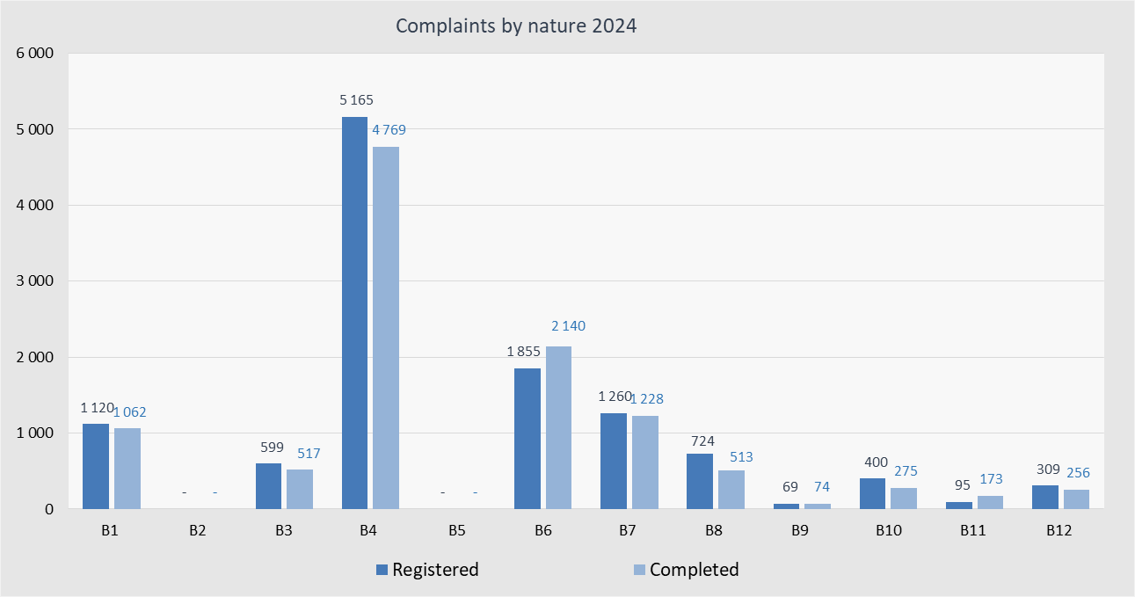
Fig. 6. 36 Customer complaints by nature for the year 20 24
Below are descriptions of the nature of customer complaints submitted to the Supplier - KESCO:
B1 - Unregistered payment - this type of complaint is if the customer notices that the payment made by him/her has not been registered in his/her account (his/her number), then the customer must appear at KESCO and file a complaint for an unregistered payment, attaching his/her payment receipt and other evidence.
B2 - Initial balance error - This type of complaint is when the customer has noticed that an error was made during the transfer of the initial data, and as such requests that the initial balance be corrected.
B3 - Non-receipt of invoices - This nature of complaints is related to the fact that electricity bills do not arrive regularly or do not arrive at all, and on this basis the customer should file a complaint with KESCO so that this does not happen in the future.
B4 – Overlimit - This nature of complaints relates to the customer's complaint that they have been billed over the limit due to reading or billing errors.
B5 - Change of lump sum - This nature of complaints is related to cases where the customer was once billed flat rate/without metering, and now has an electric meter installed, and the customer wants to be billed according to the measurement recorded on the meter.
B6 - Incorrect reading - This type of complaint is related to the fact that the customer's electricity consumption (kWh) read does not match the electricity consumption billed, then the customer must file a complaint of this nature.
B7 - Irregular reading - This nature of the complaints is related to the fact that the electric meter that records the energy consumed is not being read regularly, month after month, and consequently there is accumulation of electricity consumption on only one bill.
B8 - Inaccurate meter - This nature of complaints is related to the fact that if the customer suspects that the meter is measuring incorrectly, then he or she should report to KESCO and file a complaint for inaccurate measurement of the metering point.
B9 - Request for debt settlement - This type of complaint relates to cases where a customer has privatized a company, and in the transactions of the privatized company there is a debt that belongs to the former (old) company. In such cases, the debt must be settled and the name changed. Therefore, the customer must provide all documentation related to the privatization process and the company’s information, in order for the complaint to be processed.
According to a court decision, KESCO J.S.C. is obligated to settle a debt related to the customer’s transactions, and the customer must appear at KESCO with all the relevant documentation.
In cases where the customer owns a property that was occupied by different individuals and there is an outstanding debt accumulated by those individuals, the customer must report to KESCO and present documents issued by the Kosovo Property Agency, which prove that the property was occupied. Based on the provided documentation, the customer requests the settlement (write-off) of the disputed debt. Naturally, any undisputed debt must be paid.
B10 - Disconnection without notice - This nature of complaints has to do with whether the customer believes that they have been disconnected from the electricity network without notice.
B11 - Other – this nature of complaints is related to the fact that if none of the above points suit the customer, then the customer must write down his complaint in words.
B12 – Unauthorized use of electricity (recovery of losses) – This nature of customer complaints concerns complaints related to unauthorized use of electricity, such as uncontracted use of electricity and theft of electricity.
From the data reported by KESCO for 2024, it is noticed that of the total number of customer complaints, the most complaints were related to bills over the limit due to reading or billing errors of 5,165 or expressed as a percentage of 43.33%, complaints related to incorrect readings of 1,855 or expressed as a percentage of 19.44%, followed by complaints related to non-regular readings of monthly expenses of 1,260 or expressed as a percentage of 11.16%, while the least complaints were related to requests for debt resettlement with only 69 complaints or 0.67%.
Based on the data reported by KESCO on customer complaints, it is noticed that there is an increase in the number of complaints in 2024, and this increase is generally related to over-limit bills due to reading or billing errors as well as errors in reading at the metering point (incorrect reading and irregular reading) and due to irregular readings of monthly expenses. In general, it should be noted that the number of customer complaints regarding errors in reading the metering point is decreasing and this is owing to the new way of reading the metering point using a hand-held device (Hand Held Unit), which has significantly improved the reading of the metering points and has reduced the possibility of errors during the reading of the metering point, since reading and billing are done at the same time and due to remote readings for customers who have smart meters installed.
Below is a figure with the data on complaints resolved by KESCO for 2024, or more precisely the status of resolved complaints.
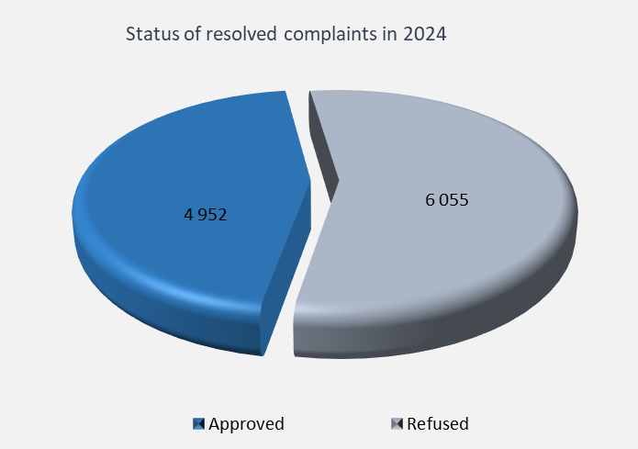
Fig. 6. 37 Status of resolved customer complaints for the year 2024
From the figure above, it is noticed that out of 11,007 resolved customer complaints, KESCO approved 4,952 complaints in favor of the customers or 44.99%, while it rejected 6,055, or expressed as a percentage 55.01%.
Below is a diagram showing the ratio of complaints submitted and resolved to the supplier KESCO for the years 2014-2024.
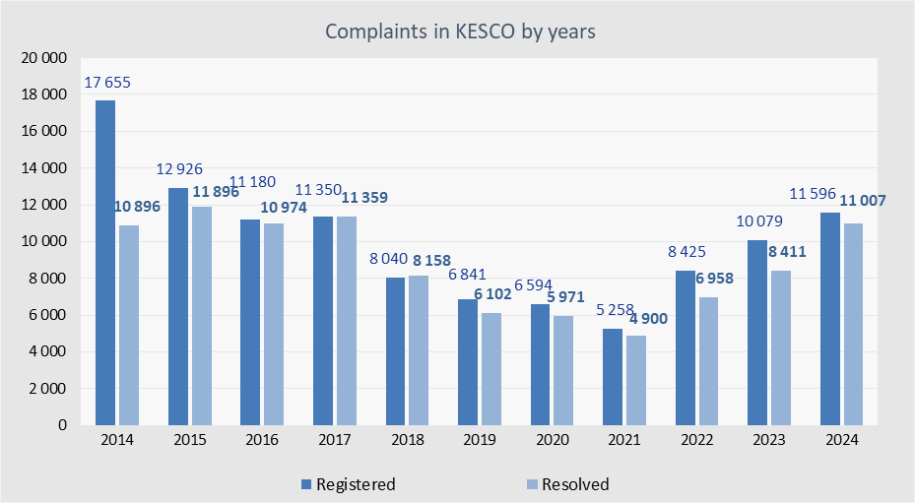
Fig. 6. 38 Customer complaints in KESCO by years

Reporting of the Electricity Supplier "Elektrosever Company" LLC
The electricity supplier " Elektrosever Company" LLC, as a licensed supplier for the supply of electricity in the four municipalities in the northern part of Kosovo, began operations in February 2024 and reported for the first time on the number of registered and billed customers as well as the number of complaints received and resolved for this period of time.
According to the data submitted for the period February-December 2024, it is confirmed that this supplier has 24,312 active customers who are billed on a regular monthly basis, some of whom have regular monthly readings while the rest are estimated customers. Also, according to the data submitted, it is confirmed that 397 customers are temporarily deactivated and 51 with permanent deactivation.
Of the total number of customers reported, 21,530 are household customers, including billing for shared expenses, and 2,782 are non-household customers, including public lighting. Of this number of customers, only 6,286 have signed an electricity supply contract.
The graph below shows the number of customers and invoices issued by this supplier for the period February-December 2024 for the four municipalities.

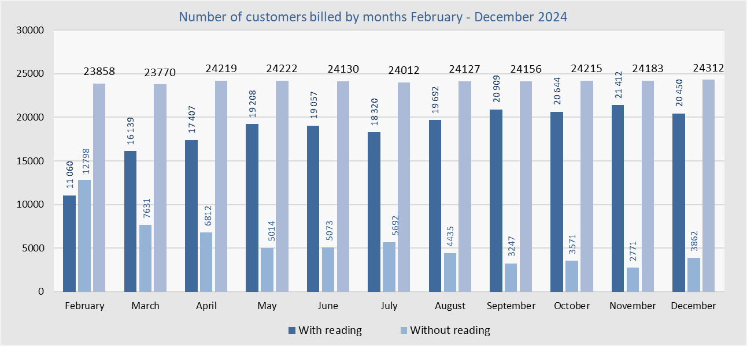
Fig. 6. 39 Number of customers billed during 2024

1.3.1 Customer complaints to the supplier – “Elektrosever Company” LLC
According to the data reported on complaints received from customers of " Elektrosever Company" LLC for 2024, it is noted that the total number of customer complaints registered in the Customer Department is 8,522, and that 8,522 have been resolved or completed.
Below is a chart of customer complaints registered and resolved by nature of complaint for 2024.
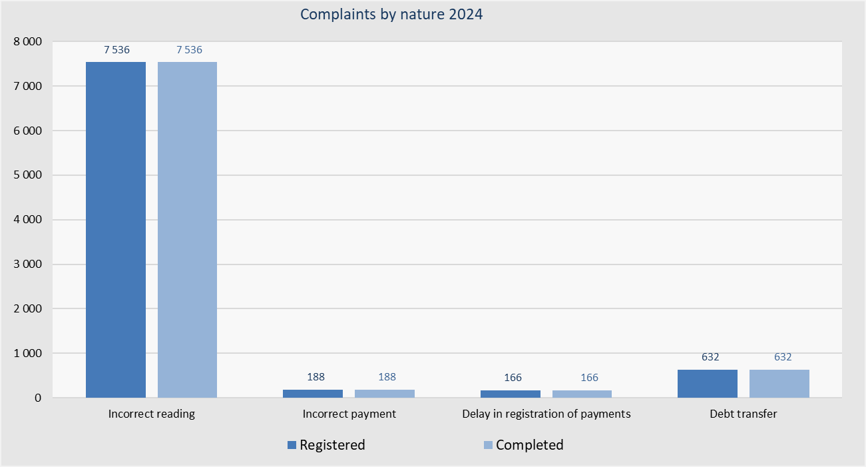
Fig. 6. 40​ Customer complaints by nature for 2024
From the reported data, it is noted that from the total number of customer complaints, the most complaints were related to invoices due to inaccurate readings or billing of 7,536 or expressed as a percentage of 88.43%, complaints related to the transfer of debts of 632 or expressed as a percentage of 7.42% (Referring to the process of transferring debt for electricity from a customer to the current user of electricity, i.e., to the customer who is the true beneficiary of the service), complaints related to incorrect payments, or incorrect registration of payments of 188 or expressed as a percentage of 2.21%, as well as complaints related to delays in the registration of payments of 166 or expressed as a percentage of 1.95%. According to the reported data, it is confirmed that all complaints submitted by customers have been reviewed and resolved.
Below is a figure with data on complaints filed by customers and resolved by the supplier Elektrosever for 2024, or more precisely, the status of resolved complaints.
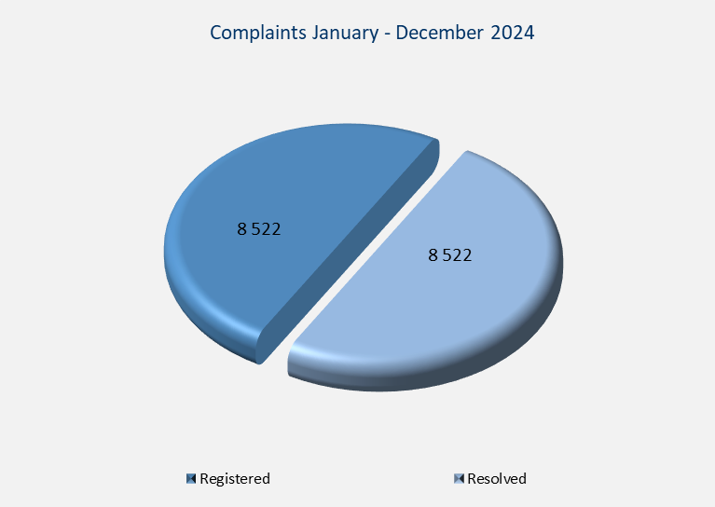
Fig. 6. 41​ Status of resolved customer complaints for 2024

Data reported by DH Termokos
According to the data reported by the District Heating Company PE Termokos J.S.C., it is noted that throughout 2024, customers submitted various complaints and requests regarding the services provided by the company. These include: verification of heating quality, verification of heating area, requests for name changes on accounts, requests for various technical interventions, complaints regarding billing without metering, applications for new connections, as well as disconnections and reconnections to the distribution system.
Below is a diagram with the ratio of complaints/requests submitted by customers and resolved by the Termokos District Heating company during 2024.
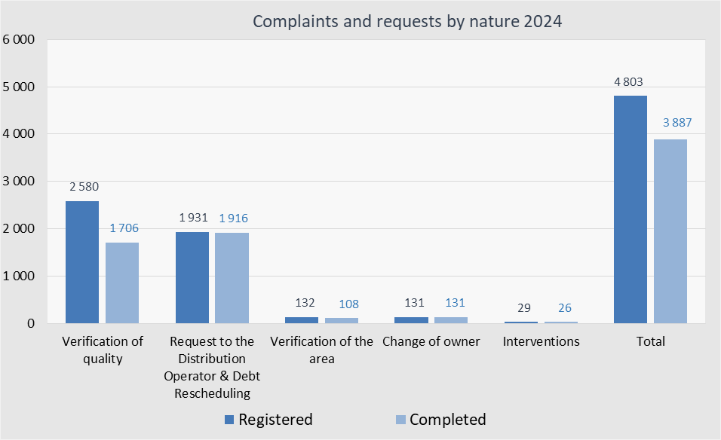
Fig. 6. 42​ Customer complaints and requests by nature for 2024
As can be seen, during 2024, DH Termokos received a total of 4,803 customer requests and complaints. Of these, 3,887 have been reviewed, and customers have received responses to their complaints or requests. It should be emphasized that 916 requests and complaints remain not reviewed; however, these will be addressed by the company, and customers will receive appropriate responses. It is also worth noting that a significant number of requests were directed to the Distribution System Operator, particularly regarding new connections, disconnections, and reconnections to the system. A total of 1,916 responses have been issued for these requests, which also include requests related to debt rescheduling.
Furthermore, during this reporting year, DH Termokos reported that it had concluded 2,952 contracts for heat supply with domestic customers (households), while 302 contracts for heat supply were concluded with non-household customers (businesses) .

Data reported by DH Gjakova
According to data reported by DH Gjakova, a total of 7 new connections for domestic (household) and non-household (business) customers were provided. Furthermore, there are 50 thermal energy supply contracts concluded between the enterprise and customers for this reporting year. DH Gjakova has also applied 159 disconnections and reconnections of customers. Furthermore, the total number of complaints received by is 95 complaints, which are related to disputing thermal energy bills, verifying the quality of heating, verifying the heating area, high energy prices and billing methods, as well as requests for technical clarifications regarding metering and billing.
Below is a diagram with the ratio of complaints/requests submitted by customers and resolved by Gjakova District Heating company during 2024.
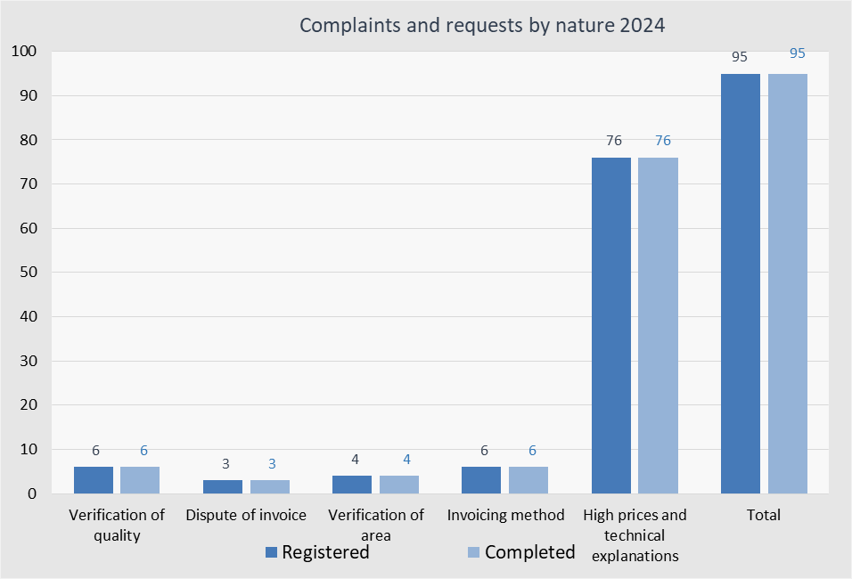
Fig. 6. 43​ Customer complaints and requests by nature for 2024

Of the complaints received, a total of thirty-five responses were issued, including a joint response to a collective complaint from sixty residents.

THERMAL ENERGY SECTOR
The thermal energy sector in Kosovo consists of four systems: DH Termokos – Prishtina, DH Gjakova – Gjakovë, DH Termomit – Mitrovica, and in Zveçan. This sector has a very limited scope at the local level, meeting approximately 3 - 5% of the total heating demand in Kosovo.

Technical characteristics of thermal energy systems
The thermal energy sector in Kosovo consists of 4 thermal energy systems (district heating) with an installed production capacity estimated to be around 289 MWTH. The Termomit, Mitrovica and Zveçan district heating plants, due to known circumstances, do not fulfill the requirements for licensing/regulation and monitoring by ERO, therefore making it impossible to provide relevant updated data; for this reason, detailed data for the Termokos and Gjakova district heating plants are presented below.

Thermal energy production plants
The thermal energy production plants of the DH Termokos consist of the main heating plant with a total installed capacity of 120 MW _{TH} , and the auxiliary heating plant at the University Clinical Center with a capacity of 14 MW _{TH} . With the connection of the thermal energy extraction station in units B1 and B2 of the Kosovo B Thermal Power Plant, this capacity has been increased by the installed cogeneration capacity of 140 MW _{TH} . It should be noted that the heavy fuel oil boilers in the DH Termokos heating plant have not been decommissioned, but they serve as reserve capacity to be activated in cases of any eventual breakdown in the Kosovo B Thermal Power Plant units.
The new biomass heating plant in Gjakova is equipped with two units for the production of thermal energy only with an installed capacity of 2 x 5.5 MW _{TH} , respectively 11 MW _{TH} , and a co-generation unit with a thermal energy production capacity of 4 MW _{TH} and an electrical energy production capacity of 1.12MW _{EL} . Therefore, the new biomass heating plant has a total installed thermal energy production capacity of 15 MW _{TH} .

Thermal Energy Distribution Systems
Thermal energy distribution systems in Kosovo consist of the primary distribution network that extends to the supply point at substations, and the secondary network that extends from the supply point at substations to end users.
The primary distribution network of the DH Termokos has a route length of 58.5 km, respectively a pipeline length of about 117 km. An integral part of the distribution network is also the pumping station and heat exchangers located in the Sunny Hill and 900 active substations which are dividing points between the primary and secondary network. In addition to the existing distribution network, there is also the thermal energy transportation network TPP Kosova B – DH Termokos, with a length of about 10.5 km.

The primary distribution network of DH Gjakova extends over a length of about 23.5 km of route, respectively a pipeline of 47 km. An integral part of this network are also about 257 active substations which are dividing points between the primary and secondary network.
A summary of the technical characteristics of the district heating systems of DH Termokos and DH Gjakova is presented in the table below.
Tab. 7. 1 Technical data of district heating systems
* The cogeneration unit of DH Gjakova has a thermal capacity of 4MW _{TH} and an electrical capacity of 1.12 MW _{EL.}

Key developments in the thermal energy sector
Referring to the development of the thermal energy sector in general, it is important to note that, in May 2024, the drafting of the Feasibility Study for new thermal energy systems (district heating) in eight cities of Kosovo was completed. This study was developed within the framework of the WBIF platform, where the leading financial institution is the European Investment Bank, and analyzed the economic-financial and technical feasibility of establishing thermal energy systems in 8 cities of Kosovo – Peja, Prizren, Gjilan, Ferizaj, Mitrovica, Drenas, Obiliq and Zveçan.
Further development of this project will be based on the results of the study and will have a positive impact on Kosovo's energy stability, primarily by significantly reducing the use of electricity for heating, as well as having a positive effect on environmental protection by contributing to achieving energy efficiency and renewable energy targets.

Developments in Termokos District Heating
The implementation of the project for the rehabilitation and expansion of the network and the installation and rehabilitation of the thermal substations of the DH Termokos was completed in the first half of 2024. This project, which was led by the German Development Bank (KfW), was financed in large part as a donation from the German Government in the amount of €10 million and the Government of Luxembourg in the amount of €2.3 million, funds that were allocated and managed through KfW, and the rest of the investment cost was covered by self-financing by Termokos. The project contains the following main components:
- Rehabilitation of the DH Termokos distribution network: Rehabilitation of the network (replacement of pipelines) in a length of 6.5 km, in the neighborhoods of Center, Ulpianë and Sunny Hill;
- Expansion of the network with new segments with a total length of about 18 km of track, mainly in Mati 1, East Center and Arbëria neighborhoods, as well as densification of the network in different parts of the city;
- Rehabilitation and modernization of 256 existing substations in the Ulpiana, Dardania, Sunny Hill and Center neighborhoods;
- Installation of 325 new substations in almost all neighborhoods of the city – where expansion and densification of the network is planned; it should be noted that the largest number of new substations (145) are planned in the Mati 1 neighborhood.
- Installation of 2 heat storage tanks with a capacity of 800 m³ (2x400 m ³ ), as well as equipment for chemical water treatment.
- Improvement of the pressure maintenance system in the primary network including the installation of new pumps, and the remote control system - SCADA
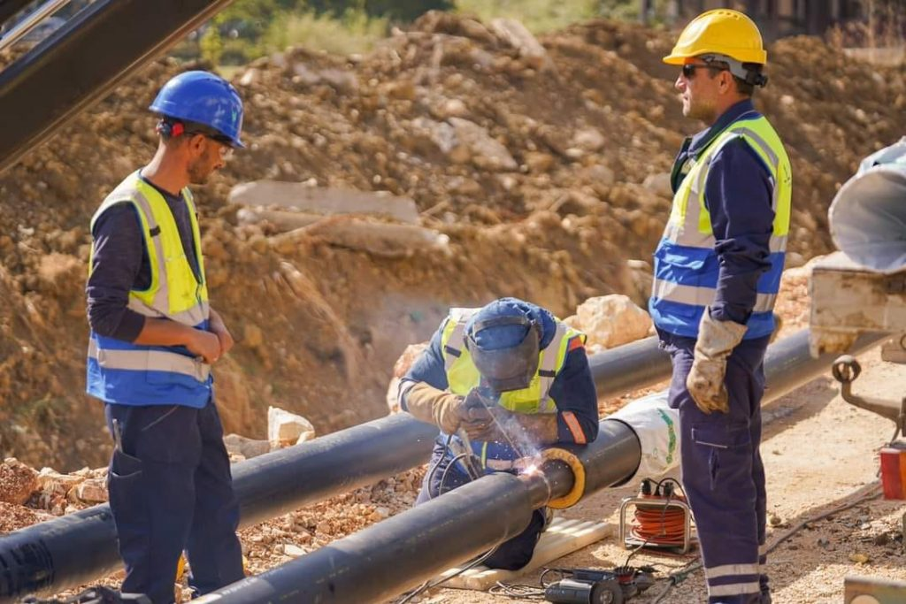
Fig . 7. 1 View from the works on the network expansion and rehabilitation of heating networks
It is estimated that the completion of this project will have a positive impact on reducing losses in the thermal energy distribution network and improving the quality of heating in some areas that are more problematic; also, the expansion of the network and the installation of new substations will increase the number of customers who benefit from thermal energy supply (district heating), respectively, increasing the heating area of the spaces covered by the supply service.
Also this year, the MCC - USA (“Millennium Challenge Corporation”) project “Metering of district heating” was almost completely implemented, which, after the completion of the “Reliable Energy Spectrum” Program, has been transferred to the “Heat Save in Prishtina” project. With the installation of individual heating meters at the apartment level, the prerequisites have been established to start billing based on metered consumption – with a modern billing system for Termokos, the aim is to achieve efficient use of thermal energy. Otherwise, the “Metering of District heating” project, with an estimated value of $10.9 million, as a donation from MCC - USA, has included about 300 collective housing buildings, namely approximately 17,500 household and commercial customers; the main components of the project are:
- Installation of 64,000 heat allocators and 5,100 individual thermal energy meters;
- The installation of 85,500 thermostatic valves on customer radiators (apartments and commercial units), as well as the installation of circulating pumps in a limited number of
- thermal substations;
- Development of software for billing and reading thermal energy consumption;
- Assistance in improving billing services based on metered consumption.
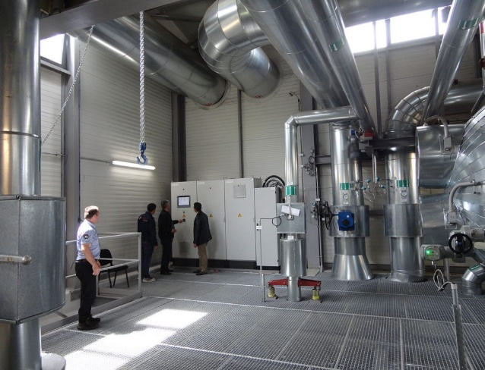
Fig . 7. 2 SEQ Fig._ \* ARABIC \s 1 View from the project to double heating capacities
In this regard, it should be mentioned that with the start of this heating season 2024/2025, the implementation of billing based on the metered heat consumption has also begun. It should also be emphasized that this implementation has not been complete - in the sense that it has not included all customers for whom meters have been installed, and has been accompanied by many problems in the implementation, including many inaccuracies in the measurement, reading and calculation of consumption. It is very important to completely eliminate the problems that have arisen and fully functionalize the metering system, reading and calculation of consumption, as well as billing based on real metered consumption. In addition, efforts should be increased to raise customer awareness of saving the heat. These are the main prerequisites for the full and correct implementation of billing based on registered metering of consumption, which will achieve thermal energy savings that will free up capacities for expanding the customer base, respectively, will enable the connection to the heating system of a considerable number of customers who currently use electricity for heating their area.
During 2024, preparatory work continued for two important projects to increase the thermal capacities of the DH Termokos:
- Project “Solar4Kosova – Solar for district heating”: A project initiated within the framework of the cooperation of our Government with KfW and EBRD, for the production of thermal energy from solar energy, with an estimated investment value of around 80.7 million €. This project will be financed by the German Government through the German Development Bank (KfW) in the amount of 53.1 million €, of which 21.5 million € grant and 31.6 million € loan, EBRD with 23.2 million € loan and 4.4 million € from PE “Termokos” JSC as co-financier of this project. Specifically, for this project:
The following are completed:
- Feasibility Study and ESIA Project (Environmental and Social Impact Evaluation);
- A location in the Hade e Re area of 25 hectares of land has been defined and approved for the installation of solar panels and a heating energy reservoir;
- A consulting company has been selected for the project.
While the activities in progress are:
• Preparation of detailed design;
• Preparation of tender documentation (technical tender specifications);
• The tendering process and selection of the company for the execution of the works
- Project for doubling the thermal energy extraction capacity from co-generation at TPP Kosova B: This project, which is also in the preparatory and study phase, is supported by the EU and the EIB (European Investment Bank) under the IPA. In June 2022, the Government of Kosovo signed an agreement with the EIB for a financial grant in the amount of €1.5 million for the preparation of the study for this project. €25 million has been pledged to finance this project - €17.5 million has been pledged by the European Commission, €5 million by the Municipality of Pristina, and €2.5 million by Termokos as a co-financier of this project. This project will contribute to the further expansion of the Termokos district heating system with a positive impact on preserving the environment and increasing the quality of life for the citizens of Pristina.
Regarding these two development projects, it should be emphasized that within their framework, during 2024, relevant master plans have been drafted for the expansion of the network in the areas included in these two projects. Currently, the master plans are in the finalization phase.

Developments in DH Gjakova
The project "Improving the performance of the Gjakova district heating system" was fully completed in early 2024. This project was financially supported by the Swiss State Secretariat for Economic Affairs (SECO), in the amount of €5.5 million, and by the Municipality of Gjakova in the amount of €500 thousand.
This project included the complete rehabilitation of the DH Gjakova system and the increase in energy efficiency, as well as the improvement of the operational and financial performance of the enterprise; the following briefly describes 4 main components:
- Corporate development of the Gjakova District Heating company;
- Rehabilitation of the distribution network and substations: rehabilitation of about 9.7 km of pipelines, mostly replacing 6.2 km of old steel pipes; rehabilitation of 342 thermal substations, including the installation of pressure/temperature/flow control devices (instruments) and measuring equipment;
- Rehabilitation of the internal network (secondary network) and 14 thermal substations of the Gjakova Regional Hospital; and
- Connection to the district heating system of 13 new buildings - mainly public - including the installation of new substations.

Performance of thermal energy companies
In the 2023/2024 season, DH Termokos has continued the positive trend of sustainable production and supply of thermal energy, offering uninterrupted 24-hour supply, which is mainly a result of sufficient production from the co-generation plants at TPP Kosova B, but also the implementation of rehabilitation projects of the network and thermal substations.
Regarding the DH Gjakova, it should be mentioned that in the 2023/2024 season it only activated the units for the production of thermal energy only, and that the production and supply of heat began in early November 2023 and ended at the end of March 2024. The reasons for the late start of the season were mainly related to the inability to provide timely and sufficient amounts of fuel - biomass.

Production, supply and losses in the system
DH Termokos
- Thermal energy production
DH Termokos has based the production of thermal energy from co-generation plants at TPP Kosova B. In fact, in the 2023/2024 season, all thermal energy production was from co-generation plants at TPP Kosova B, while there was no thermal energy production from the DH Termokos heating plant.
The amount of thermal energy extracted from co-generation in the 2023/2024 season was 329,617 MWh _{TH} , which is 21,461 MWh _{TH} or approximately 7% greater than the amount of thermal energy in the previous season (308,156 MWh_{TH}). While the amount of thermal energy received at the heat exchange station in the DH Termokos was 323,025 MWh _{TH}, which also represents an increase of about 7% compared to the previous season (301,993 MWh _{TH}).
The summarized data on thermal energy production from cogeneration are presented in the following table:
Tab. 7. 2 Thermal energy production from cogeneration

- Thermal energy supply
In the 2023/2024 season, DH Termokos has also continued with sufficient quantitative and qualitative supply of thermal energy, which is mainly a result of the continuous improvement of thermal energy production, as well as maintenance, repairs and rehabilitation of the network.
The supply of thermal energy (district heating) to customers in this season is estimated to be 285,728 MWh _{TH,} which represents an increase of 15,146 MWh _{TH.} or 5.6% compared to the previous season 2022/2023 (270,582 MWh _{Th)}. This achieved supply is quite satisfactory and has met the plans and objectives for a sufficient and quality supply.
- Losses in the system
The thermal energy system of DH Termokos has its own specifics regarding system losses, due to the integration of thermal energy from co-generation. Therefore, network losses include two components: losses in the transport network TPP Kosova B – DH Termokos and losses in the primary distribution network.
Losses in the thermal energy transportation network TPP Kosova B – DH Termokos, with a length of 10.5km, have been determined from measurements carried out at the thermal energy extraction station at TPP Kosova B and at the thermal energy reception station at DH Termokos. From the measurements carried out in the period October 2023 – April 2024 it results that the quantitative losses in this period are 6,592 MWh _{TH,} or 2%; the level losses in the transportation network is the same as last season. The following table provides details on losses in the thermal energy transmission network.
Tab. 7. 3 Thermal energy and losses in the transmission network TPP Kosova B – DH Termokos – season 2023/2024
Losses in the primary thermal energy distribution network are normally determined from thermal energy metering at the entry of the distribution network and from the thermal energy supply at the customer substations. However, in the absence of complete thermal energy supply meterings (at substations), some approximations have been made to calculate the supply using, first of all, parameters such as: specific demand for heating capacity (W/m ² ) and full load hours, respectively specific consumption (kWh/m²). The calculated consumption value is 285,728 MWh _{Th.} By subtracting this consumption value from the amount of thermal energy introduced into the distribution network (322,660 MWh _{Th)} it results that the quantitative losses in the distribution network for the 2023/2024 season are 36,932 MWh _{TH} , which in percentage represents 11.45 %. This level of losses represents an increase of 1.29% compared to the previous season (10.16%); this reduction in losses is as a result of the network rehabilitation project, where several segments of the network pipeline have been replaced and the rehabilitation of thermal substations has also had a positive impact.
The following table presents summarized data on production, supply and total losses in the network - the thermal energy transportation network and the distribution network:
Tab. 7. 4 Energy performance of the DH Termokos – season 2023/2024
DH Gjakova
- Thermal energy production
In the 2023/24 season, DH Gjakova continued the third season of commercial operation in the new biomass heating plant. However, due to the inability to secure the necessary amount of fuel, thermal energy production was also reduced in this season - gross production was 17,696MWh _{TH.} which represents an increase of 3,933 MWh _{TH} or 28.5% compared to the previous season (13,763 MWh _{TH}), while the net production of thermal energy was 17,636 MWh_{TH}. For this production of thermal energy in this season, 8,125 tons of fuel - biomass were spent.
- Heating supply
As a result of reduced production, DH Gjakova during the 2023/2024 season has offered a reduced supply; it should also be noted that for this reason the supply was interrupted before the official end of the season – at the end of March 2024. The supply of thermal energy to customers in this season has been 15,140 MWh _{TH} which is higher by 3,767 MWh _{TH} than in the previous season (11,373 MWh _{TH} )s.
- Losses in the system
Regarding losses in thermal energy production, it should be emphasized that the metering devices in the new heating plant are installed, but accurate reading of these devices, as well as correct processing and reporting of data on thermal energy production, must be carried out. According to the company's report, the efficiency of the boilers for thermal energy production is estimated at around 85%, which causes a loss during the process of transforming fuel energy into thermal energy, which is estimated to be 1,967 MWh_{TH} .
Losses in the primary distribution network are calculated as the difference between the amount of thermal energy entering the distribution network and the supply/consumption. In the absence of metering of the amount of thermal energy supplied (at substations), some approximations have been made to calculate the supply, using first of all parameters such as: specific demand for heating capacity (W/m²) and full load hours, respectively specific consumption (kWh/m²). The calculated consumption value is 15,140 MTh. By subtracting this consumption value from the amount of thermal energy introduced into the distribution network (17,636 MWh_{Th}), it results that the quantitative losses in the distribution network for the 2022/2023 season are 2,496 MWh_{TH} , which in percentage terms is about 14%.
The following table presents summarized data on production, supply and losses in the distribution network:
Tab. 7. 5 Energy performance of DH Gjakova – season 2023/2024
The following table presents data on production, supply and system losses summarized for the entire thermal energy sector.
Tab. 7. 6 Energy performance of the thermal energy sector – season 2023/2024

Billing, collection and heating area

Billing and collection
Regarding billing, it should initially be mentioned that even in the 2023/2024 season, the billing of thermal energy customers has mainly been based on the heating area (per square meter), while a smaller number of customers have been billed based on metered consumption. Specifically, in DH Termokos, the number of customers billed with metering has reached 170 customers, mainly commercial and institutional, while DH Gjakova, in the absence of functionalization of reading and registration of metering at substations, has almost entirely billed according to the heating area.
DH Termokos, in the 2023/2024 season, has recorded an increase in billing compared to the previous season, which is mainly due to the increase in the number of customers, respectively the increase in the heating area and the continuous improvement of the supply. In fact, the billing realized in the 2023/2024 season was €9,753,546, which represents an increase of €1,056,667 or about 12.15% compared to the 2022/2023 season (€8,696,879). Of the total billing realized in the 2023/2024 season of €9,753,546, billing with metering was € 2,772,431 (28%) and without metering €6,981,116 (72%); The ratio of metered and unmetered billing and the respective values are presented in the diagram below.

Fig. 7.3 Share of metered and unmetered billing values in total billing
In the 2023/2024 season, Termokos District Heating collected the amount of €6,719,196, which represents an overall collection rate of 68.89%. It should be noted that the collection level is 1.44% higher than in the previous season 2022/2023, where the collection rate was 67.45%. It should be noted that in this season, the collection of payments from the household customer group is higher (58.85%) compared to the previous season (53.94%); while the collection of payments from commercial and institutional customers was 84.05%.
As mentioned above, DH Gjakova during the 2023/2024 season has offered a reduced supply, as a result of the shortening of the heating season and also the active heating surface still remains small compared to the total connected heating area. Consequently, billing in this season has been quite small – €687,801, while cash collection has reached the value of €557,557, which represents a collection rate of 81.06%.
Details regarding billing and collection are shown in the table and graph below.
Tab. 7 . 7 Invoicing and collection – season 2023/2024
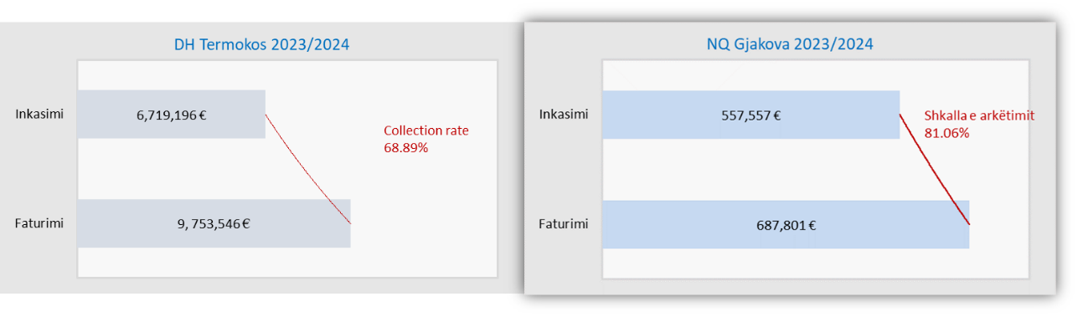
Fig. 7. 4 Billing and collection of DH Termokos – season 2023/2024

Heating area
In the 2023/2024 season, DH Termokos had a total customer heating area of 2,047,108 ^{m2} , which is divided into household and commercial and institutional customer groups according to the proportion of 65%:35%.
While the total heating area of DH Gjakova is 123,190 m ^{2,} divided in the proportion of 35% household customers and 65% commercial and institutional customers. As mentioned above, the heating area of active customers is still small compared to the total area of customers connected to the system and it remains a challenge for DH Gjakova to activate passive customers by providing sufficient and quality supply.
The graphs below show the heating areas of DH Termokos and DH Gjakova, divided by customer groups.
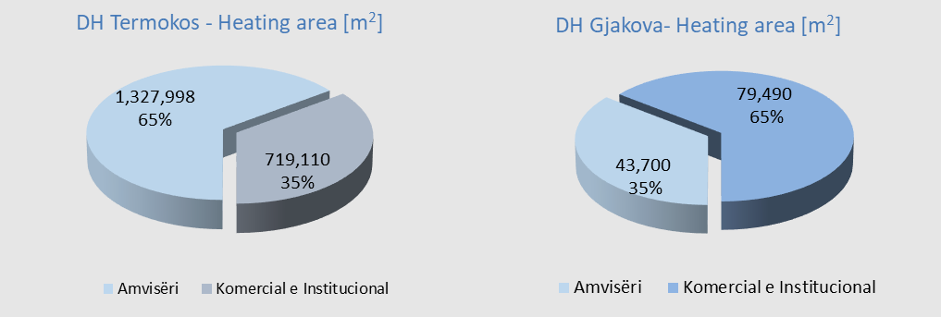
Fig. 7. 5 Heating area by customer groups in the 2022/2023 season
Address of the Regulator
Energy Regulatory Office
Street: Bekim Fehmiu (former Fazita Building), 2nd Floor
Prishtina 10000, Kosovo
Tel: +383 (0) 38 247 615 Fax: +383 (0) 38 247 620
Email: info@ero-ks.org
Web: www.ero-ks.org

The Board of the Energy Regulatory Office:
Tel: +383 (0) 38 247 615 ext. 101

Reception:
Tel: + 383 (0) 38 247 615 ext. 104

Customer Protection Department:
Tel. + 383 (0) 38 247 615 ext. 116 and 125
Email: ankesa.dmk@ero-ks.org

Implementation performance - Energy Community Homepage
V_1925_2024.pdf
https://www.ero-ks.org/zrre/sites/default/files/Publikimet/Licencat/2017.03.31_2022_Amendment_Rregulla_per_Licencimin_e_Aktiviteteve_te_Energjise_ne_Kosove.ALB.pdf
ERO has been a member of the Energy Regional Regulatory Association ( ERRA) since 2005. ERRA is a voluntary organization composed of independent energy regulators mainly from Europe, Asia, Africa, the Middle East, South America and North America. https://erranet.org/

